Pupil premium strategy statement

This statement details our school’s use of pupil premium (and recovery premium for the 2021 to 2022 academic year) funding to help improve the attainment of our disadvantaged pupils.

It outlines our pupil premium strategy, how we intend to spend the funding in this academic year and the effect that last year’s spending of pupil premium had within our school.

School overview
Detail | Data
School name | Buckminster Primary School
Number of pupils in school | 80
Proportion (%) of pupil premium eligible pupils | 9
Academic year/years that our current pupil premium strategy plan covers (3 year plans are recommended) | 3 (2020/21 – 2021/2022, 2022/23)
Date this statement was published | November 2021
Date on which it will be reviewed | April 2022
Statement authorised by | Debbie Clarke
Pupil premium lead | Clare Smith
Governor / Trustee lead | Katherine Coleman
Funding overview
Detail | Amount
Pupil premium funding allocation this academic year | £13,450
Recovery premium funding allocation this academic year | £2000
Pupil premium funding carried forward from previous years (enter £0 if not applicable) | £0
Total budget for this academic year | £15,450

Part A: Pupil premium strategy plan

Statement of intent
At Buckminster Primary we believe all children, including those from a ‘socially disadvantaged’ background, should achieve their potential whilst feeling safe and happy during their primary education. This belief drives our overarching school vision of developing active and responsible global citizens.
All members of staff and the governing body understand that, through no fault of their own, children come to our school from varied backgrounds and social settings. We accept responsibility for those pupils who are ‘socially disadvantaged’ and are committed to meeting their pastoral, social and academic needs within a caring and nurturing environment.
By identifying barriers to learning, which our socially disadvantaged children may be experiencing, we are able to deploy a range of strategies to support children in breaking through those barriers, whether they are linked to academic progress, self-esteem, life experience or financial issues.
Our key focus for the whole school, supporting academic progress and agility, is Quality First and Responsive teaching. Frequent intervention groups are also planned and delivered as required. These are fluid and based on children’s needs each week. As a small school where all teachers know all the children, it is easier for our staff to flex and adapt to changing needs. By continually monitoring and evaluating each child and initiative we are able to ensure we remain effective and efficient.

Challenges

This details the key challenges to achievement that we have identified among our disadvantaged pupils.
Challenge number | Detail of challenge
1 | Only 22% (2/9) PP children are on track to make expected progress in reading, writing and maths
2 | Learning behaviours/lack of independent learning strategies
3 | 44% (4/9) of PP children are on the SEND register
4 | 44% (4/9) of PP children do not have secure level of phonics knowledge
5 | External Barriers  - Work with outside agencies (2/9)  - Poor attendance (1/9)  - Lack of engagement in after school clubs for some pupils  - Financial support- uniform, trips, residential (3/9?)

Intended outcomes
This explains the outcomes we are aiming for by the end of our current strategy plan, and how we will measure whether they have been achieved.
Intended outcome | Success criteria
Improved progress for all disadvantaged children | Children will make progress in line with (or above) the national average expectation
Improved learning behaviours and uptake of independent learning strategies. | Children will feel more accountable for their own learning and have a positive attitude to school and their work during lessons (recorded using a scale 0-10) – this will be reviewed 2x a year with children and teachers in a 1:1 discussion.
Provide more support for PP children with SEND | In addition to QFT, those children with SEND will receive specialised intervention. Children will make ‘small step’ progress each half term versus individual targets – interventions will be reviewed for efficacy and changed where progress not evident
Improve phonics and reading outcomes for disadvantaged children | Phonics screening pass rate for the school (& the PP group) will be at least the national average expectation.  Older PP children make small step progress each half term versus individual targets in daily phonics sessions
Improved attendance and participation in after school clubs. | All PP children to attend at least 1 after school club during the year
Develop parental engagement and relationships | Parents feel comfortable to ask for help for their families in relation to school and barriers to learning – better links with agencies and improve attendance

Activity in this academic year
This details how we intend to spend our pupil premium (and recovery premium funding) this academic year to address the challenges listed above.

Teaching (for example, CPD, recruitment and retention)
Budgeted cost: £6000
Activity | Evidence that supports this approach | Challenge number(s) addressed
Quality First Teaching emphasises high quality, inclusive teaching for all pupils in a class including differentiated learning and strategies to support SEND pupils’ learning.  There will be personalising learning to the individual needs of pupils, encouraging greater inclusion of pupils with SEN needs, and working to narrow the attainment gap for all children. | EEF Guide to Pupil Premium Key Principles  https://educationendowmentfoundation.org.uk/evidence-summaries/pupil-premium-guide/  page 3 – Quality Teaching Helps Every Child  “Quality of teaching is one of the biggest drivers of pupil attainment, particularly for those from disadvantaged backgrounds”  “Early Years education has huge promise in preventing the attainment gap becoming entrenched before children start school.”  (EEF The Attainment Gap 2018) | 1  3
Quality feedback which allows children to;  - engage in dialogue with their teacher  - instantly improve their work  - understand any misconceptions  how to develop learning | School development plan – OFSTED feedback  EEF Teacher Feedback to Improve Learning Report  “Regardless of whether a teacher chooses to give grades, offer praise, or comment on effort, the feedback they give on learning is more likely to be effective at improving pupil attainment if it includes a focus on the task, subject, and/or self-regulation strategies.” | 1  3
Daily phonics/spelling sessions for all children needing phonics support targeted at the individual needs of the child from highly trained teachers / TAs | “We know that a good grasp of phonics is crucial for supporting younger pupils to master the basics of reading. Educational prospects for children who don’t achieve good literacy skills by the end of primary school are bleak.”  (EEF Article – Phonics Attainment Gap Widens September 2017)  https://educationendowmentfoundation.org.uk/public/files/Publications/Literacy/Improving_Literacy_in_KS1_Recommendations_Poster.pdf | 3  4
Ensure regular reading slots with class teachers /TA at least 3 x a week for all PP children (those with SEN – daily readers) |  | 1  3  4
Differentiated and targeted activities during whole class guided reading lessons to encourage inclusion of all pupils and narrow any gaps in reading / phonics |  | 1  3  4

Targeted academic support (for example, tutoring, one-to-one support structured interventions)
Budgeted cost: £5000
Activity | Evidence that supports this approach | Challenge number(s) addressed
Class teachers will provide short pre & post teaching sessions during the day where gaps are identified as part of the additional and highly personalised interventions for specific children / pairs of children. | EEF Guide to Pupil Premium Key Principles  https://educationendowmentfoundation.org.uk/evidence-summaries/pupil-premium-guide/  page 5 – Targeted Academic Support  “Evidence consistently shows the positive impact that targeted academic support can have, including on those who are not making good progress across the spectrum of achievement. Considering how classroom teachers and teaching assistants can provide targeted academic support, including how to link structured one-to-one or small group intervention to classroom teaching, is likely to be a key component of an effective Pupil Premium strategy.” | 1  3  4
A trained teacher / TA will provide weekly pre / post / additional teaching as required and discussed with class teacher for pairs / small groups of children. |  | 1  3  4
Activities and interventions to support specialised individual needs as required – outside agency fees / diagnosis fees / 1:1 online tutoring | Evidence indicates that one to one tuition can be effective, delivering approximately five additional months’ progress on average.  EEF / Sutton Trust – Teaching Learning Toolkit  https://www.gov.uk/government/publications/pupil-premium/pupil-premium#use-of-the-pupil-premium | 1  2
1. Continue to follow Route 2 Resilience training.  2. Refer to, model and praise character strengths  3. Promote 5 Ways to Wellbeing encouraging children to choose a positive outlook  4. Model and teach metacognition and self-regulation techniques as outlined in EEF meta cognition and self | “Developing pupils’ metacognitive knowledge of how they learn—their knowledge of themselves as a learner, of strategies, and of tasks—is an effective way of improving pupil outcomes.”  EEF Metacognition & Self-Regulated Learning 2018  “Meta-cognition and self-regulation are sometimes known as ‘learning to learn’and are intended to help pupils think, more explicitly, about their own learning” – An effective low cost strategy recommended by Third Space Learning, adding up to 8 months progress  TSL: New Primary School Guide to Pupil Premium 2016/7  (See also feedback strategies above) | 2

Wider strategies (for example, related to attendance, behaviour, wellbeing)
Budgeted cost: £1900
Activity | Evidence that supports this approach | Challenge number(s) addressed
Funding towards Educational Visits, activities, afterschool clubs, music lessons | EEF Guide to Pupil Premium Key Principles  https://educationendowmentfoundation.org.uk/evidence-summaries/pupil-premium-guide/  page 5 – Wider Strategies | 5
Uniform, resources provided as necessary and as identified between class teacher, pupil and family. | “A pupil cannot benefit from a lesson if they are not present in the classroom, engaged in the lesson, and behaving appropriately for learning.  EEF Behaviour Report | 5
Regular contact with families to confirm the school is here to support them as and when we are able.  Timely action taken to address punctuality |  | 5

Total budgeted cost: £15,450

Part B: Review of outcomes in the previous academic year

Pupil premium strategy outcomes
This details the impact that our pupil premium activity had on pupils in the 2020 to 2021 academic year.
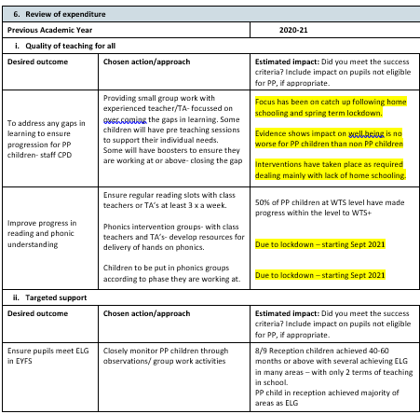
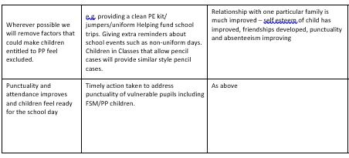
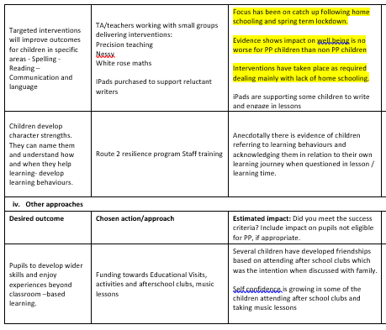

Externally provided programmes
Please include the names of any non-DfE programmes that you purchased in the previous academic year. This will help the Department for Education identify which ones are popular in England
Programme | Provider
Mathletics | ??
?? | ??

Service pupil premium funding (optional)
For schools that receive this funding, you may wish to provide the following information:
Measure | Details
How did you spend your service pupil premium allocation last academic year?
What was the impact of that spending on service pupil premium eligible pupils?

Further information (optional)
Use this space to provide any further information about your pupil premium strategy. For example, about your strategy planning, or other activity that you are implementing to support disadvantaged pupils, that is not dependent on pupil premium or recovery premium funding.

