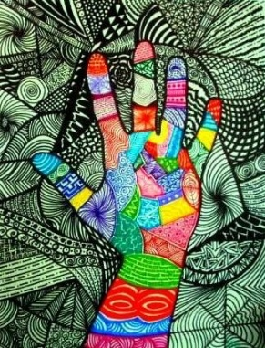
Art Activities
Activity 1 - Pattern drawings – https://www.youtube.com/watch?v=eYlPYEQil54
We are going to draw around our hand and decorate it using different patterns and colours.
You will need different coloured pens and paper.

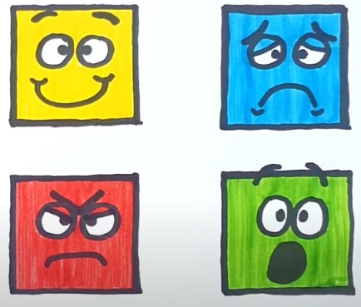
Activity 2 – Expression drawing – https://www.youtube.com/watch?v=LbUr6zbBDLA
We are going to learn how to draw facial expressions like a happy face, a sad face, an angry face and a shocked face.
You will need different coloured pens and paper.

Activity 3 – Nature art
Collect items from your garden or on a walk to design a nature picture.
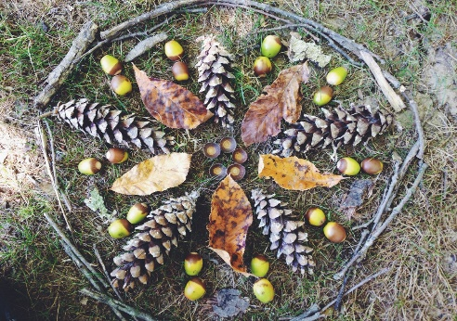
You can use sticks, leaves, seeds, pinecones, stones, whatever you find, create a pattern or a picture ;smiley faces, hearts, a house etc.

Activity 4 - Piet Mondrian Paintings
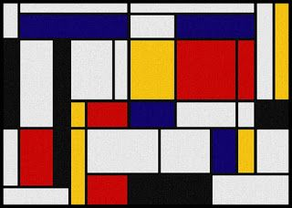
Piet Mondrian’s simple style is perfect for little artists to recreate. Challenge them to stick lines of masking tape across an A4 page, then paint in the gaps. Once the tape is removed, use a ruler to draw some black lines and voila! A perfect Mondrian replica.
Alternatively, use a ruler and black pen to make different sized rectangles and colour them in with coloured pens or pencils.

