Reading Suggestions
The Secret Garden by Frances Hodgson Burnett | Five Children and It by Edith Nesbit | Treasure Island by Robert Louis Stevenson | The Railway Children by E Nesbit | The Phoenix and the Carpet by E Nesbit
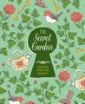 | 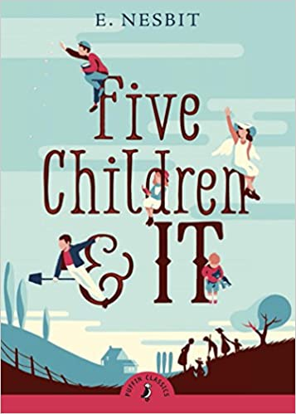 | 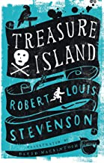 | 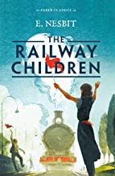 | 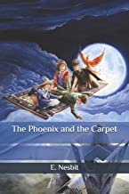
Kensuke’s Kingdom by Michael Morpurgo | Wonder by R J Palacio | The Nowhere Emporium by Ross MacKenzie | Robinson Crusoe by Daniel Defoe | Charlotte’s Webb by E B White
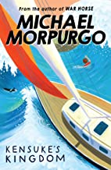 | 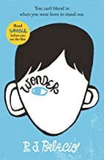 | 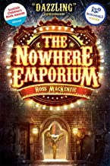 | 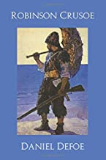 | 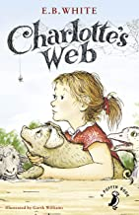
Time Travelling with a Hamster by Ross Welford | A Boy Called Hope by Laura Williamson | Absolutely Everything by Christopher LLoyd | The Girl of Ink and Stars by Kiran Millwood Hargrave | Cogheart by Peter Bunzl
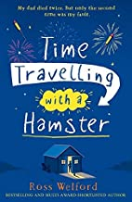 | 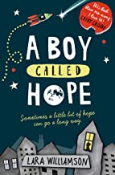 | 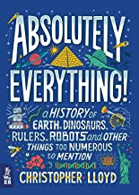 | 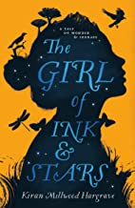 | 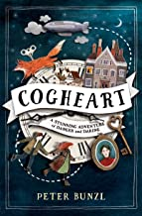
The Secret Seven by Enid Blyton | Carrie’s War by Nina Bawden | From Hereabout Hill by Michael Morpurgo | The Hobbit by J.R.R. Tolkein | Granny by Anthony Horowitz
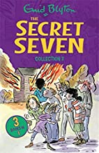 | 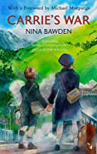 | 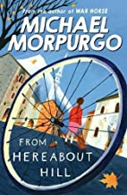 | 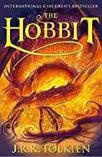 | 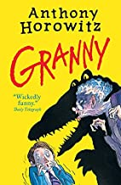
Goodnight Mister Tom by Michelle Magorian | The Chronicles of Narnia by C.S.Lewis | The Borrowers by Mary Norton | Superfudge by Judy Blume | The Viewer by Gary Crew (picture book)
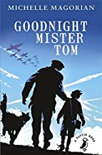 | 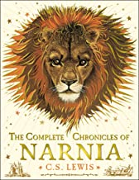 | 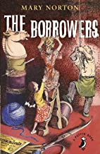 | 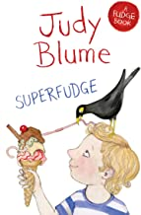 | 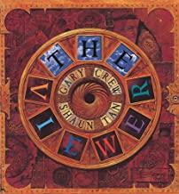
Lion Boy by Zizou Corder | George’s Sectret Key to the Universe by Lucy and Stephen Hawking | The Witches by Roald Dahl | Horrible Histories Smashing Saxons by Terry Deary and Martin Brown | The Complete Nonsense of Edward Lear by Edward Lear
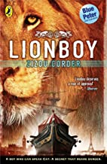 | 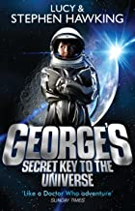 | 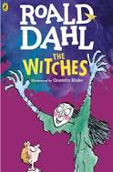 | 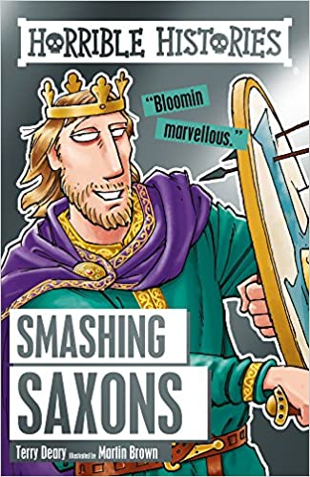 | 