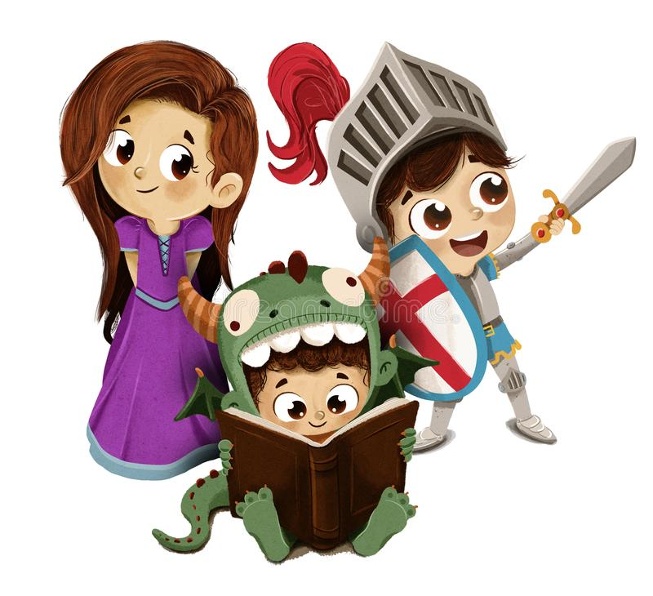

**Phonics**

* **Oo**
* **Ar, ur, oo, or**
* **Ow, oi, ear, air**
* **Ure, er, ow**
* **Review**
* **Assessment**

**Communication, Language and Literacy**

* **Understanding what it was like in a castle, carrying out research to know how they lived.**
* **Naming special parts of a castle**
* **Who was a knight and what did they do?**
* **Talk about dragons as part of fairy stories**
* **Cinderella – what do we know about the story, act out parts t retell the story**

**Expressive Arts and Design**

* **Designing coats of arms**
* **Medieval dance**
* **Junk modelling sword and shield**
* **Exploring sounds**
  + **Environmental**
  + **Nature sounds**
* **Deigning outfits for the Cinderella Ball**
* **Making wands**

**Mathematics**

**Alive in 5**

* **Introducing 0**
* **Comparing numbers to 5**
* **Composition of 4 and 5**

**Personal, Social and Emotional Development**

* **Team work- working together creatively**
* **Being brave – what does it mean to be brave?**
* **Personal hygiene – the importance of keeping clean**
* **Being kind- what can we do to be kind?**

|  |
| --- |
|  |

**EYFS Curriculum Plan**

**Spring 1**

**Once upon a time**

**(Castles, knights, dragons and princesses)**

**Physical Development**

**In spring 1 children will take part in the Get Set for PE topic titled Fundamentals, a gymnastics unit.**

**They will also**

* **Construct bridges**
* **Make castles**
* **Pretend to be knights**
* **Take part in a dragon egg hunt**
* **Create a healthy feast for the ball**
* **Have a go at ballroom dancing**

**Understanding the World**

* **Exploring castles – what are the different parts?**
* **Comparing life now to that long ago**
* **What is a magnet and how does it work?**
* **Creating digital paintings**
* **Design and technology – designing a dragon trap**
* **Thinking about where people might get married**