**Early Years Foundation Stage**

**Curriculum Plan**

**Autumn 1.1**

**Book Theme**

**Under the Sea**

[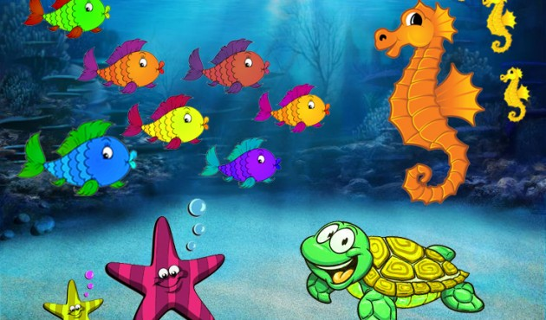](https://www.acta-bristol.com/what-can-you-see-under-the-sea/)

**Communication, Language and Literacy**

Listening to stories and retelling stories

Phonics

Mark making

Develop listening and attention skills

Talk partners

Guided Reading & individual reading

**Expressive Arts and Design**

Acting out story- role play

Making instruments- ‘sounds of the sea’

Loud and soft sounds- tapping a beat

Singing songs

Cutting and sticking

Using imagination in art, design and music

Modelling with clay

Scissor skills

**Understanding the World**

Finding the biggest and smallest sea creatures

Identifying similarities and differences

Freezing water- how can we melt ice quickly?

Sensory bottles

Floating and sinking

Under the sea habitats

Make a pulley

**Physical Development**

Opportunities for large movements e.g. climbing, balancing equipment, large construction.

Opportunities for fine motor skill development e.g. threading, disco dough, peg boards

Working alongside others to develop tool use eg scissors, sellotape, knives in playdough

Ball skills- throwing, rolling, catching, kicking

**Personal, Social and Emotional Development**

Following rules- settling children in to school routines e.g. tidying away, looking after toys, sharing

Keeping safe at school and at home- knowing where everything is in school and adults in school

Saying Please and Thank you (Harvest) - using manners in school

Feelings when we are happy and sad

Being a good friend

|  |
| --- |
|  |

**Mathematics**

Counting carefully

Finding the odd one out

Measuring- comparing size and length of various fish

Ordering numbers