**Early Years Foundation Stage**

**Curriculum Plan**

**Spring 1.2**

**Noah's Ark**

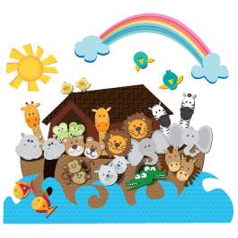

**Personal, Social and Emotional Development**

Understanding good and bad

Sharing and taking turns

Resolving disputes

Respecting other people and their things

Working as a team

Having a goat persevering

Co operation

|  |
| --- |
|  |

**Communication, Language and Literacy**

Speaking and listening to others

Responding to and asking questions

Making up own stories

Role play

Retelling stories

**Mathematics**

Time - feeding times

2 by 2 - counting in pairs

pairs

Ordering height of animals

Adding legs 4+4=8

Counting, recognising, ordering and writing numbers to 20

Adding and taking away

Learning names and describing 2D and 3D shapes

Understanding measure- height and length

**Physical Development**

Disco Dough

Fine motor development

Gross motor skills

Control and coordination

Dressing independently

Handling tools and equipment

**Reading and Writing**

Ships log

Animal care notes

Character/Animal descriptions

Diary entries

Passports

Lists of things to take

Reading and writing simple sentences

Exploring different kinds of writing

Phonics and handwriting

Learning key words

Understanding story structure

Retelling stories

**Understanding the World**

Weather station - rain

Floating/sinking

Poo?

Aminals - types/habitats

Construction - building boats

Cooking and food tasting

Properties of materials

Water and sand exploration

Building and constructing

**Expressive Arts and Design**

Ark mobile from paper plate

Pizza box frame to fill with animals

Dove hand print art

Rainbow fruit kebabs and smoothies/biscuits

Colour mixing

Bubble painting/blow painting

How to draw- step by step

Explore different materials, tools and techniques

Learn a variety of songs and dances

Explore different musical instruments

Use imagination in art using a variety of different media