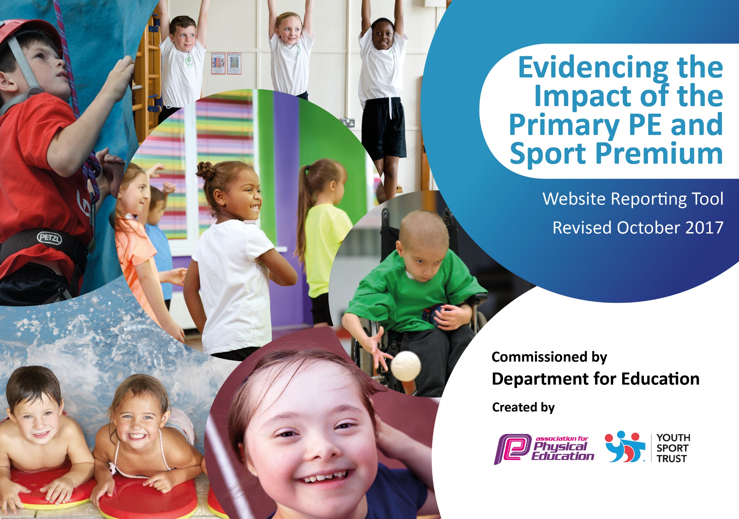

Buckminster Primary School
2021/22

Schools must use the funding to make additional and sustainable improvements to the quality of PE and sport they offer. This means that you should use the Primary PE and Sport Premium to:

- develop or add to the PE and sport activities that your school already offers
- build capacity and capability within the school to ensure that improvements made now will benefit pupils joining the school in future years

Please visit gov.uk for the revised DfE guidance including the 5 key indicators across which schools should demonstrate an improvement. This document will help you to review your provision and to report your spend. DfE encourages schools to use this template as an effective way of meeting the reporting requirements of the Primary PE and Sport Premium.

We recommend you start by reflecting on the impact of current provision and reviewing the previous spend.
Under the Ofsted Schools Inspection Framework, inspectors will assess how effectively leaders use
the Primary PE and Sport Premium and measure its impact on outcomes for pupils, and how effectively governors hold them to account
for this.

Schools are required to publish details of how they spend this funding as well as on the impact it has on pupils’ PE
and sport participation and attainment.
We recommend regularly updating the table and
publishing it on your website as evidence
of your ongoing review into how you are using the money
to secure maximum, sustainable impact. To see an example of how to complete the table please click HERE.

Support for review and reflection - considering the 5 key indicators from DfE, what development needs are a priority for your setting and your students now and why? Use the space below to reflect on previous spend, identify current need and priorities for the future.

Key achievements to date: 2021/22 | Areas for further improvement and baseline evidence of need:
- Recruited a sports apprentice who supported school in delivering more sporting and physical opportunities across school  - Signed up to participate in more competitive fixtures and tournaments  - Pupil Premium child – review meetings focused on encouraging them to participate in more after school clubs  - Get Set 4 PE Scheme has been embedded throughout the school  - Secure and robust assessment procedures in place and data in analysed termly | - Increase opportunities to take part in a wider range of sports (competitive and non-competitive)  - Target pupils who are more sedentary and Pupil Premium pupils  - Provide at least 2 sports clubs for each year group every week of the year

Meeting national curriculum requirements for swimming and water safety (9 children) | Please complete all of the below:
What percentage of your Year 6 pupils could swim competently, confidently and proficiently over a distance of at least 25 metres when they left your primary school at the end of last academic year? | 100%
What percentage of your Year 6 pupils could use a range of strokes effectively [for example, front crawl, backstroke and breaststroke] when they left your primary school at the end of last academic year? | 100%
What percentage of your Year 6 pupils could perform safe self-rescue in different water-based situations when they left your primary school at the end of last academic year? | 100%
Schools can choose to use the Primary PE and Sport Premium to provide additional provision for swimming but this must be for activity over and above the national curriculum requirements. Have you used it in this way? | No

Action Plan and Budget Tracking
Capture your intended annual spend against the 5 key indicators. Clarify the success criteria and evidence of impact that you intend to measure to evaluate for students today and for the future.

Academic Year: 2021/22 | Total fund allocated: £16,970  £8000 contribution to membership of Inspire+ | Date Updated: July 2022
Key indicator 1: The engagement of all pupils in regular physical activity – Chief Medical Officer guidelines recommend that primary school children undertake at least 30 minutes of physical activity a day in school |  |  |  | Percentage of total allocation:
 |  |  |  | 100%+ (over spent by £417)
School focus with clarity on intended impact on pupils: | Actions to achieve: | Funding allocated: | Evidence and impact: | Sustainability and suggested next steps:
- Develop a range of sustainable programmes to encourage more children to engage more regularly in additional physical activity opportunities | - Build upon and extend the existing programme of activities  - Identify any further areas of need / gaps in provision and identify additional strategies, resources and programmes to further develop 30 Minutes a Day across the school  - Provide training for new cohort of Sports Ambassadors  - Ensure all staff (including new staff) are using the REAL PE approach within all PE lessons and the assessment tool from Allison consultancy  - Continue to provide the Top Up Swimming programme  - Continue with the wrap around care which is currently financially sustainable  - Continue the daily mile run for all children  - Get Set 4 PE to be embedded and all classes to have regular, well taught and active PE lessons | £8000 Inspire membership for all KIs unless specified separately  £4893 sports apprentice  £3300 sports coach (in house)  £458 – PE Scheme  £736 – Mini buses | Evidence  - Sports Apprentice appointed with additional skills to those already in School  - Fixtures and whole year group sports festivals through the Melton and Belvoir Sports  - Events attended through Inspire+  - Specialists in School (Inspire+)  - Wrap around care includes physical activities  - Sports Ambassadors have attended training and organised events  Impact/Outcomes for Children  Number of children attending a sports club  - Autumn Term = 53% 100% E6 50% LAC 0% PP  - Spring Term = 56% 100% E6 50% LAC 20% PP  - Summer Term = 48% 100% E6 50% LAC 0% PP | - Capture pupil and staff voice to identify the increased amount of physical activity children are doing within and beyond the PE curriculum.  - Use pupil and staff voice to identify barriers to children’s engagement and identify solutions.  - Review and develop the Active Lunch-time programme to include any ‘Top-Up’ training for new Lunch-time Supervisors including training in identifying mental health issues in children  - Provide training for new co-hort of Sports Ambassadors  - Continue with the wrap around care which is currently financially sustainable  - Continue the daily mile run for all children

 | Key indicator 2: The profile of PE and sport being raised across the school as a tool for whole school improvement |  |  |  |  |  |  | Percentage of total allocation:
 |  |  |  |  |  |  |  | Spent as in Key indicator 1
 | School focus with clarity on intended impact on pupils: | Actions to achieve: |  | Funding allocated: |  |  | Evidence and impact: | Sustainability and suggested next steps:
 | - Develop opportunities for pupil engagement with PE and sport throughout the school.  - Celebration assembly every week to celebrate the sporting/fitness achievements of individuals and teams  - Raise profile of PE and Physical Activity with a sports board and newsletter content.  - Role models - local sporting personalities so pupils can identify with success and aspire to be a local sporting hero. | - Ensure the PE and Sport Premium Plans are strategically embedded within and support and inform the Whole School Improvement Plan  - Extend competition opportunities for all children so more children are engaged in and experience competition and the personal development it fosters  - Further develop opportunities to recognise and share achievements include website updates, social media and school newsletter  - Ensure that as many staff across the school are engaged in future PE CPD that can support whole school improvement so that skills, knowledge, understanding and resources remain in the school even if key staff leave  - Develop links with whole-school focus on healthy eating. Book Root to Food workshop for the whole school  - Develop links to PHSE programme around mental health and wellbeing |  | Inspire+ Membership  £458 – PE Scheme |  |  | Evidence:  - PP review meeting specifically focus on the ability to attend sports clubs after school and to support any barriers children and parents may have.  - Fixtures and sports festivals were attended; however, many were cancelled due to the weather.  - Success is celebrated in assemblies, on the weekly newsletter, on Facebook and Twitter.  - All staff are using Get Set 4 PE  - 5 Ways to Wellbeing is embedded into the school and children are able to talk about the 5 ways and how they support their wellbeing.  - All planning for PSHE is from the PSHE Association scheme  Impact/Outcomes for Children:  - 90% of all children YR to Yr6 are WAE or above in PE | - Active Playground training for new cohort of Sports Ambassadors – develops transferable leadership and team-building skills and qualities  - Extend competition opportunities for all children so more children are engaged in and experience competition and the personal development it fosters  - Identify new programmes/ CPD and resources to support active learning across whole school e.g. Maths of the Day
Key indicator 3: Increased confidence, knowledge and skills of all staff in teaching PE and sport |  |  |  |  |  |  |  | Percentage of total allocation:
 |  |  |  |  |  |  |  | Spent as in Key indicator 1
School focus with clarity on intended  impact on pupils: |  |  | Actions to achieve: |  | Funding  allocated: | Evidence and impact: |  | Sustainability and suggested  next steps:
- Improve the progress and achievement of all children by increasing staff knowledge, skills, understanding and confidence to deliver outstanding PE, School Sport and Physical Activity |  |  | - Get Set 4 PE to be embedded and all classes to have regular, well taught and active PE lessons  - Staff use the assessment tool to gain accurate data for each child  - Teachers are accountable for their class’s progress even if they do not teach PE.  - Staff are to work with coaches and sports specialist to develop their own confidence and knowledge  - PE and Sport Premium – implications for Subject Lead  - Review and development of PE Curriculum Map / SoW  - Identify budget spend  - Support the Sports coach to lead the subject whilst the PE lead is on maternity leave |  | As in KI1 | Evidence  - Sports coach and apprentice organised fixtures, event and CPD. They worked closely with Inspire+ and Melton Sports  - Sports coach and apprentice ensure assessments were up to date and accurate  - Sports coach and apprentice taught PE alongside teachers  - Clear understanding of what needs to be done / key priorities and actions to ensure compliance  - Clear understanding of the updated National Outcome Indicators  - Staff across the school supported to self -review and develop own practice  - Staff across the school planning and delivering higher quality PE lessons  - Improved confidence in teaching good and outstanding PE lessons  - Clear understanding of how to plan and deliver PE lessons to engage children in healthy, sustained, physical activity  - More effective planning skills including clearer differentiation within lessons  - Teachers have been able to address gaps in their knowledge and improve their confidence in specific areas  Impact/Outcomes for staff:  - Good succession of leadership skills  - Staff felt they had someone to support them  - Greater understanding of Ofsted and DfE requirements in relation to PE and School Sport Premium  - Effective use of the funding leading to enhanced provision and opportunities for children  - Staff have more accurate data to show attainment and progress.  - Children challenged more effectively through more differentiated PE lessons  - Children learning through all areas of PE as required by the National Curriculum  - Children receive a broad and balanced offer within and beyond the curriculum  - Enhanced opportunities for healthy exercise through the day  - Children engaged in enhanced, more effective PE lessons  - Enhanced pupil understanding of and learning across all four areas of National Curriculum PE  - Pupils developing enhanced Fundamental movement skills  - Improved challenge and engagement for all pupils |  | - Develop a more focused action plan to enhance standards of provision incorporating greater sources of evidence and increased impact / outcome statements for both staff and children possible through GS4PE  - Key Strategic Actions Identified ensuring the greatest, most sustainable outcomes for our staff and children  - Upskill and quality assure PE Lead in their role of upskilling staff and Young Leaders across the school  - Ensure that as many staff across the school are engaged in future CPD so that skills, knowledge, understanding and resources remain in the school even if key staff leave  - PE Lead to monitor impact of the CPD – Observations / Pupil and Staff Voice  - Provide Active Playground Training for new cohort of Sporting Ambassadors
Key indicator 4: Broader experience of a range of sports and activities offered to all pupils |  |  |  |  |  |  |  | Percentage of total allocation:
 |  |  |  |  |  |  |  | Spent as in KI1
School focus with clarity on intended  impact on pupils: |  |  | Actions to achieve: |  | Funding  allocated: | Evidence and impact: |  | Sustainability and suggested  next steps:
- Increase the range of activity opportunity outside the curriculum in order to get more pupils involved. Focus particularly on those pupils who do not take up additional Sport opportunities. |  |  | - Continue to offer a wider range of activities both within and outside the curriculum that promote physical activity and are accessible to all  - In addition to the existing wide range of opportunities that we currently offer (such as Gymnastics, Cricket, Athletics, and Swimming) look at introducing some new clubs  - Aim to increase the number of children engaged  - Focus particularly on those children who do not take up additional PE and Sports opportunities  - PE Lead to monitor actions and impact  - Ensure new Sports Clubs timetable disseminated to pupils and parents and uploaded to website |  |  | Evidence  - Participation registers  - Two different sports clubs per week for each year group  - Additional opportunities for children to engage with physical activity through the Melton Sports partnership  - Increased number of children participating in school clubs / activities. 52% of all children 2021/22 compared to 48% in 2018/19  - Widened range of healthy activities developed. Root 4 Food day  - Children develop greater understanding of the health benefits of exercise  - Barriers to participation addressed where possible through PP review meetings  - More engagement from children usually disaffected, particularly noticeable at playtimes. More equipment available and the opening up of the sensory garden  - Pupils inspired to try sports / activities they would not usually have access to.  - Some children have expressed interest in pursuing these activities outside of school hours.  - Vast majority of pupils say they enjoy PE and Sport and want to get involved in more activities. They particularly enjoy ‘sporting visitors and professionals’ coming in. |  | - Activity Tracker used for more accurate data  - Children involved in choosing activities to engage with – more ownership  - Sports Lead to monitor the different aspects of PE and look at which elements are under achieving and why  - Increase further the number of children attending at least one sports club a week  - Increase the number of PP children attending at least one sports club a week.
Key indicator 5: Increased participation in competitive sport |  |  |  |  |  |  |  | Percentage of total allocation:
 |  |  |  |  |  |  |  | Spent as in KI1
School focus with clarity on intended  impact on pupils: |  |  | Actions to achieve: |  | Funding  allocated: | Evidence and impact: |  | Sustainability and suggested  next steps:
- To introduce additional, inclusive competitive sports opportunities providing the opportunity for all children to participate |  |  | - Inter/intra School Competition  - Continue to enter and encourage a wide range of competitive sports and celebrate personal and team successes  - Inter school – to enter as many events on the calendar as is possible, including those we do not usually attend  - Intra school – to develop competition within the school  - Focus on improving netball High 5 – netball coach in for a term |  | Mini buses | Evidence  - Participation Registers  - Awards/Certificates although not many due to flooding and Covid-19  - Sporting gallery  Impact / Outcomes for Children  Increased pupil:  - Experience and understanding of how to work as a team and how to handle winning and losing and the importance of good sportsmanship  - Confidence  - Enjoyment of sport and games across the school  - Sense of belonging  - Opportunities to participate in a wider variety of activities  - Awareness of the importance of physical activity and health and socialising with children from different backgrounds / other schools  - Experience of the feeling of achieving their best and of gaining awards and certificates, both as individual, teams and a school  - New parents to the school see us as a small school that puts PE and physical activity as a key priority |  | - Intra school – to develop competition within the school  - Continue to enter teams for competitive events and celebrate success with our local community.  - Further develop parent involvement  - Extend competition opportunities for all children so more children are engaged in and experience competition and the personal development it fosters  - Work with mentally healthy schools resources and the new PSHE curriculum to thread PE into our daily lives to increase wellbeing  - To work towards the School Games Mark – gold award  - Focus on improving triathlon - Continue with Buckminster Triathlon event and the Brownlee foundation event for KS2

