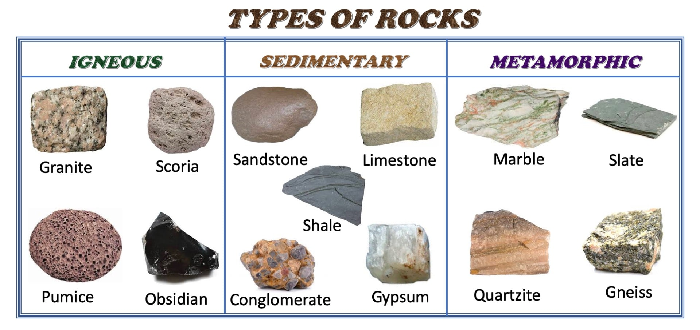
1.Igneous rocks – This type of rock is created during a volcanic eruption. Magma is forced through the weakness in the Earths crust and as it cools and solidifies it forms rock this is known as intrusive Igneous rock. When the magma is forced onto the Earths surface it is known as lava and produces rock called extrusive Igneous rock.
2.Sedimentary rocks – These are made from fragments of rocks and the remains of animals and plants.
3.Metamorphic rocks – these are formed when Igneous and Sedimentary rocks are altered by high temperatures or pressure or both.

