### Talk and Learn: All About Me Topic Summary

### Things to Talk About and Find Out:

* I wonder how this feels/smells/tastes/sounds/looks…
* Can you describe it to me?
* Can you name that part of your body?
* How do you feel? Why?
* How do you think they feel? Why?
* Who is in your family?
* What special things do you do together?
* Where do you live?
* What places/buildings are near to your home?
* How does the place you live in look   
  the same/different to this place?

# Topic Words

### First, I can try to use these words:

### Taste, touch, hear, smell, see, main body part names (leg, foot, head, hand, back, hair, eyes, nose, mouth, ears), happy, sad, angry, worried, home, different, same.

### Then, I can try to use these words:

Names of special places (such as church, mosque, temple), describing words linked to our senses (such as rough, sharp, loud, spicy, sweet), elbow, shoulder, ankle, chest, wrist.

## Things I Will Learn

I can name the five senses.

I can name the main parts of my body.

I can name my different emotions.

I can talk about people in my family.

I can talk about things that are the same and different   
between myself and others.

I can talk about where I live.

I can compare where I live to other places and say what   
is the same and what is different.

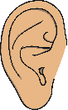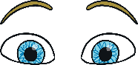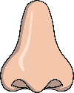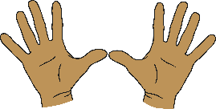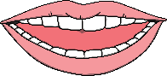

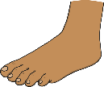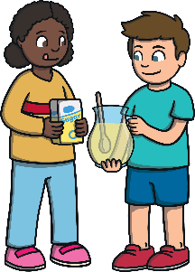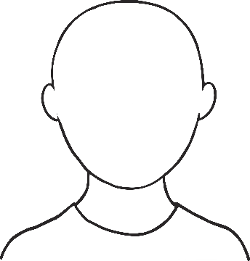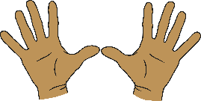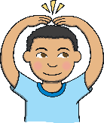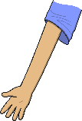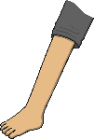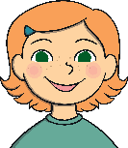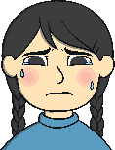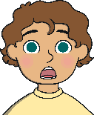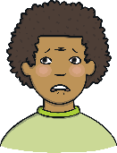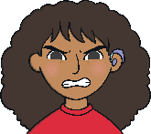

**This is me!**

### hear

### happy

### sad

### angry

### surprised

### worried

### nose

### arm

### eyes

### leg

### foot

### hand

### head

### ear

### taste

### touch

### smell

### see

### Stories, songs and rhymes:

### The Colour Monster

### Marvellous Me

### A Handful of Buttons

### Kipper’s Birthday