Expanded Noun Phrase Puzzle
Use your amazing writing skills to create expanded noun phrases using nouns and adjectives to describe something or someone from our story.
Read the noun in each phrase and then add your own adjective choices (separated by a comma). The first one is done for you.
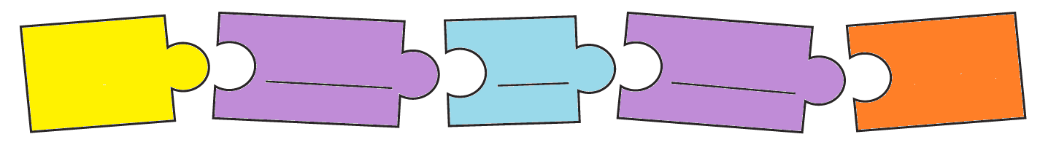
Frog.
Fire.
Mountains.
Fire Beings.
Coyote.
Village people.
,
kind
brave
The

