Map of the World

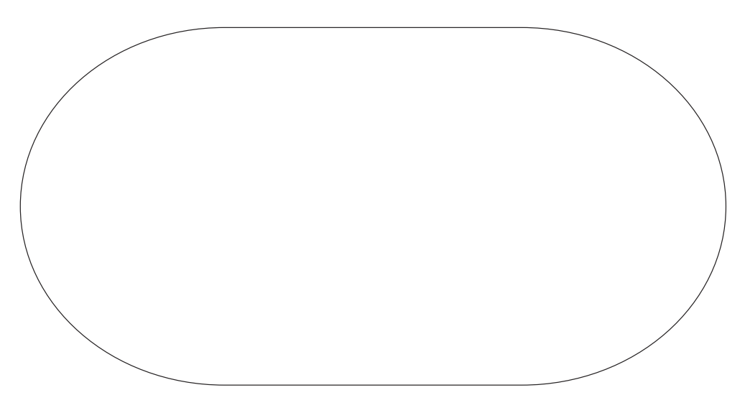

|  |
| --- |
| Asia |
| Africa |
| South America |
| North America |
| Europe |
| Australia |
| Antarctica |
| Pacific Ocean |
| Atlantic Ocean |
| Indian Ocean |
| Southern Ocean |
| Arctic Ocean |

Cut out the continents and arrange then in then to create a map of the world.

Next, use the words to label the continents and oceans.