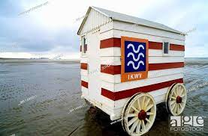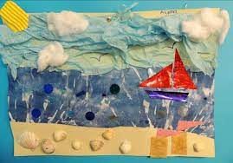

**Art**

Collage- tearing, overlapping and overlaying

Cutting shapes

Seaside collage

**DT**

Design and make a mechanical wheeled beach hut

**Science**

Seasonal changes

What do plants need

Use scientific vocabulary

Make observations

Structures of common plants

**English**

**Writing Genres**

* Rhymes
* Non Chronological Reports
* Instructions
* Information texts
* Recounts

**SPAG**

* Verbs
* Adverbs
* Subordination
* Adjectives
* Punctuation . , ? !

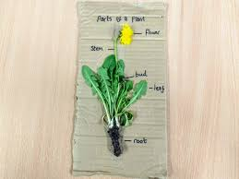

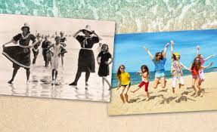

**Computing**

Online Safety

Coding

**Maths**

**Year 1**

* Measure
* Multiplication
* Fractions
* Time
* Place value
* Position and direction

**Year 2**

* Mass and capacity
* Fractions
* Time
* Statistics
* Position and direction

**History**

Seaside’s now and then

Similarities and differences past and present seaside holidays

Identify changes to seaside holidays within and beyond living memory

Life of Captain James Cook and his contribution to national achievements

**PSHE Jigsaw**

**Relationships**

Families

Keeping safe

Friends and conflict

Secrets good and bad

Trust and appreciation

**Changing Me**

Life Cycles in nature

Growing rom young to old

The changing me

Boys and girls bodies

Assertiveness

Looking ahead

**RE**

What is the ‘good news’ Jesus brings?

**PE**

Target Game

Striking & Fielding

Invasion

Athletics

**Music**

**Orchestral Instruments**

Listen and analyse

Select sounds to match events and characters

Write a play script

Perform

On the island

Music of the British Isles

Create and compose

Evaluate

**Geography**

* Naming the countries that make up the UK
* Naming the seas that surround the UK
* Identifying what is a coastline
* Human and physical features near the coast
* Using a compass
* Compare and contrast uk coast with seaside abroad

**Key Stage 1 Curie**

**Seaside Holidays**

