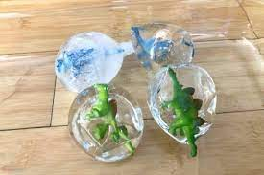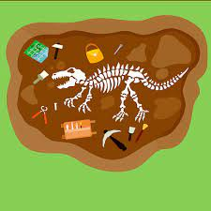

**Communication, Language and Literacy**

New vocabulary- archaeologists, excavator, omnivore, carnivore, herbivore

What noises did they make?

Sequencing stories beg, mid and end

Dinosaur stories/ Non-fiction books

Write excavation notes

Name writing in dinosaur footprints

Describing dinosaurs

Labelling a dinosaur

**EYFS Curriculum Plan**

**Autumn 1.2**

**All Creatures Great and Small**

**Dinosaurs**

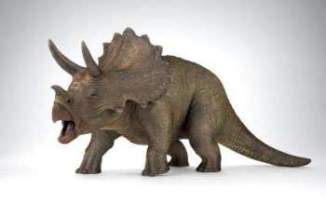

**Understanding the World**

Why do we no longer have dinosaurs on the planet?

Descendants of dinosaurs

Types of dinosaurs

What did they eat?

What was life like in prehistoric times?

Investigate dinosaur poo!

**Expressive Arts and Design**

Sing dinosaur songs- role play

Archaeology role play

Plastic dinosaurs in small world play

Macaroni pictures of dinosaur bones

Junk modelling

Ice egg excavation

Painting dinosaurs

Split pin dinosaurs

**Mathematics**

1 more 1 less

Investigating number

Digging deeper

Comparing groups

**Physical Development**

Dinosaur stencils to create pictures

Move like dinosaurs- large and small

Make dinosaurs out of clay

Dinosaur sensory tray

Dinosaur dancing

Dinosaur biscuits

Disco Dough

**Personal, Social and Emotional Development**

Talk about dinosaur food choices

How did dinosaurs disappear? How do you feel about them not existing anymore?

If you were a dinosaur, which would you be?

Pass the dinosaur- what are your likes and dislikes about dinosaurs?

|  |
| --- |
|  |