Tuesday English Activity – Year 2
Vocabulary Activity.

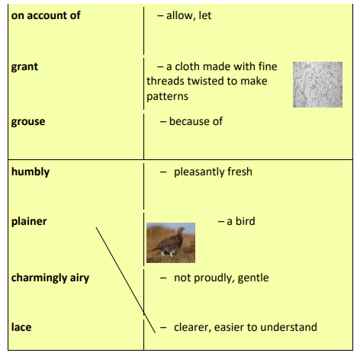
Can you find any other vocabulary in the text that you have never read before?
What does it mean?

Challenge – Can you spell all of the words above ?

