Find the expanded noun phrases!

Find and underline all the expanded noun phrases in the story below.

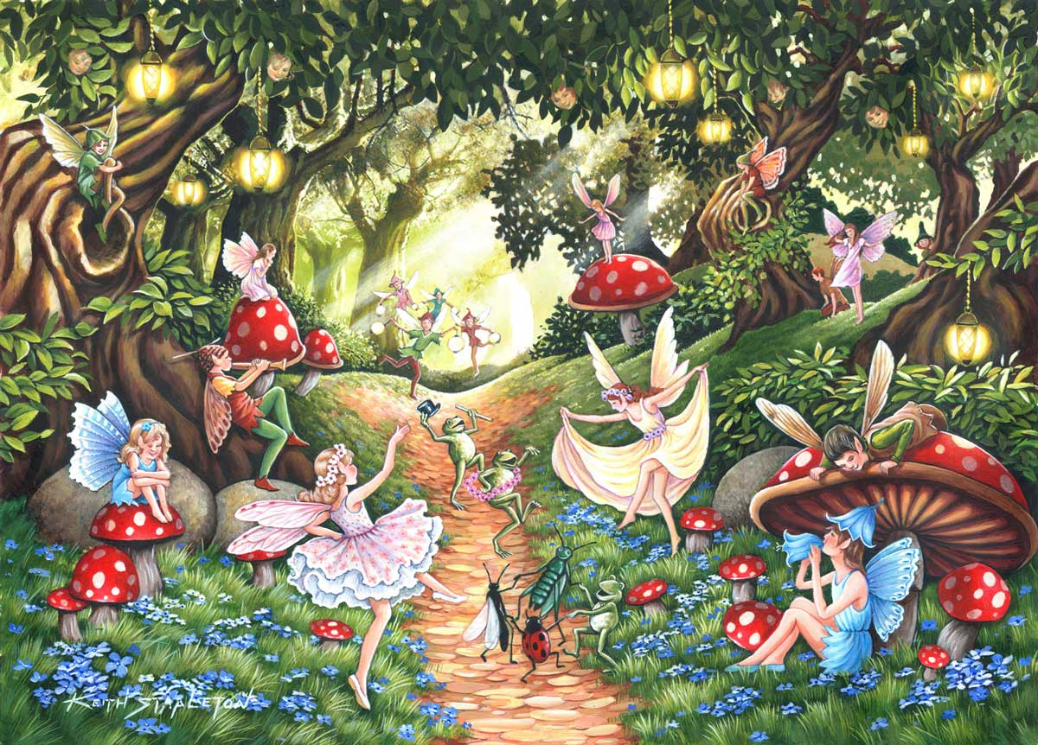
It was a bright, sunny day in the middle of May. Sally was getting ready for her playdate with Sam. She was trying to decide on which toy to take, her big, yellow ball or her long red skipping rope. She decided to take the ball because she knew it was Sam’s favourite. She walked down through the beautiful, lush garden until she reached the tall, rusty gate. All of a sudden, a little black cat appeared. It gave her such a fright; she ran as fast as she could. When she stopped running, she realised that she was lost. She looked around. She was in the forest, she could see the sun poking through the dense, green leaves above her. She could hear something; a sweet, calming sound. It was music and it was coming from a hole in a tree. She crept over to peek inside. Inside she could see tiny, magical creature dancing on a dancefloor of petals. A dry, brittle twig snapped under her foot and the tiny creatures stopped dancing and stared at her.

