Buckminster Primary School
Wellbeing Newsletter No. 1
Hope that you are all keeping well and safe.

The purpose of this newsletter is to offer some ideas and suggestions for activities linked to looking after our mental health and wellbeing which is particularly vital in these challenging circumstances. There is no expectation to complete these tasks, just there for you to use as you wish.

If you have any concerns about your child’s mental health/wellbeing, you can contact me via email between 9am and 5pm Monday to Friday on rebeccalongley@buckminster.leics.sch.uk.

Mrs Bagshaw

Five Ways to Wellbeing
At school we are going to be promoting the ‘Five Ways to Wellbeing’ approach which is all about how positive actions can contribute to and boost feelings of wellbeing. Each of these actions or ways will have a beneficial impact. Here is an explanation of each one. More ideas/activities will be added in the next newsletter. I’d love to hear how you’re getting your ‘Five a day.’ Email me on the address above to let me know what you’ve been doing.
Connect | Be active | Take Notice | Keep Learning | Give
Connect with the people around you which is particularly important and challenging during this crisis.  Online platforms are a great way to enable us to see family and friends as well as speaking on the phone.  However, you stay in contact with others simply talking about how you feel can make a big difference. | Current guidance says that we can exercise as much as we want. So why not try something different. There are lots of online workouts covering a wide range of activities and abilities that can be done within the home. If you have access to a garden or outdoor space why not design your own workout for your family, or try a new sport. | Being aware of the world around you and what you’re feeling. Take some time each day to talk about how everyone is feeling and to connect with one another. There are some additional ideas for conversation topics listed below. Also, when going outside for exercise, take a few moments to notice the feelings of fresh air and sunshine on your face. Listen to the sounds around you. What do you notice? | Learning something new or improving a skill you already have is great for giving a sense of achievement. As a family you could talk about the things you enjoy doing and what you can teach each other. Set yourselves a challenge and enjoy the steps you take in attempting to master it. More than ever, there are also lots of free online courses and classes to access which cover a wide range of activities. | There are ways you can help others while still following the guidelines. Do something kind for a family member or friend. Thank someone. Smile. Make thank-you notes and coloured/painted rainbows that can be stuck in windows.  Ask a family member if they need help in completing a household job, eg hanging out the washing or assist with meal preparation.
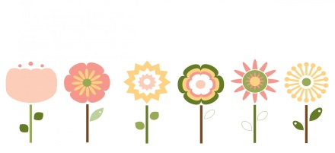

Mindfulness
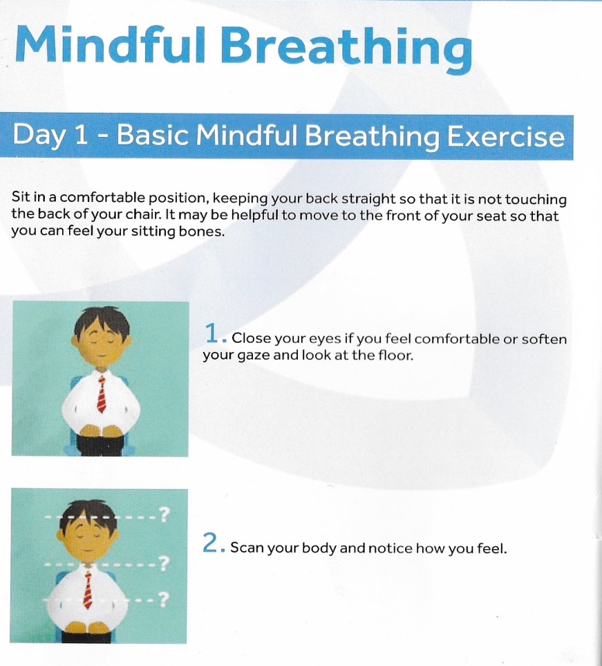
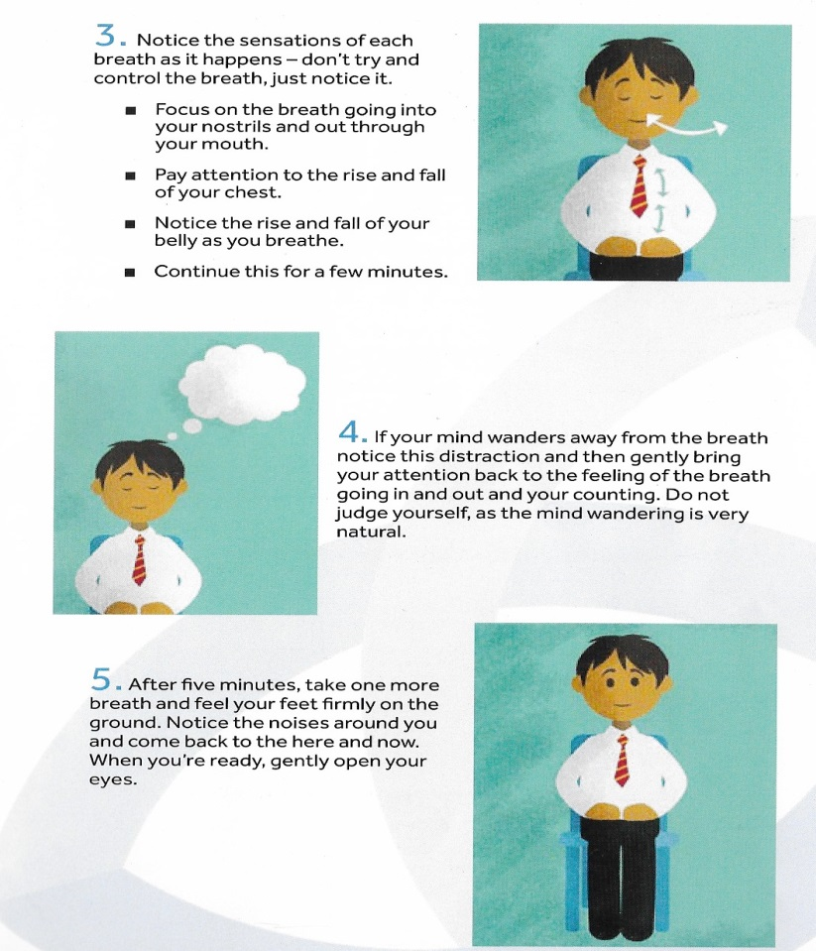
Thoughts in the sky  - Focus on breathing as outlined above.  - Imagine any distracting thoughts or feelings as clouds in the sky, floating away gently.  - Continue this for a few minutes. | Waves  - Focus on breathing as outlined above.  - Imagine any distracting thoughts or feelings as waves in the ocean, coming and going, rolling in and leaving again.  - Continue this for a few minutes.
Conversation Corner
Some questions to discuss in your families:
- What makes you proud?
- What happens that you think is wasteful?
- What is the best gift you have ever been given?
- What do you like about being you?

When it rains, it pours…
but soon, the sun shines again.
Stay positive. Better days are on their way.

