Geography – Compass Points

Task 1 – Make a compass points sentence to help you remember the compass points.

N_____________ E______________ S____________ W______________

Task 2 – Label the compass.

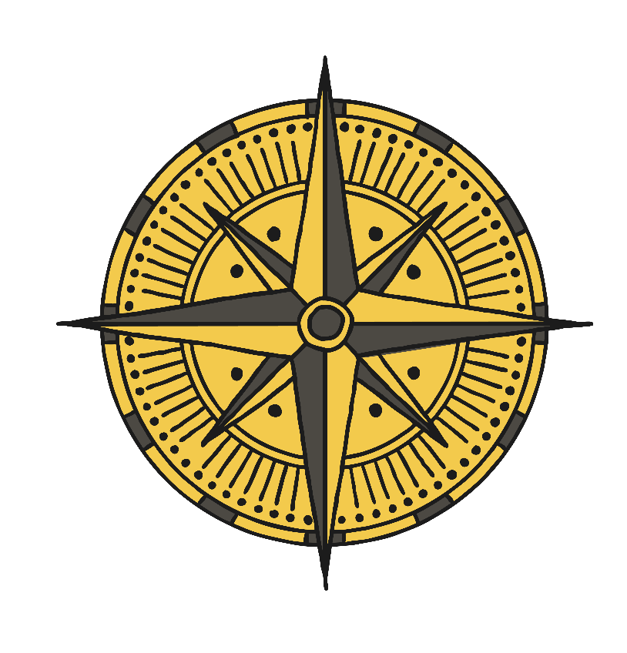

Task 3 – Write the compass directions for the pirate to find the treasure and then get back to his ship.

From the ship to the treasure.

________________________________________________________________________________________________________________________________________________________________________________________________
From the treasure to the ship.
________________________________________________________________________________________________________________________________________________________________________________________________

