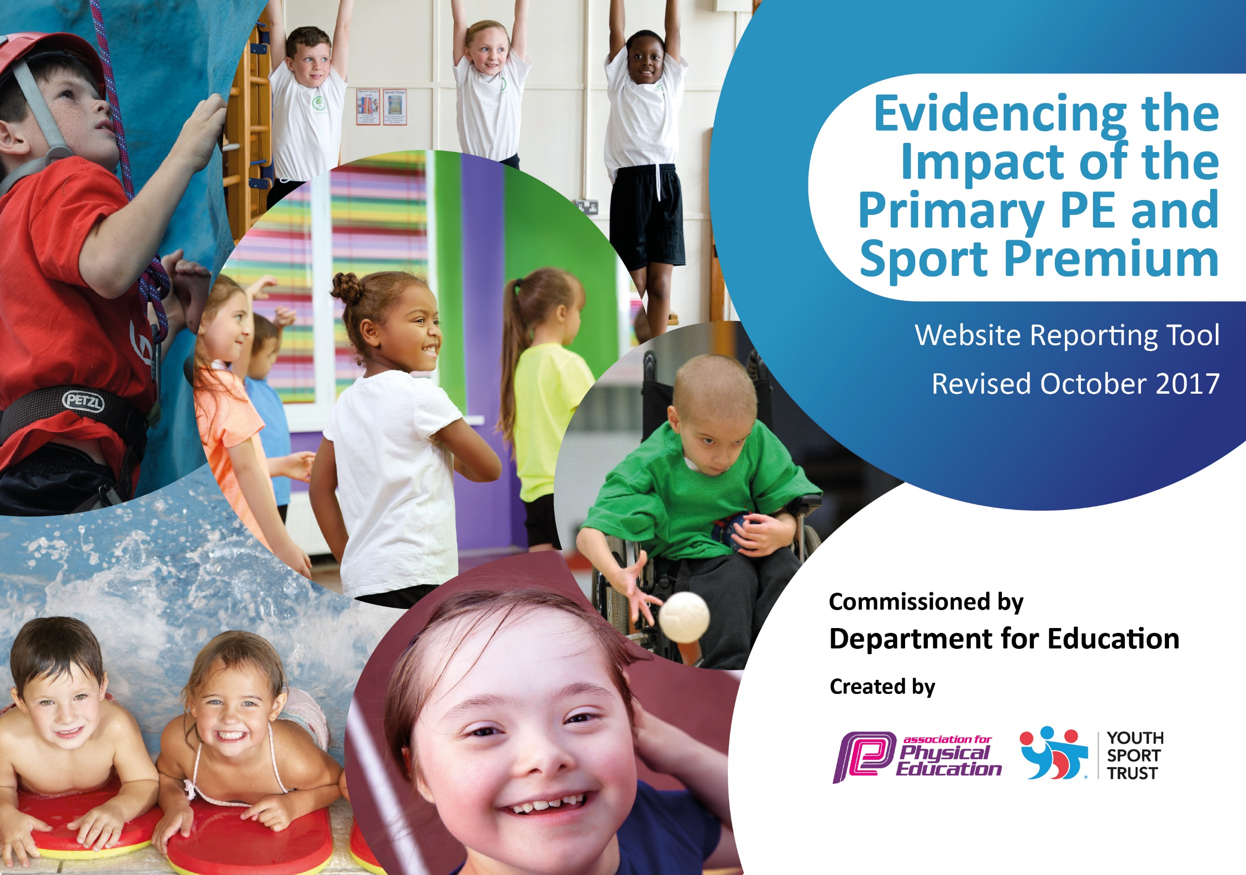

Buckminster Primary School
2018/19

Schools must use the funding to make additional and sustainable improvements to the quality of PE and sport they offer. This means that you should use the Primary PE and Sport Premium to:

- develop or add to the PE and sport activities that your school already offers
- build capacity and capability within the school to ensure that improvements made now will benefit pupils joining the school in future years

Please visit gov.uk for the revised DfE guidance including the 5 key indicators across which schools should demonstrate an improvement. This document will help you to review your provision and to report your spend. DfE encourages schools to use this template as an effective way of meeting the reporting requirements of the Primary PE and Sport Premium.

We recommend you start by reflecting on the impact of current provision and reviewing the previous spend.
Under the Ofsted Schools Inspection Framework, inspectors will assess how effectively leaders use
the Primary PE and Sport Premium and measure its impact on outcomes for pupils, and how effectively governors hold them to account
for this.

Schools are required to publish details of how they spend this funding as well as on the impact it has on pupils’ PE
and sport participation and attainment.
We recommend regularly updating the table and
publishing it on your website as evidence
of your ongoing review into how you are using the money
to secure maximum, sustainable impact. To see an example of how to complete the table please click HERE.

Support for review and reflection - considering the 5 key indicators from DfE, what development needs are a priority for your setting and your students now and why? Use the space below to reflect on previous spend, identify current need and priorities for the future.

Key achievements to date: 2018/19 | Areas for further improvement and baseline evidence of need:
- Introduced a wider range of healthy physical activity opportunities available to all children in school  - Recruited a sports apprentice who supported school in delivering more sporting and physical opportunities across school  - Introduced Balance Bikes in EYFS. Children have free access plus specific training sessions with trained staff  - Wake n Shake was introduced each morning before the bell for parents and children to access. 10 minute daily boost of exercise before the start of school | - Increase opportunities to take part in a wider range of sports (competitive and non-competitive)  - Target pupils who are more sedentary and Pupil Premium pupils  - Engage additional CPD providers to support staff development to ensure highest quality outcomes for our children

Meeting national curriculum requirements for swimming and water safety | Please complete all of the below:
What percentage of your Year 6 pupils could swim competently, confidently and proficiently over a distance of at least 25 metres when they left your primary school at the end of last academic year? | 100%
What percentage of your Year 6 pupils could use a range of strokes effectively [for example, front crawl, backstroke and breaststroke] when they left your primary school at the end of last academic year? | 94%
What percentage of your Year 6 pupils could perform safe self-rescue in different water-based situations when they left your primary school at the end of last academic year? | 94%
Schools can choose to use the Primary PE and Sport Premium to provide additional provision for swimming but this must be for activity over and above the national curriculum requirements. Have you used it in this way? | Yes
Action Plan and Budget Tracking
Capture your intended annual spend against the 5 key indicators. Clarify the success criteria and evidence of impact that you intend to measure to evaluate for students today and for the future.

Academic Year: 2018/19 | Total fund allocated: £16,100  £8000 contribution to membership of Inspire+ | Date Updated: September 2019
Key indicator 1: The engagement of all pupils in regular physical activity – Chief Medical Officer guidelines recommend that primary school children undertake at least 30 minutes of physical activity a day in school |  |  |  | Percentage of total allocation:
 |  |  |  | 91%
School focus with clarity on intended impact on pupils: | Actions to achieve: | Funding allocated: | Evidence and impact: | Sustainability and suggested next steps:
- Develop a range of sustainable programmes to encourage more children to engage more regularly in additional physical activity opportunities | - Provide opportunities for at least 30 minutes of physical activity a day  - Work with Allison Consultancy to help improve the level of activity in PE lessons  - Engage the sports apprentice in providing more opportunities  - Ensure sports ambassadors receive regular training so they can support children to become and stay involved in regular physical activity  - Ensure that a wide range of playground equipment is available for the sports ambassadors/playground staff/children to use to enable increased physical activity at playtimes and lunchtimes  - Ensure all equipment is inclusive and can be accessed by all children (age appropriate)  - Sustain and develop our wrap around care to encourage those attending to engage in extra active activities  - Review participation tracter to identify non-participants  - Take advantage of national fundraising events to promote sport for all  - Take part in large whole school events in and out of school  - Prioritise additional swimming sessions for children in yr6 who have not yet reach the NC standard  - Communicate better with parents about the sporting/physical opportunities available to children including clubs run in the community during weekends and holidays  - Develop Wake n Shake sessions each morning before morning bell to engage parents and children for 10 minutes each day | £8000 Inspire membership for all unless specified separately  £6500  £200 | Evidence  - Training taken place  - Sports apprentice in place  - Additional swimming provision in place  - Participation tracter used and regularly updated  - New equipment purchased for playtimes and PE lessons  - Whole school participation in large whole school events such as the Buckminster Triathlon and sports Relief etc  - Wrap around care includes physical activity  - Impact/Outcomes for Children  - Ambassadors develop personal, social, leadership and team-building skills that helps to identify and support more inactive children  - Children attending wrap around care are engaging in increased physical activity  - Sports Ambassadors up skilled and using new leadership and communication skills  - Increased awareness of the wide range of different types of healthy activity available through different sports festivals run by Inspire+ and the Melton area sports opportunities  - Increased opportunities for healthy activity available  - Increased engagement in exercise  - Increased understanding of the benefits of exercise for health  - All children engaged in moderate to vigorous physical activity in PE lessons due to Allison training  - Increased participation by children who normally don’t engage with sporting / physical activity opportunities  - The 30 minutes a day will mean children get a change in their activity and focus resulting in concentration increasing during lesson times  - More opportunities to develop swimming and water safety skills  - More children achieving the national swimming and water-safety targets  - It is very rare now that any Year 6 child leaves not able to achieve the 25 meter swimming target | - Build upon and extend the existing programme of activities  - Identify any further areas of need / gaps in provision and identify additional strategies, resources and programmes to further develop 30 Minutes a Day across the school  - Capture pupil and staff voice to identify the increased amount of physical activity children are doing within and beyond the PE curriculum  - Use pupil and staff voice to identify barriers to children’s engagement and identify solutions  - Identify any new staff who could provide extra-curricular opportunities for our children  - Review and develop the Active Lunch-time programme to include any ‘Top-Up’ training for new Lunch-time Supervisors including training in identifying mental health issues in children  - Provide training for new co-hort of Sports Ambassadors  - Ensure all staff (including new staff) are using the REAL PE approach within all PE lessons and the assessment tool from Allison consultancy  - Continue to provide the Top Up Swimming programme  - Continue with the wrap around care which is currently financially sustainable  - Continue and develop the ‘Wake and Shake’ sessions

 | Key indicator 2: The profile of PE and sport being raised across the school as a tool for whole school improvement |  |  |  |  |  |  | Percentage of total allocation:
 |  |  |  |  |  |  |  | 6%
 | School focus with clarity on intended impact on pupils: | Actions to achieve: |  | Funding allocated: |  |  | Evidence and impact: | Sustainability and suggested next steps:
 | - Develop opportunities for pupil engagement with PE and sport throughout the school.  - Celebration assembly every week to celebrate the sporting/fitness achievements of individuals and teams  - Raise profile of PE and Physical Activity with a sports board and newsletter content.  - Role models - local sporting personalities so pupils can identify with success and aspire to be a local sporting hero. | - Encourage sporting opportunities for all and raise the profile of PE and sport as a toolkit for positive wellbeing and confidence.  - Certificate tailored to different activities. Demonstration assemblies to showcase skills and achievements.  - Daily Mile and Legacy Challenge achievements to be celebrated within these assemblies.  - School to highlight importance of PA through newsletter, awards board and/or sports notice board.  - Release the sports apprentice to update the board and keep the interest of all children maintained.  - Use Inspire+ membership to the full and be available for all assemblies/workshops from their ambassadors and role models. Ensure follow up in our own assemblies to continually raise the profile of taking part in a sporting or active lifestyle. Current visitors include: Sophie Allen (Olympic swimmer), Sam Ruddock (Paralympian), Ben Smith (marathon legend and mental wellbeing expert), Shona McGillan (Olympic hockey player). |  | Inspire+ Membership  Mini bus hire for fixtures, tournaments and other physical activities  £70 each time x15  £1050  Inspire+  Membership |  |  | Evidence  - Matches and fixture results  - Success at competitions  - More children being rewarded for fitness related activities, rather than competitive success  - Happiness and Physical Activity questionnaires/pupil voice  - New activities offered  - School vision, ethos linked to PE and School Sport and school reward system  - Celebration assemblies each week, daily mile awards, certificates and medals, Legacy challenge success, ambassadors.  - PE notice board visible and accessible, websites, newsletters, facebook, twitter, etc updated, shared and celebrated. Children are keen to engage in the suggested activities on the notice board e.g. what’s your favourite winter sport/active advent calendar. Sporting successes are celebrated, raising the profile of individual sports.  Impact – increased pupil:  - Confidence and enjoyment of sport and games across the school  - Opportunities to participate in a wider variety of activities  - Awareness of the importance of physical activity and health  - Experience of the feeling of achieving their best  - Experience of gaining awards and certificates and the feelings of achievement  - Ability to use transferable skills to support learning across the school  - Understanding of the importance of diet and exercise for a healthy body and mind  - Understanding of how to improve their physical and mental well-being through physical activity  - The Sports Ambassadors return enthused from the training and keen to implement strategies – they have developed transferable skills that support their learning across the school and their own personal development  - Sporting successes are celebrated, raising the profile of individual sports and the confidence of the children  - Children of all ages are encouraged to make fitness choices and more children are being rewarded for fitness related activities, rather than competitive success – this is promoting the understanding and development of healthy habits | - Ensure the PE and Sport Premium Plans are strategically embedded within and support and inform the Whole School Improvement Plan  - Extend competition opportunities for all children so more children are engaged in and experience competition and the personal development it fosters  - Active Playground training for new co-hort of Sports Ambassadors – develops transferable leadership and team-building skills and qualities  - Further develop opportunities to recognise and share achievements include website updates, social media and school newsletter  - Ensure that as many staff across the school are engaged in future PE CPD that can support wholeschool improvement so that skills, knowledge, understanding and resources remain in the school even if key staff leave  - Identify new programmes/ CPD and resources to support active learning across whole school e.g. Maths of the Day  - Develop links with whole-school focus on healthy eating  - Develop links to PHSE programme around mental health and wellbeing
Key indicator 3: Increased confidence, knowledge and skills of all staff in teaching PE and sport |  |  |  |  |  |  |  | Percentage of total allocation:
School focus with clarity on intended  impact on pupils: |  |  | Actions to achieve: |  | Funding  allocated: | Evidence and impact: |  | Sustainability and suggested  next steps:
- Improve the progress and achievement of all children by increasing staff knowledge, skills, understanding and confidence to deliver outstanding PE, School Sport and Physical Activity |  |  | - Receive update training and resources from Real PE trainer for all staff in school.  - Ensure all staff have an understanding of the PE assessment process.  - Allison Consultancy – assessment training  - Twilight  - Coaches to upskill our teaching staff by working alongside them to deliver 6 week coaching sessions.  - School booked onto training for the MOT resources in March 2018.  - Review of website and updating of information required to meet Conditions of the Grant funding  - Review and development of 2018/19 PE & sport Premium Action Plan using new, national template  - PE and Sport Premium – implications for Subject Lead  - Review and development of PE Curriculum Map / SoW  - Staff Voice for CPD needs  - Identify budget spend |  | Membership  Membership  Membership | Evidence  - Training taken place with Allison Consultancy  - Other courses attended by staff include:  - Balance Bike  - Active Maths  - Gymnastic workshops  - KS2 Friends  - Apprentice mentoring  - Learning outside  - Staff voice for PE CPD  - Lesson observations  Impact/Outcomes for staff:  - More effective subject leadership  - Greater understanding of Ofsted and DfE requirements in relation to PE and School Sport Premium  - Clearer understanding of what needs to be done / key priorities and actions to ensure compliance  - Clearer understanding of the updated National Outcome Indicators  - The PE lead has greater knowledge and understanding and enhanced capacity to support staff across the school  - Staff across the school supported to self -review and develop own practice  - Staff across the school planning and delivering higher quality PE lessons  - Improved confidence in teaching good and outstanding PE lessons  - Staff feel more competent in delivering more unusual extra curricular clubs e.g. balance bikes  - Clear understanding of how to plan and deliver PE lessons to engage children in healthy, sustained, physical activity  - More effective planning skills including clearer differentiation within lessons  - Staff training needs and strengths identified  - The Real PE has increased confidence, knowledge and skills and has maximized physical activity during a PE lesson. Brought about awareness of the progressive skill development that leads to success in sport  - Teachers have been able to address gaps in their knowledge and improve their confidence in specific areas  - Impact / Outcomes for children:  - Effective use of the funding leading to enhanced provision and opportunities for children  - Children engaged in more regular, active, healthy PE lessons where they move more and are challenged to think in an active way  - Children challenged more effectively through more differentiated PE lessons  - Children learning through all areas of PE as required by the National Curriculum  - Children experience a wider range of exciting, less traditional activities both within and beyond the curriculum  - Children receive a broad and balanced offer within and beyond the curriculum  - Enhanced opportunities for healthy exercise through the day  - Children engaged in enhanced, more  - effective PE lessons  - Enhanced pupil understanding of and learning across all four areas of National Curriculum PE  - Pupils developing enhanced Fundamental movement skills  - Improved challenge and engagement for all pupils |  | - Develop a more focused action plan to enhance standards of provision incorporating greater sources of evidence and increased impact / outcome statements for both staff and children  - Key Strategic Actions Identified ensuring the greatest, most sustainable outcomes for our staff and children  - Some mentoring support provided by Allison Consultancy to upskill and quality assure PE Lead in their role of upskilling staff and Young Leaders across the school  - Ensure that CPD that has taken place this year is cascaded to any new staff next year  - Ensure that as many staff across the school are engaged in future CPD so that skills, knowledge, understanding and resources remain in the school even if key staff leave  - Implement new resources from Allison Consultancy  - PE Lead to monitor impact of the CPD – Observations / Pupil and Staff Voice  - Provide Active Playground Training for new co-hort of Sporting Ambassadors  - Sustainability: purchase new resources which can be introduced and can be used year on year
Key indicator 4: Broader experience of a range of sports and activities offered to all pupils |  |  |  |  |  |  |  | Percentage of total allocation:
 |  |  |  |  |  |  |  | 50% membership plus 12%
School focus with clarity on intended  impact on pupils: |  |  | Actions to achieve: |  | Funding  allocated: | Evidence and impact: |  | Sustainability and suggested  next steps:
- Increase the range of activity opportunity outside the curriculum in order to get more pupils involved. Focus particularly on those pupils who do not take up additional Sport opportunities. |  |  | - Continue to offer a wider range of activities both within and outside the curriculum that promote physical activity and are accessible to all  - In addition to the existing wide range of opportunities that we currently offer (such as Gymnastics, Cricket, Athletics, and Swimming) look at introducing some new clubs  - Aim to increase the number of children engaged  - Focus particularly on those children who do not take up additional PE and Sports opportunities  - PE Lead to monitor actions and impact  - Ensure new Sports Clubs timetable disseminated to pupils and parents and uploaded to website |  |  | Evidence  - Sports Clubs / Physical Activity Timetable  - Participation registers  - Activity Tracker  - Sports Apprentice ran after school clubs  - Additional opportunities for children to engage with physical activity Increased number of children participating in school clubs / activities  - Widened range of healthy activities developed  - Children develop greater understanding of the health benefits of exercise  - Barriers to participation addressed Children involved in choosing activities to engage with – more ownership  - More engagement from children usually disaffected, particularly noticeable at playtimes  - Pupils inspired to try sports / activities they would not usually have access to.  - Some children have expressed interest in pursuing these activities outside of school hours.  - Vast majority of pupils say they enjoy PE and Sport and want to get involved in more activities. They particularly enjoy ‘sporting visitors and professionals’ coming in. |  | - Specifically choose ‘alternative’ physical activities to appeal to less active children.  - Maintain and develop existing programme  - Encourage parents to offer/train on activities of interest to them (Parent Volunteer Scheme through Inspire+)  - Develop Cycle and scooter road safety awareness  - Identify some more nontraditional less traditional activities that could build upon the programme  - Further develop an Active Playgrounds programme to include some team games  - Complete pupil voice to identify interests and barriers to participation  - Target children not engaging  - Ensure new Sports Clubs timetable disseminated to pupils and parents and uploaded to website  - Look at other possible Parent / Pupil activities that the school could engage in
Key indicator 5: Increased participation in competitive sport |  |  |  |  |  |  |  | Percentage of total allocation:
 |  |  |  |  |  |  |  | 6% from KI 2
School focus with clarity on intended  impact on pupils: |  |  | Actions to achieve: |  | Funding  allocated: | Evidence and impact: |  | Sustainability and suggested  next steps:
- To introduce additional, inclusive competitive sports opportunities providing the opportunity for all children to participate |  |  | - Inter/intra School Competition  - Continue to enter and encourage a wide range of competitive sports and celebrate personal and team successes  - Inter school – to enter as many events on the calendar as is possible, including those we do not usually attend  - Intra school – to develop competition within the school  - To work towards the School Games Mark – gold award  - Focus on improving netball High 5 – netball coach in for a term  - Focus on improving KS2 basketball  - Focus on improving triathlon - Continue with Buckminster Triathlon event and the Brownlee foundation event for KS2 |  |  | Evidence  - Participation Registers  - Awards / Trophies / Certificates Coaching programme  - Sporting gallery  - School Games mark, Gold nearly achieved  Impact / Outcomes for Children  Increased pupil:  - Experience and understanding of rules and scoring systems  - Experience and understanding of how to work as a team and how to handle winning and losing and the importance of good sportsmanship  - Confidence  - Enjoyment of sport and games across the school  - Sense of belonging  - Opportunities to participate in a wider variety of activities  - Awareness of the importance of physical activity and health and socialising with children from different backgrounds / other schools  - Experience of the feeling of achieving their best and of gaining awards and certificates, both as individual, teams and a school  - New parents to the school see us as a small school that puts PE and physical activity as a key priority |  | - Intra school – to develop competition within the school  - Continue to enter teams for competitive events and celebrate success with our local community.  - Further develop parent involvement  - Extend competition opportunities for all children so more children are engaged in and experience competition and the personal development it fosters  - Work with mentally healthy schools resources and the new PSHE curriculum to thread PE into our daily lives to increase wellbeing

