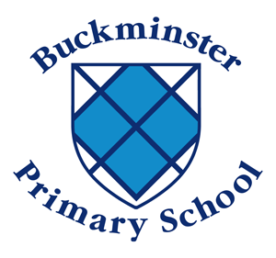

Buckminster Primary School
Handwriting Policy

Aims
- To have a consistent cursive approach across the whole school to ensure high levels of presentation.
- To adopt a common approach towards handwriting by all adults when writing in children’s books, on the whiteboard or on displays / resources.
- Children to achieve a neat, legible style with correctly formed letters in cursive handwriting.
- Children to develop fluency and speed whilst writing, so that eventually the children are able to write the letters with confidence and correct orientation.

Style

To achieve these aims we have decided to adopt a cursive script which joins all letters. This enables a child to progress naturally and quickly from learning to form a single letter correctly to using the mastered letters in a joined script.

The rules of the Cursive Style help:

- to minimise confusion for the child as every letter starts on the line with an entry stroke and leads out with an exit stroke.
- with the flow of Cursive Writing as letters naturally flow into each other, it is impossible to write separate letters without
- joining.
- form spacing between words as the child develops whole word awareness
- develop a child's visual memory
- all children's writing skills regardless of academic ability
- to develop skills of punctuation and grammar

Teaching and Learning
- As recommended by the British Dyslexia Association, we adopt a continuous cursive style of writing.
- Teachers and Learning Support Assistants model the agreed cursive style when modelling writing both in class, on displays and in feedback in books.
Our agreed cursive style is as below:

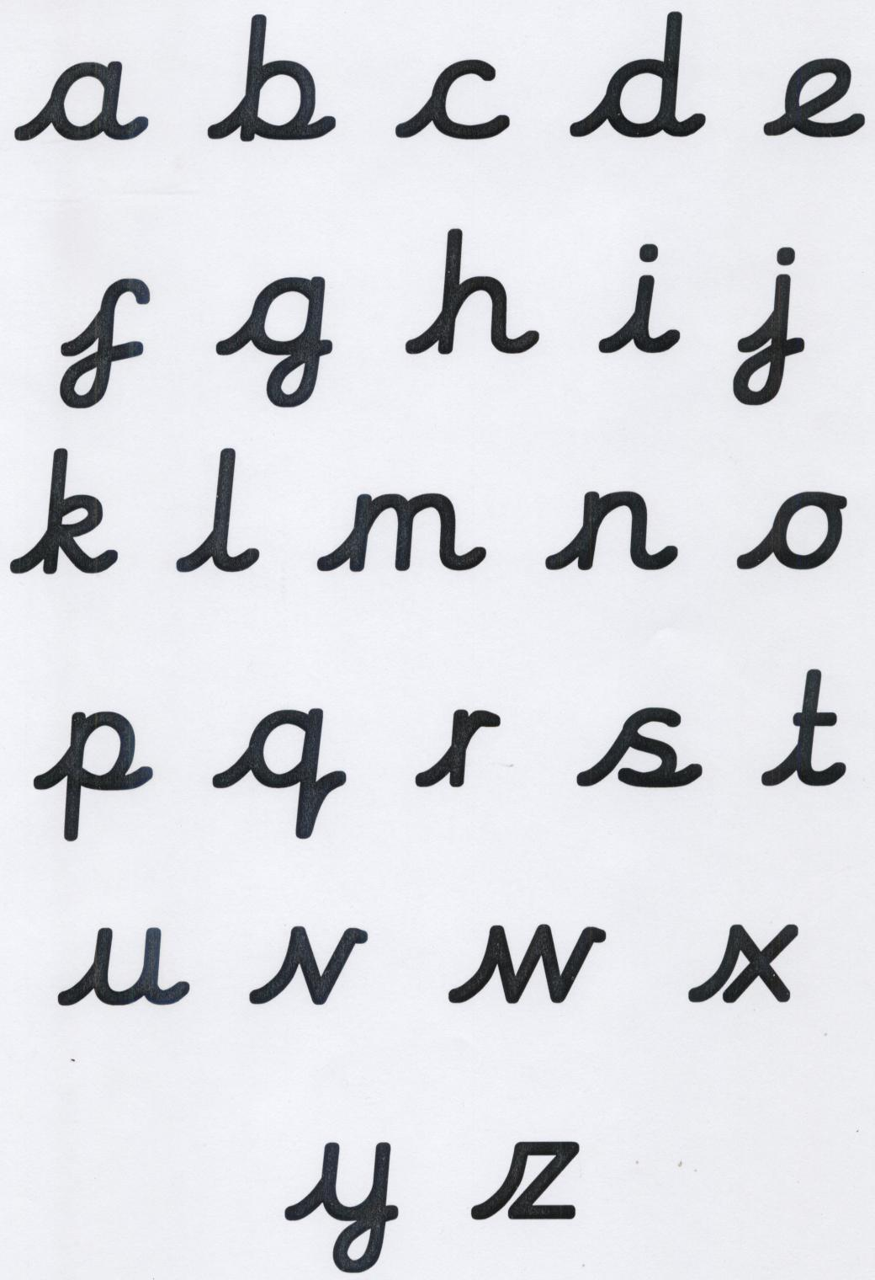
The letters will be taught in the following order/groups:
1. i l t u w e c o a d n m h

2. j y g q b p k v s r f z x

i) Early Years Foundation Stage (EYFS): Communication, language and literacy
- Children to be introduced to pre-cursive and cursive script at the earliest stages of writing.
- Children in the Foundation Stage should be writing in the pre-cursive script to enable an easier transition in Year 1 into the cursive script, depending on their ability. However, the expectation is that by the end of Reception pupils will start to transfer towards a cursive script depending on their skill and ability.
- Implements such as chunky triangular pencils, large chalks and chunky pens etc are used by pupils to rehearse skills on paper, chalk boards, pavement etc.

ii) Key Stage 1 & Key Stage 2
- Within KS1, every class will have two 15 minute handwriting sessions per week.
- Within KS2, every class will have a specific handwriting session for 15 minutes per week.
- In handwriting sessions, spellings, relevant key vocabulary or sentences/paragraphs related to core texts will be modelled by an adult then practised by children.
- Children are given a handwriting book from Foundation 2 which continues throughout the school.

Posture
- Chairs and desks within classrooms are matched to children’s age and height.
- Children’s backs should be straight and feet resting on the floor. A right-handed child should have their book slanted to the left. For a left-handed child the book should be slanted to the right.
- Always make sure that the hand which is not holding the pencil or pen holds the paper.

Implements
- Children use a standard HB pencil, well sharpened.
- When a teacher deems a child ready within KS2, they get a pen licence. They will be provided with a special handwriting pen.
- A pencil is always used within maths regardless of whether children have a pen licence.

Planning
During handwriting sessions, children will apply taught formations to letters, words or parts of text relevant to their current learning. For example, they may practise the letters from their current phonics focus, the letter strings used in their weekly spellings, key vocabulary related to core texts or use parts of text from guided reading or English texts.
Books will be used as evidence for the progression of handwriting.

Equal opportunities and Special needs
All children must have the opportunity and the encouragement to reach their full potential regardless of race, creed or sex. Children with Special Educational needs, where necessary, will be provided with specialist equipment such as pencil grips, wider ruled lined paper or coloured paper. Children will also have the opportunity to use iPads to rehearse specific skills on a more regular basis. Intervention is available for children who experience significant difficulties to practice pre writing skills and fine motor coordination.

Assessment, Monitoring and Moderation
Children in the EYFS are assessed on an ongoing basis through observation, handwriting informs part of this. Within Key Stage One and Key Stage Two, handwriting is assessed as part of children’s writing assessments on a six weekly basis.

Policy written by DC and all staff
Date January 2019
Review January 2021

