**Personal, Social and Emotional Development**

Understanding good and bad

Christian stories

Faiths from around the world

Sharing and taking turns

Resolving disputes

Respecting other people and their things

Working as a team

Having a goat persevering

Co operation

Understanding differences

|  |
| --- |
|  |

**Early Years Foundation Stage**

**Curriculum Plan**

**Spring 1& 2**

**All Around the World**

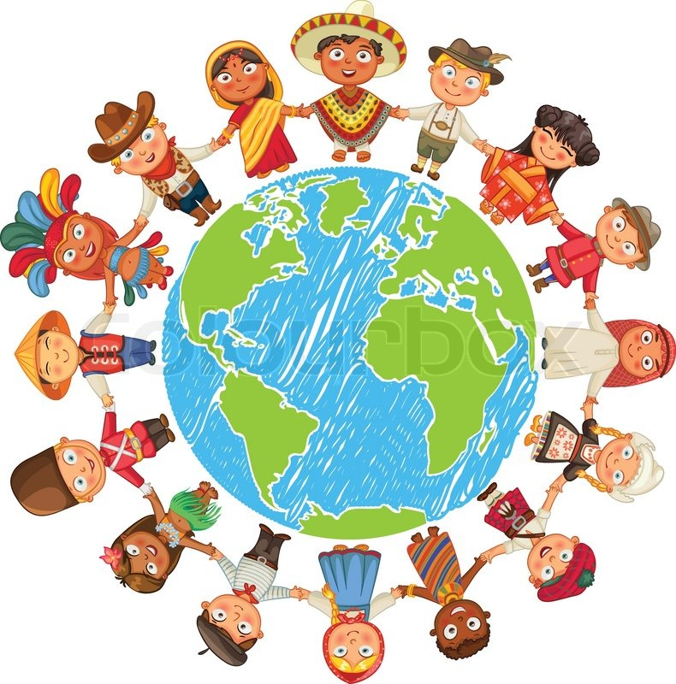

**Communication, Language and Literacy**

Speaking and listening to others

Responding to and asking questions

Making up own stories

Role play- travel agents

Retelling stories

**Mathematics**

Time –o’ clock, half past

2 by 2 - counting in2’s, 5’s, 10’s

Ordering by height and weight

Counting, recognising, ordering and writing numbers to 20

Adding and taking away

Learning names and describing 2D and 3D shapes

Understanding measure- height and length

**Physical Development**

Disco Dough

Fine motor development

Gross motor skills

Control and coordination

Dressing independently

Handling tools and equipment

Ball skills

**Reading and Writing**

Sorting sentences

Passports

Stories from around the world

Reading and writing simple sentences

Exploring different kinds of writing

Letters, lists, stories, information fact sheets

Phonics and handwriting

Learning key words

Understanding story structure

Retelling stories

**Understanding the World**

Homes around the world

Aminals from different countires

Construction – building houses from around the world

Cooking and food tasting from around the world

Properties of materials

Water and sand exploration

Investigating the Arctic

Building and constructing

**Expressive Arts and Design**

Art- mother’s day cards

Odd and even houses

Mud Huts out of clay

Paper crafts

Aboriginal art

Art from around the world

How to draw- step by step

Explore different materials, tools and techniques

Learn a variety of songs and dances

Explore different musical instruments

Use imagination in art using a variety of different media