English Planning Year 2 WK1 SP2
Quangle Wangle
This week the children will use the attached poem to work through a selection activities. You can also use the sound cloud link to listen to the poem, although I recommend using the copy below throughout the week.
Do not listen to or read the poem until after session 1.

https://www.youtube.com/watch?v=Ttv4H8YZ9HE

The Quangle Wangle’s Hat – by Edward Lear
On the top of the Crumpetty Tree
The Quangle Wangle sat,
But his face you could not see,
On account of his Beaver Hat.
For his Hat was a hundred and two feet wide,
With ribbons and bibbons on every side
And bells, and buttons, and loops, and lace,
So that nobody ever could see the face
Of the Quangle Wangle Quee.

The Quangle Wangle said
To himself on the Crumpetty Tree:
“Jam; and jelly; and bread; Are the best of food for me!
But the longer I live on this Crumpetty Tree
The plainer than ever it seems to me
That very few people come this way
And that life on the whole is far from gay! ”
Said the Quangle Wangle Quee.

But there came to the Crumpetty Tree,
Mr. and Mrs. Canary;
And they said, — “Did ever you see
Any spot so charmingly airy?
May we build a nest on your lovely Hat?
Mr. Quangle Wangle, grant us that!
O please let us come and build a nest
Of whatever material suits you best,
Mr. Quangle Wangle Quee!”

And besides, to the Crumpetty Tree
Came the Stork, the Duck, and the Owl;
The Snail, and the Bumble -Bee,
The Frog, and the Fimble Fowl;
(The Fimble Fowl, with a corkscrew leg;)
And all of them said: “We humbly beg,
We may build our homes on your lovely Hat:
Mr. Quangle Wangle, grant us that!
Mr. Quangle Wangle Quee!”

And the Golden Grouse came there,
And the Pobble who has no toes,
And the small Olympian bear,
And the Dong with a luminous nose.
And the Blue Baboon, who played the flute,
And the Orient Calf from the Land of Tute,
And the Attery Squash, and the Bisky Bat,
All came and built on the lovely Hat
Of the Quangle Wangle Quee.

And the Quangle Wangle said
To himself on the Crumpetty Tree:
“When all these creatures move
What a wonderful noise there’ll be!”
And at night by the light of the Mulberry moon
They danced to the Flute of the Blue Baboon,
On the broad green leaves of the Crumpetty Tree,
And all were as happy as happy could be,
With the Quangle Wangle Quee.

Monday
Please do this activity before you listen to or read the poem.
Do you know what a poem is?
That’s right, it’s a piece of writing in which the words are chosen for their sound. Some poems are serious, and some are fun; some tell a story and others are just nonsense (full of unreal things or just silly).
We are going to read a nonsense poem called The Quangle Wangle’s Hat by Edward Lear.

★ Talk Challenge Talk to someone at home about the Quangle Wangle.
Given its strange name, what do you think it is?
What do you think the poem will be about?

★ Nobody knows what a Quangle Wangle is.

In the poem, it says that the Quangle Wangle sits on the top of a tree.
What do you think a Quangle Wangle could look like?

Activity - All

Warm up - For this activity, I would like you to think, discuss possibilities and then draw, what you think a Quangle Wangle looks like.

Main – Now read the first verse of the poem.

Now you have heard some of the poem, I would like you imagine and draw what you see to be the Quangle Wangles hat…

Tuesday

There are many animals mentioned in the poem, as a warm up I would like you to find and circle the animals mentioned in the poem.

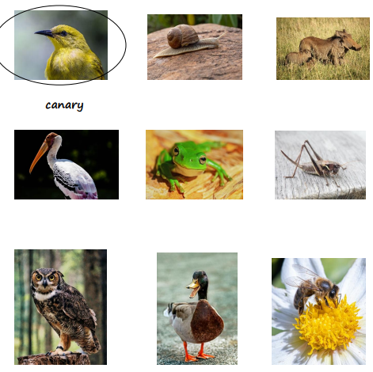
Year 1 – Please could you identify adjectives within the poem?

Year 2 - Please complete the vocabulary challenge attached to the web pages as well as the thinking challenge.

Wednesday

Can you make Mr Quangle Wangle’s Hat?

Your challenge is to make a model or collage (an image made by sticking things like paper, images, ribbons etc all together).
You can use anything you like to make the hat, be creative with what you have at home. When you have finished your creation, please send pictures

Ads a recap from previous learning I would like the children to list the equipment used and write instructions of how they made their hats.

Thursday

Story Map Challenge

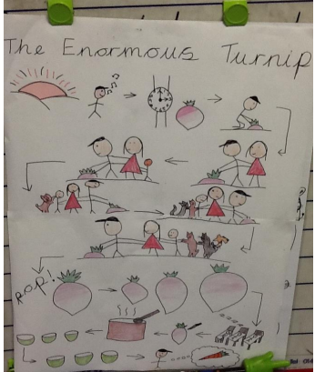

Here’s a version of the story for you to listen to.
https://www.youtube.com/watch?v=mGw5yTOPTSQ

Can you see which bits of the story have been included in the map?

All - Your challenge is to turn the first verse of Mr Quangle Wangle’s Hat poem into a story map.
Read the verse slowly and draw a picture for each new idea until you have a map of the whole verse!

Year 2 - You could continue and do the whole poem. You can use this page or draw on a bigger piece of paper if you have one at home.

Friday

★ Description Challenge Here’s the last but one verse again.

There are many creatures in it.

And the Golden Grouse came there,
And the Pobble who has no toes,
And the small Olympian bear,
And the Dong with a luminous nose.
And the Blue Baboon, who played the flute,
And the Orient Calf from the Land of Tute,
And the Attery Squash, and the Bisky Bat,
All came and built on the lovely Hat Of the Quangle Wangle Quee.

Here’s a description of one of them:

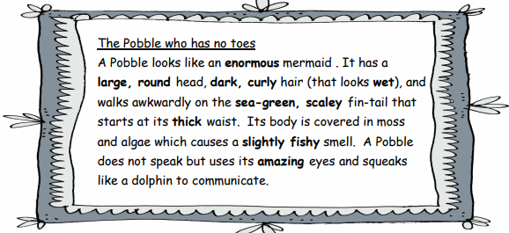

All the adjectives, the words that describe things, have been highlighted. Read it through and circle the adjectives you like best. The Pobble who has no toes A Pobble looks like an enormous mermaid . It has a large, round head, dark, curly hair (that looks wet), and walks awkwardly on the sea-green, scaley fin-tail that starts at its thick waist. Its body is covered in moss and algae which causes a slightly fishy smell. A Pobble does not speak but uses its amazing eyes and squeaks like a dolphin to communicate.

Now you are going to imagine what two other characters from The Quangle Wangle’s Hat, Dong and Attery Squash, are like.

Think about what they look like and other things like what they smell or sound like.

Year 1 – I would like you to choose of the other creatures mentioned in the verse – use adjectives to describe the creature. Dont forget to use your sentence structure knowledge to complete the task.

Year 2 – Could you please select two of the different creatures and complete as above.

When descriptions are finished please could you illustrate your work with how the characters will look.

