**Science**

* Senses
* Naming parts of the body
* Seasonal changes
* Animals
* Animal types

**English**

During the first term, the focus within Year 1 and 2 will be sentence structure and descriptive writing.

* Stories in familiar settings
* Traditional Tales – re tell
* Letters
* The children will learn how to write grammatically correct sentences, using the appropriate punctuation, and will spend time improving their handwriting skills.
* Phonics will be delivered daily to support reading, writing and spelling.

**PSHE**

Mental wellbeing

* Celebrating strengths
* Identify comfortable and uncomfortable feelings
* Describing feelings
* Understand change and loss
* Develop simple strategies for managing feelings
* Set goals for the future

**PE**

* Ball skills
* Team building
* Gymnastics

**DT**

Design and make a Christmas tree decoration

* Exploring different decorations
* Cutting skills
* Sewing skills



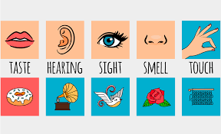

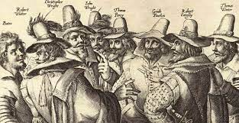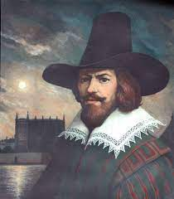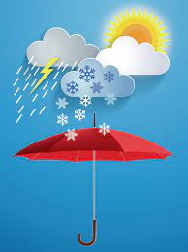

**Computing**

* Old and new technology
* What is technology
* Communication
* Digital art
* Self-image and identity.
* Online relationships

**Music**

**Musical Me & West African Call**

* Sing and play instruments
* Dynamics and timbre
* Find out about melody
* Notation
* Write own melody

**CURIE CLASS (KS1) Autumn 2022**

**Geography**

Whatever the weather

* Identifying different types of weather
* Understand weather symbols
* Investigating shadows
* Presenting and filming our own weather forecasts
* Comparing the weather in the UK to other parts of the world
* Identifying the dangers of weather

**All Creatures Great & Small**

**Maths**

The children will use concrete objects and pictorial representations to compare, order and recognise place value of numbers. They will study the following units

* Place Value
* Addition and subtraction
* Shape

**Art**

* Self portraits
* Collage self portraits
* Sketching self portraits
* Colour mixing
* Proportions
* Painting self portraits

**RE**

* Harvest Festival
* Who do Christians say made the world?
* Creation
* Forgiveness
* Who is God?

**History**

* Guy Fawkes
* The Gunpowder Plot
* Make large and small guys
* Remember Remember 5th of November
* Changes in living history