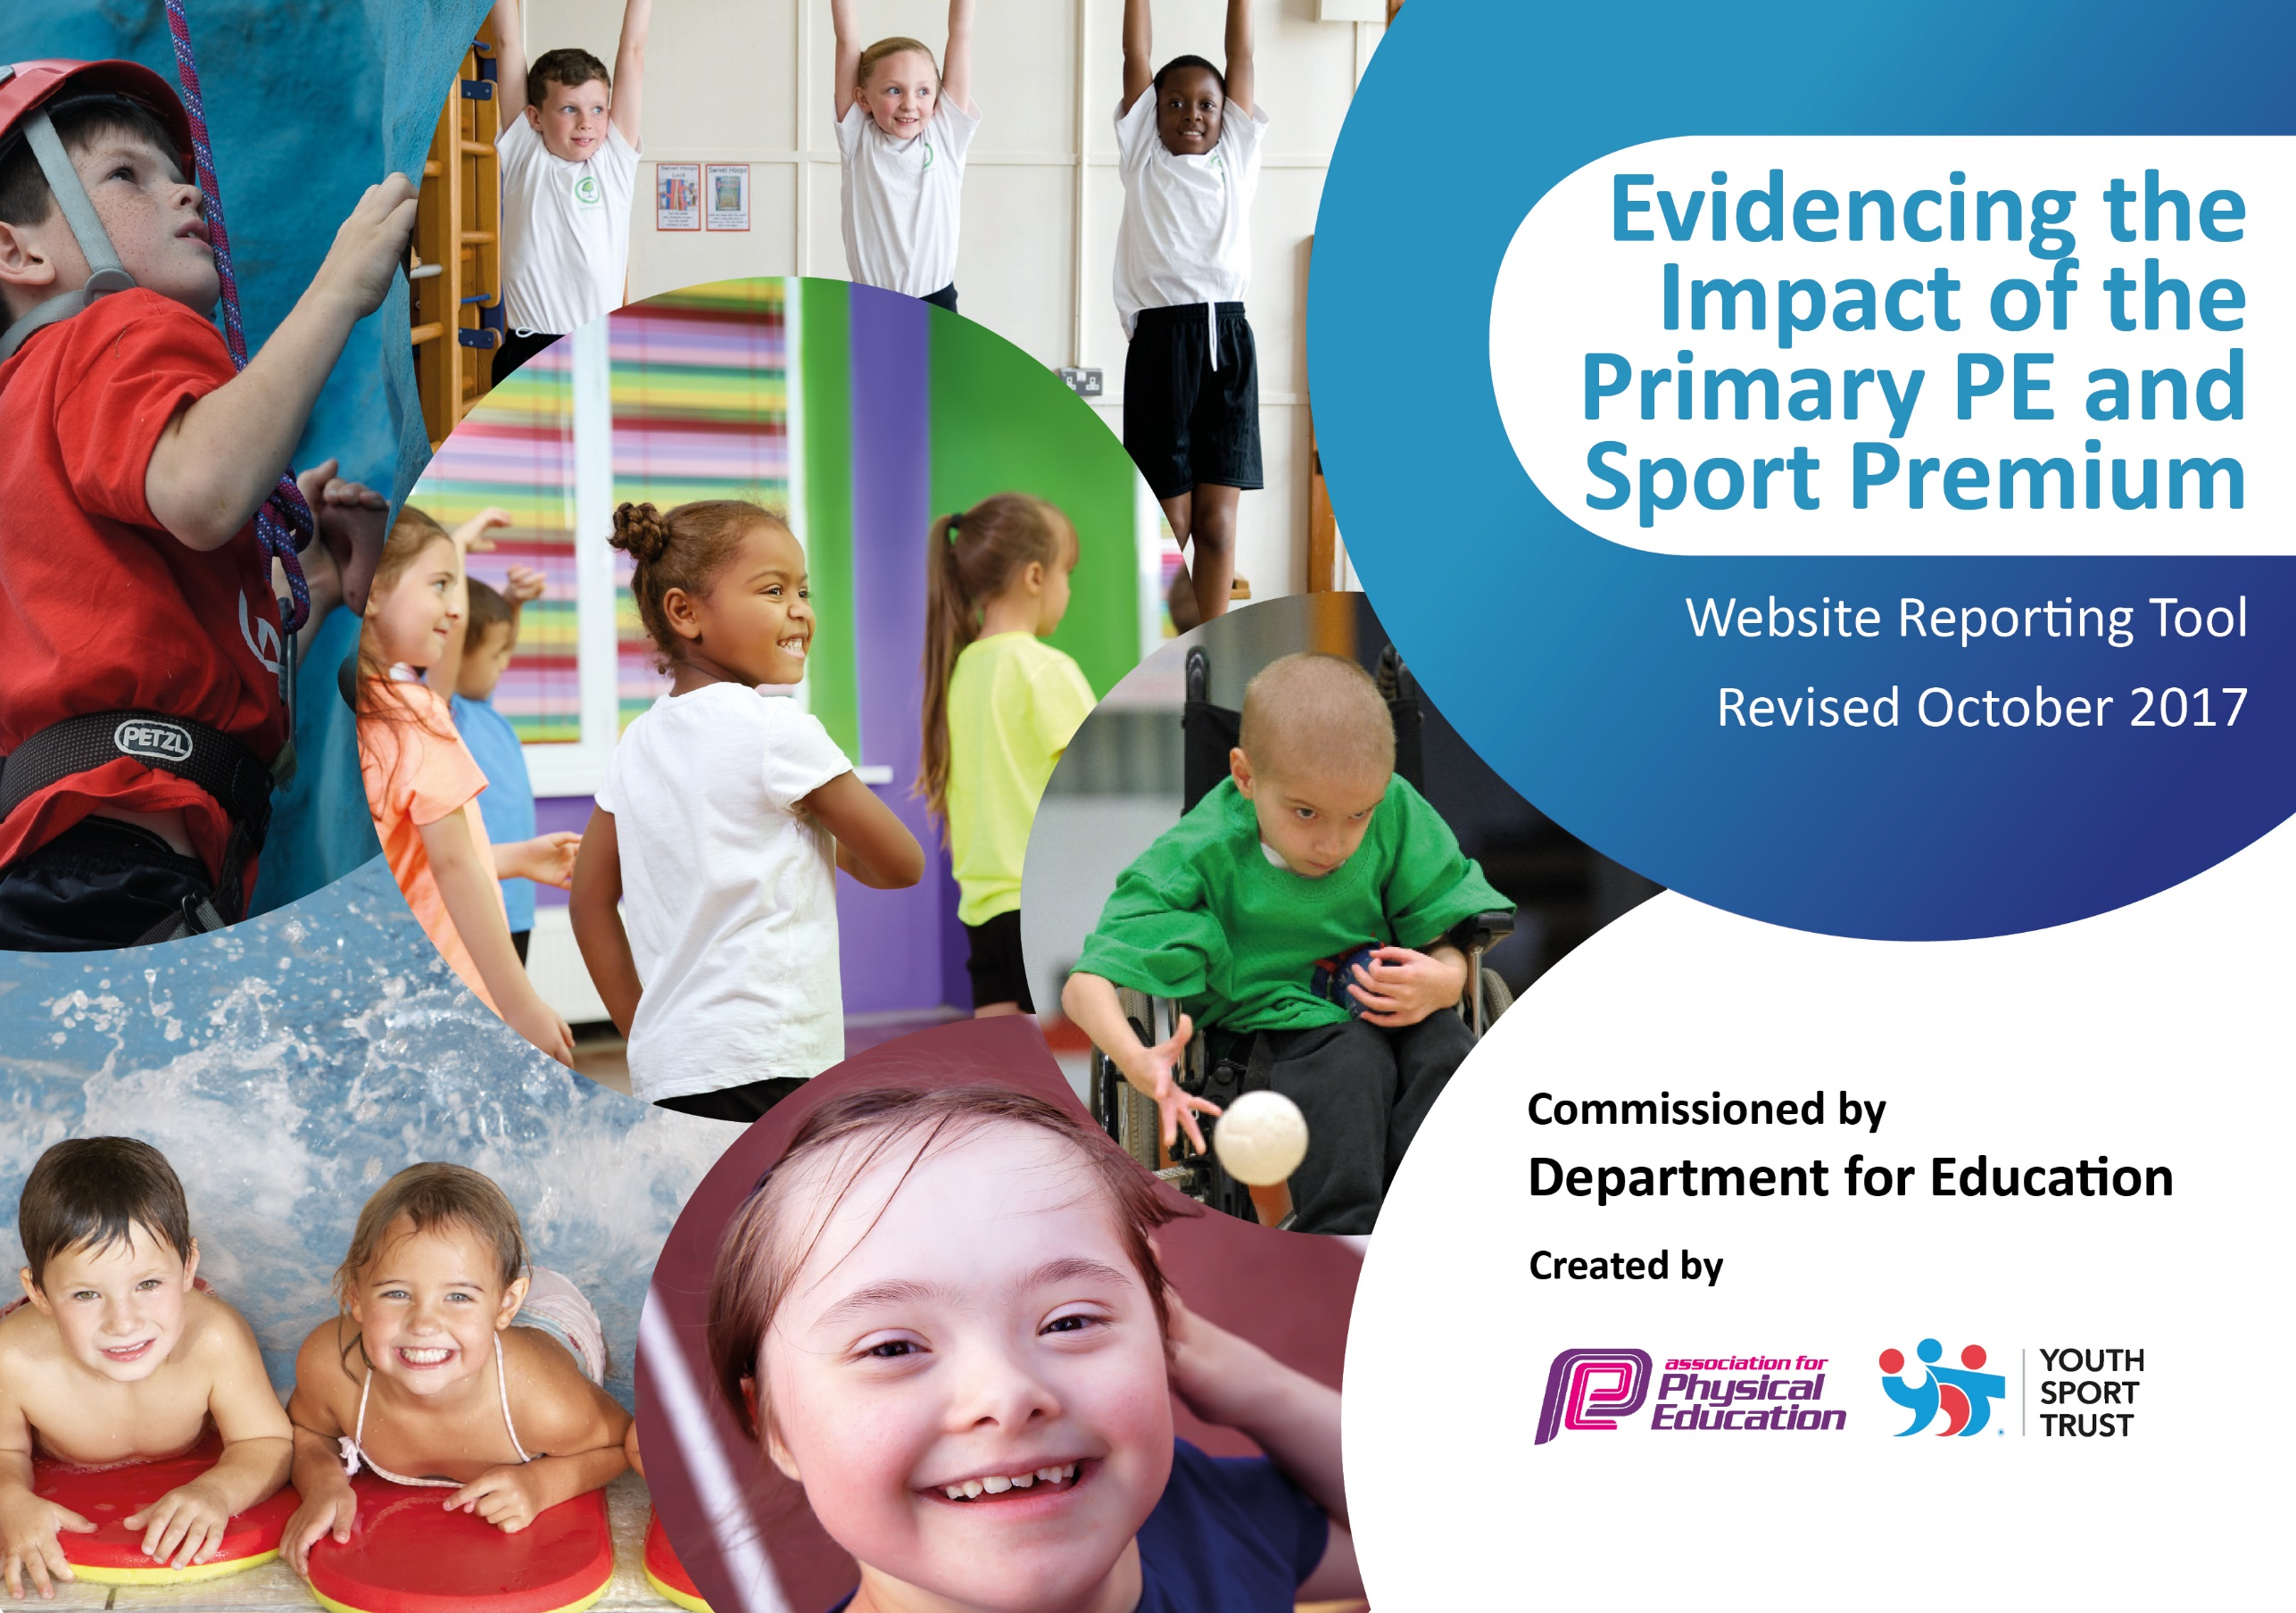

Buckminster Primary School

Schools must use the funding to make additional and sustainable improvements to the quality of PE and sport they offer. This means that you should use the Primary PE and Sport Premium to:

- develop or add to the PE and sport activities that your school already offers
- build capacity and capability within the school to ensure that improvements made now will benefit pupils joining the school in future years

Please visit gov.uk for the revised DfE guidance including the 5 key indicators across which schools should demonstrate an improvement. This document will help you to review your provision and to report your spend. DfE encourages schools to use this template as an effective way of meeting the reporting requirements of the Primary PE and Sport Premium.

We recommend you start by reflecting on the impact of current provision and reviewing the previous spend.
Under the Ofsted Schools Inspection Framework, inspectors will assess how effectively leaders use
the Primary PE and Sport Premium and measure its impact on outcomes for pupils, and how effectively governors hold them to account
for this.

Schools are required to publish details of how they spend this funding as well as on the impact it has on pupils’ PE
and sport participation and attainment.
We recommend regularly updating the table and
publishing it on your website as evidence
of your ongoing review into how you are using the money
to secure maximum, sustainable impact. To see an example of how to complete the table please click HERE.

Support for review and reflection - considering the 5 key indicators from DfE, what development needs are a priority for your setting and your students now and why? Use the space below to reflect on previous spend, identify current need and priorities for the future.

Key achievements to date: N/A | Areas for further improvement and baseline evidence of need: N/A
Training on REAL PE  Implementation of a new tracking system for sporting participation (competitive and non-competitive)  Run a mile a day | Increase opportunities to take part in a wider range of sports (competitive and non-competitive)  Target pupils who are more sedentary and Pupil Premium pupils  Ensure 30 mins physical activity per day.

Meeting national curriculum requirements for swimming and water safety | Please complete all of the below:
What percentage of your Year 6 pupils could swim competently, confidently and proficiently over a distance of at least 25 metres when they left your primary school at the end of last academic year? | 100%
What percentage of your Year 6 pupils could use a range of strokes effectively [for example, front crawl, backstroke and breaststroke] when they left your primary school at the end of last academic year? | 89%
What percentage of your Year 6 pupils could perform safe self-rescue in different water-based situations when they left your primary school at the end of last academic year? | 89%
Schools can choose to use the Primary PE and Sport Premium to provide additional provision for swimming but this must be for activity over and above the national curriculum requirements. Have you used it in this way? | Yes/No

Action Plan and Budget Tracking
Capture your intended annual spend against the 5 key indicators. Clarify the success criteria and evidence of impact that you intend to measure to evaluate for students today and for the future.

Academic Year: 2017/18 | Total fund allocated: £16,100  £8000 contribution to membership of Inspire+ | Date Updated: March 2018
Key indicator 1: The engagement of all pupils in regular physical activity – Chief Medical Officer guidelines recommend that primary school children undertake at least 30 minutes of physical activity a day in school |  |  |  | Percentage of total allocation:
 |  |  |  | 50% membership plus 12%
School focus with clarity on intended impact on pupils: | Actions to achieve: | Funding allocated: | Evidence and impact: | Sustainability and suggested next steps:
Continue with Inspire+ membership and access the initiatives offered to build on the success of last year linked to healthy lifestyles, participation & sports opportunities.  Organise assemblies by Inspire+ ambassadors as good role models for the children – linked to healthy lifestyles and wellbeing.  Introduce playtime and lunchtime activities to promote more active minutes in school.  Comprehensive selection of playground markings, facilitated by the Sports Ambassadors to enable increased physical activity at playtimes and dinner times.  Lunch time supervisors coordinate games and other physical activities.  Continue to offer free after school clubs to all age ranges.  Participation tracker for club membership. | To deliver the Legacy Challenge and promote health and fitness.  To encourage more sports opportunities for our pupils.  Pupils to be offered the opportunity to lead on health initiatives in school.  Visiting ambassadors to raise the profile of physical and mental wellbeing.  Train staff/Yr6 pupils to deliver playground leader activities and games – timetabled throughout the week.  Monitor use of games and the impact on physical activities at break times  Co-ordinate use of Inspire+ coaches for club delivery and staff development for club delivery.  Use of participation tracker in school for tracking those involved in clubs, those with leadership opportunities and those less likely to engage in sport/physical activity. Staff support required. | £8000 Inspire membership  membership  membership  £3200  £350  membership | 100% students participating in and accessing legacy challenge  10% students accessing G and T program  100% students attended assembly  100% students now taking part in playground activities  100% students now taking part in playground activities  100% of all students taking part in at least one afterschool/lunchtime club  Wider impact – increased attendance? More active pupils, better EHWB, less reports of bullying, incidents etc, any measure of happy children, SAT results improved | Sports Council  Improve facilities  Upskill staff L5/L6 course for Leading Physical Education  Breakfast clubs, link to healthy eating, free breakfast?  Wider range of Extra curricular activities  If participation not 100% address areas  Introduce Early Years cycling training on balance bikes
Key indicator 2: The profile of PE and sport being raised across the school as a tool for whole school improvement |  |  |  | Percentage of total allocation:
 |  |  |  | 50% membership plus 6%
School focus with clarity on intended impact on pupils: | Actions to achieve: | Funding allocated: | Evidence and impact: | Sustainability and suggested next steps:
Develop opportunities for pupil engagement with PE and sport throughout the school.  Celebration assembly every week to celebrate the sporting/fitness achievements of individuals and teams.  Raise profile of PE and Physical Activity with a sports board and newsletter content.  Role models - local sporting personalities so pupils can identify with success and aspire to be a local sporting hero. | Encourage sporting opportunities for all and raise the profile of PE and sport as a toolkit for positive wellbeing and confidence.  Certificate tailored to different activities. Demonstration assemblies to showcase skills and achievements.  Daily Mile and Legacy Challenge achievements to be celebrated within these assemblies.  School to highlight importance of PA through newsletter, awards board and/or sports notice board.  Release of PE Coordinator to update the board and keep the interest of all children maintained.  Use Inspire+ membership to the full and be available for all assemblies/workshops from their ambassadors and role models. Ensure follow up in our own assemblies to continually raise the profile of taking part in a sporting or active lifestyle. Current visitors include: Sophie Allen (Olympic swimmer), Sam Ruddock (Paralympian), Ben Smith (marathon legend and mental wellbeing expert), Shona McGillan (Olympic hockey player). | Inspire+ Membership  Plus minibus hire £70x10  £700  Notice board  £300  Membership | match and fixture results  Success at competitions  More children being rewarded for fitness related activities, rather than competitive success  Happiness and Physical Activity questionnaires  New activities offered?  School vision, ethos linked to PE and School Sport and school reward system  Celebration assemblies each term, daily mile awards, certificates and medals, Legacy challenge success, ambassadors.  PE notice board visible and accessible, websites, newsletters, facebook, twitter, etc updated, shared and celebrated. Children are keen to engage in the suggested activities on the notice board e.g. what’s your favourite winter sport/active advent calendar. Sporting successes are celebrated, raising the profile of individual sports. | Improve facilities  More local fixtures with Vale Schools  The HT and governors recognises the benefits of the raised profile and are committed to funding these areas if the Primary PE and Sport Premium is discontinued  Sports Council  School PE ethos, values etc introduced, embedded shared with all, students, staff, parents, common language seen in all lessons linked to being physically active  Wider range of Extra-curricular activities

Key indicator 3: Increased confidence, knowledge and skills of all staff in teaching PE and sport |  |  |  | Percentage of total allocation:
 |  |  |  | 50% membership plus 6%
School focus with clarity on intended  impact on pupils: | Actions to achieve: | Funding  allocated: | Evidence and impact: | Sustainability and suggested  next steps:
Introduce Real PE across the school.  Embedding of the REAL PE assessment process so accurate assessments can be passed through the school with the children.  Use of the Stuart Allison PE MAPS assessment toolkit.  Inspire+ coaches to continue to work alongside staff.  Access the Stuart Allison MOT training and resources and Inspire+ Health check for any further support | Receive update training and resources from Real PE trainer for all staff in school.  Ensure all staff have an understanding of the Real PE assessment process.  Develop use of Stuart Allison across the school. Staff refresher training to be considered.  Coaches to upskill our teaching staff by working alongside them to deliver 6 week coaching sessions.  School booked onto training for the MOT resources in March 2018. | £1000 to include resources  Membership  Membership  Membership | Increased subject knowledge across the subject leading to improved outcomes, sport, competitions.  Subject leader PE Co-coordinator more confident, raises the quality, improved quality assurance  Effective, timely and purposeful assessment, with all PE departments understanding where their strengths lie and areas of improvement  Increased understanding of ‘picture’ of PE in the school. | PE Coordinator can sustain staff training, should funding be lost.  More time dedicated to PE as part of school development cycle.
Key indicator 4: Broader experience of a range of sports and activities offered to all pupils |  |  |  | Percentage of total allocation:
 |  |  |  | 50% membership plus 12%
School focus with clarity on intended  impact on pupils: | Actions to achieve: | Funding  allocated: | Evidence and impact: | Sustainability and suggested  next steps:
Children able to access extra-curricular activities.  Continue to offer a wider range of activities both within and outside the curriculum in order to get more pupils involved.  - Focus particularly on those pupils who do not take up additional PE and Sport opportunities.  Questionnaire for pupils & staff about sporting opportunities and what could be offered.  Children experience a range of sports in a competitive environment.  Purchase equipment to be able to facilitate more sports | Inspire+ coaches to work with staff in curriculum time and after school clubs twice a week. Ensure Inspire + Coaches deliver a variety of sports. Staff to work with and upskill existing staff members.  In School Activities:  KS2 Boxercise  KS1 Wheelchair football  KS2 Fencing  KS2 Street Dance  After School clubs:  Whole School Bootcamp  KS2 Netball  KS1&2 football  Inspire+ to help deliver a questionnaire/survey to identify the needs of the pupils/staff.  Work with local Primary Schools to organise a sports event for Key Stage 1 and FS children.  Netball and basketball posts  Boxercise equipment | Membership plus £350  £900  £1000 | Evidence and impact:  Pupils inspired to try sports they would not usually have access to. Some children have expressed interest in pursuing these activities outside of school hours.  We have specifically chosen ‘alternative’ physical activities to appeal to less active children.  Vast majority of pupils say they enjoy PE and Sport and want to get involved in more activities. They particularly enjoy ‘sporting visitors and professionals’ coming in.  Include Wider impact – increased attendance? More active pupils, better EHWB, less reports of bullying, incidents etc, any measure of happy children, SAT results improved | Sustainability and suggested  next steps:  To encourage parents to offer/train on activities of interest to them (Parent Volunteer Scheme through Inspire+).
Key indicator 5: Increased participation in competitive sport |  |  |  | Percentage of total allocation:
 |  |  |  | 50% membership plus 10%
School focus with clarity on intended  impact on pupils: | Actions to achieve: | Funding  allocated: | Evidence and impact: | Sustainability and suggested  next steps:
Continue to enter and encourage a wide range of competitive sports and celebrate personal and team successes.  Focus on improving netball High 5.  Inter house competitions?  Schools Games organisers and local competitions | Liaise with local schools to arrange competition opportunities throughout the year.  Enter a Yr3/4 team in the Inspire+ Mini Olympics  Arrange competitions at start of the year, linked to curriculum  Attend meetings at start of year, include dates, model extracurricular timetable around competition calendar  Work with Clare Marlow from Leicester-shire & Rutland School Games competitions | Minibus hire  £300 from January to April | From January to April 2018:  St Hugh’s Year 5 football tournament – 3rd  Melton Volleyball Year 4 – 1st  Belvoir Year 6 Tag rugby 1st  3 Yr6 children went through to represent the Melton area in the National cross country champs  (all within 4 months of new PE lead taking on the role)  Younger children see the progression available and are keen to take up competitive sport.  New parents to the school see us as a small school that achieves highly in sport.  School prioritises swimming and children swim from Year 1 to Year 6. It is very rare that a Year 6 pupil would leave the school unable to reach the NC 25m criteria. | Continue to enter teams for competitive events and celebrate success with our local community.  Organise a Vale football league  Swimming costs are high, but the governing body have committed to the increased expenditure.

