**Science**

Materials

* Identify different materials and their uses

Habitats

* Identify habitats and the animals and food sources found within them.

**English**

During the second term, KS1 will continue to develop their writing skills by exploring a variety of genres, which include;

* Fantasy stories
* Tales from different cultures
* Information texts

The children will also focus on nouns, verbs and a variety of suffix and prefixes, as well as homophones, adjectives and different types of sentences.

Phonics will be delivered daily to support reading, writing and spelling.

**DT**

* Inuit sculptures and prints

**PE**

* Dance
* Net & Wall
* Fitness
* Send & Receive

**PSHE/RSE**

Keeping safe on the internet

* Balancing screen time
* Personal Information
* Communicating online
* Not all information online is true

Physical health, fitness and prevention

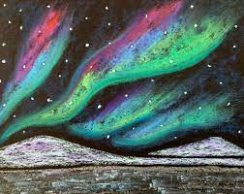



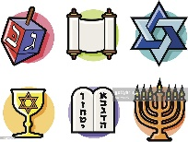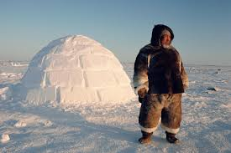 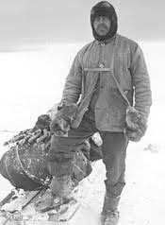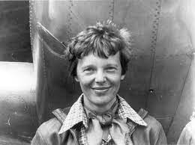

**Key Stage 1 Curie**

**Term 2 2022/23**

**RE**

During this term we will be focussing on developing our understanding of the Jewish faith.

**Computing**

As part of the project evolve curriculum we will be looking at online privacy and security.

We will then look at simple coding with the BeeBots and game creation.

**Maths**

This term the children will focus on

**Year 1**

* Place value
* Addition and Subtraction
* Length and height
* Mass and volume

**Year 2**

* Money
* Multiplication and Division
* Length and Height
* Mass, Capacity and Temperature

**Art**

* Colour mixing- primary and secondary colours
* Creating a colour wash
* Develop drawing skills

**History**

* Find out about Scott of Antarctica
* Compare to modern day explorers
* Who is Amelia Earhart?
* Compare and contrast equipment used by modern day explorers and that used by Scott’s expedition

**Music**

Myths and Legends

* Creating a rhythm
* Show structure on a graphic score
* Write a graphic score to show texture
* Compose a piece of music with a given structure
* Perform a group composition

**Once Upon a Time**

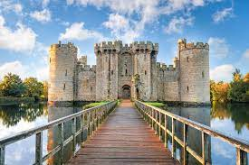

**Geography**

* Naming 7 continents and 5 oceans
* Compare and contrast what it is like in the Arctic to parts of the UK.
* Look at human and physical features of the Arctic and the UK
* Find out about where we live.
* Local study of the area- field work
* Use maps and create maps and record symbols