

Prospectus 2017-2018

Buckminster Primary School



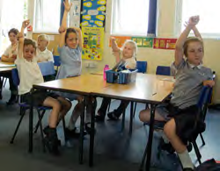

Welcome to

Buckminster Primary School

Buckminster Primary School aims to have an ethos that is tolerant,

civilised and fair. All of our children are encouraged to respect each

other and are expected to behave appropriately wherever they are, in and

out of school. The school aims to produce a recognisable and attractive

senior pupil who will be confident and well educated in the broadest

sense, with a feeling of affection for the school. We want the children

in our care to be happy, we want the children to enjoy learning and we

want the children to be proud of Buckminster Primary School.

Contents

Introduction 3

The Staff 6 & 16

The Governors 6 & 17

The PTFA 6

The Curriculum 6

School Routine 12

Academic Attainment 9

List of Staff 15

School Uniform 17

**Introduction**

Thank you for considering Buckminster Primary School as a possible start for your children/child. Our working principle is making sure that improving social experiences and enjoyment of the world around them, alongside the academic standards to give the children a thirst for lifelong learning.

When children, parents, staff and governors

were asked for their views on Buckminster

School, one particular comment was repeated time and time again - “We are all like one big happy family”.

This statement sums up the ethos of our school, where we learn together in a happy and caring atmosphere. However, just like a real family, we all support and challenge each other to ensure we achieve our very best. Our core values are the 4 R’s;

**Respectful, Responsible, Reflective, Resourceful**

Our small classes and our personal approach to teaching and learning allow us to support and meet the needs of every child. Our children’s progress is closely monitored to make sure that every child is achieving their true potential.

Our exciting broad and balanced curriculum

and our excellent provision of extra-curricular activities provide an opportunity for every child to discover and develop their own individual talents and interests.

The school’s Farm Garden and our connection with the Forest School provide children with a wealth of learning experiences. We truly believe children must be taught a wide range of knowledge, skills and practical and technical abilities that will enable them to become lifelong learners and achieve future happiness and success.

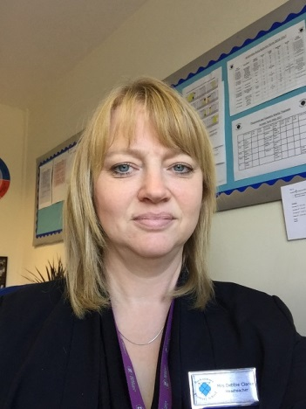

**Head Teacher**

**Mrs Debbie Clarke**

Please look at our website which will provide you with important information and direct you to other sites that may be of use. Pictures and information about our children’s learning can also be found in the different areas. Our News and Diary section will also keep you informed about day to day events and special occasions.

We have a very supportive team of Parent volunteers (PTFA) and are always grateful for any extra help you can offer. We have an open door policy at Buckminster, so please feel free to come in and join us!

We hope that you will find this prospectus useful and informative. This prospectus only acts as a window into the life of our school and you are very welcome to arrange a visit and see our greatest ambassadors, our children, in action.

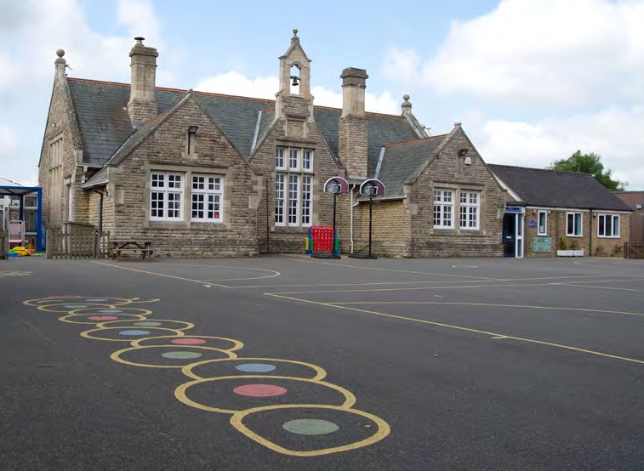

# BUCKMINSTER PRIMARY SCHOOL

Buckminster Primary School stands between the villages of Buckminster and Sewstern overlooking the rolling countryside. It is a beautiful Victorian building housing our Foundation Stage 2, Year 6, Library, Community Room, School Office and the School Hall. Our three other classrooms are in modern outbuildings behind the main school building. The new Pre-school is in a new purpose built building next to the reception class. The two classes now form the new Foundation Stage Unit and share a spacious outside learning area. All our classes have interactive smartboards and a range of technology to support learning. We also have our own farm, forest and an all-weather sports pitch known as the MUGA! Buckminster is a popular village school with a very high level of parental support. If it is over- subscribed and where applications for admission exceed the number of places available, children will be admitted according to the school’s current admissions policy.

The school will agree any changes to its admission arrangements with Leicestershire County Council. It will establish arrangements for appeals against non- admission with Leicestershire County Council.

The school has a large playing field which extends our games and recreational facilities. We regularly take part in sporting competitions with a great deal of success against other small schools throughout the Vale of Belvoir and immediate locality.

The class teachers present two merit certificates per class at the end of each week and these are awarded for hard work, excellent achievement or simply a demonstration of politeness and good manners; Living out the values of the 4 Rs. The whole school work towards achieving excellence in the 4Rs and can collect tokens which go towards a whole school reward.

01476 860315 www.buckminster.leics.sch.uk

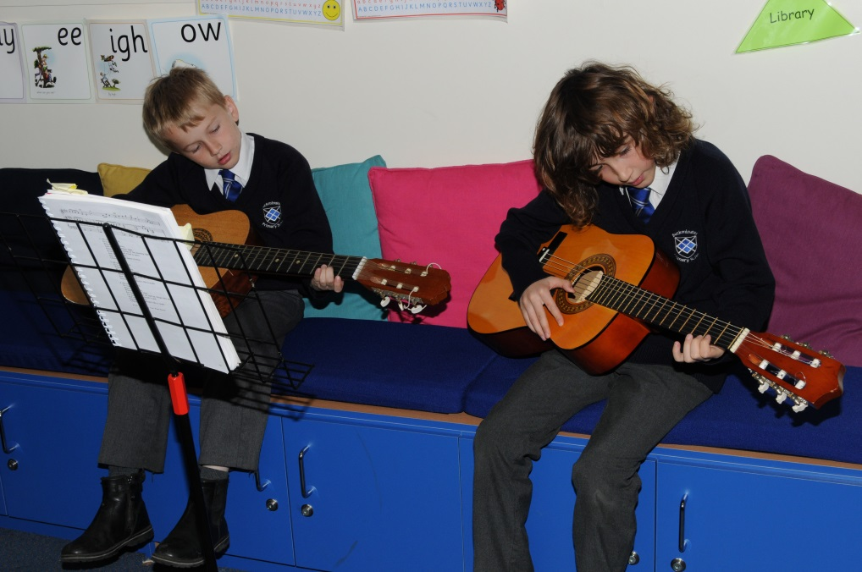

We publish a weekly newsletter “Buckminster Bites” every Friday and we also update our school website on a regular basis: [http://www.buckminster.leics.sch.uk](http://www.buckminster.leics.sch.uk/)

We try to keep parents informed of everything that is going on at school with regular communication. We want parents to involve themselves in their child’s education. By working together we feel we can ensure all children reach their full potential. We also encourage all parents to contact the school with any concerns or worries, however small, so that we can work together to find a solution. An open door policy is in full operation in the school and we do our upmost to see you as soon as is conveniently possible

**ADMISSIONS POLICY**

The Governing Body of Buckminster Primary School has adopted the following arrangements with respect to the admission of pupils to the school.

Pupils will be admitted in September in the year they become five years of age. The maximum number of intended admissions for the year commencing 1st September 2016 will be 15 and the published admission number for each year group is 15. All applications are sent directly to Leicestershire county Council.

Buckminster Primary follows the agreed co- ordinated scheme for admissions and this is available from the local authority. We will take account of our statutory responsibilities in respect of children with special educational needs.

Where applications for admission exceed the number of places available all appeals are dealt with Leicestershire County Council Admissions Department.

|  |
| --- |
| PRE-ADMISSION ARRANGEMENTS Parents of prospective Foundation children have the opportunity to view the school and meet with staff. Our Pre-School and local playgroups and nurseries work closely with the Foundation team to help develop pre-school links. The Foundation teacher visits all settings and meets with any children due to start school in September. Parents are invited to attend a meeting held in the Summer term prior to their child starting school and children are also invited to the school for two afternoons during this term if they are not already in our Pre-School. Uniform is also available to order from the school office via our Office Manager.  Children generally enter the school in the September of the year that they are five. They spend their initial year in the Foundation Unit in a class that does not usually exceed 15. They then spend a further two years in Key Stage One, before moving to the Key Stage Two. Their final two years are used to prepare them for secondary school and the Headteacher is available to advise parents on the range of secondary options and if necessary prepare children for the Common Entrance Examination – normally known as the 11+. During the final term, pupils transferring to local secondary schools get the chance to spend the day there to familiarise themselves with their school to be. |

01476 860315 www.buckminster.leics.sch.uk

STAFF

The school is very generously staffed. In addition to five full-time permanent teaching staff, we have three members of support staff and a Pre-school leader. We also have a dedicated special needs teacher on the teaching staff. Rather than simply identifying a child with special needs this enables us to create an individual Support Plan for those children that need a little extra support or to stretch the more able and ensure that the plan is implemented. We also have a part-time teacher for Music and visiting Sports Specialist on a regular basis. Several parents also give valuable help with cooking and other activities which vary from term to term.

GOVERNORS

The Governors are responsible for the ethos and the reputation of the school. They are also in a very direct sense, employers of the staff and custodians of the buildings and grounds. They represent a wide spectrum of local interests and the Parent Governors are always willing to convey information to and from parents.

Governors have legal duties, powers and responsibilities. They can only act together, they cannot act individually.

Governors are appointed to help:

* Decide what is taught
* Set standards of behaviour
* Interview and select staff
* Agree the school budget

Governors are chosen from:

* Parents
* School staff
* Community representatives
* People with special skills

**PTFA**

The main representative body for parents is the PTFA committee that liaises closely with staff and governors. The PTFA is very active with fundraising, supporting the school by helping children cook, go swimming and other exciting activities. Alongside this they provide a wide range of fantastic social events for the school and wider community. The parents appreciate the benefits of small classes and are therefore heavily committed to fund raising.

Every year we hold assorted termly events which include discos, Christmas and Summer fetes, quiz nights and many other different fundraising activities

Not only do these events raise money, but they are also great fun and are enjoyed by the children, parents and staff. It is a great opportunity to bring the whole community together. It is our aim to feel that all parents can share in their child’s school life and this is a balance that is well met at Buckminster.

**THE CURRICULUM**

The National Curriculum is mandatory for all Foundation Schools and is prescribed by the Government. The way that the curriculum is delivered is, however in most cases, left to the school. At the start of every term we will send you an outline of the curriculum your child will be covering that term. We also communicate regular information via the Home School Diaries that provide lots of information to support you in supporting your child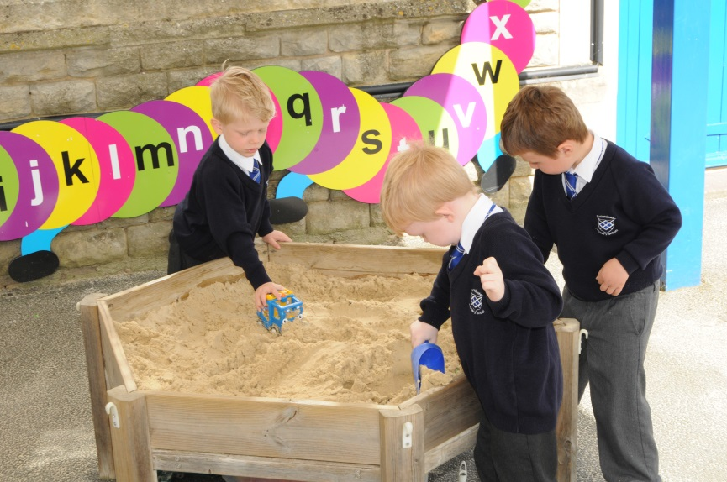’s learning.

|  |
| --- |
| **FOUNDATION STAGE: Pre-school and Reception**  During the first years at Buckminster, the teachers follow the statutory framework for the Early Years Foundation Stage (EYFS) as laid down by the government. Throughout the two years, pupil progress is monitored with reference to the Foundation Stage Profile. This is a statutory document relating to the Early Learning Goals, which address the following areas: Personal, Social and Emotional development; Communication, Language and Literacy; Problem Solving, Reasoning and Numeracy; Understanding of the World; Physical Development; Expressive Arts and Design. |

**Personal, Social and Emotional Development.**Children learn to work together, to share and co-operate. They are helped to develop good self-esteem and confidence. This area is the basis for success in all other areas of the curriculum.

**Communication, Language and Literacy** Children develop speaking and listening skills in a variety of situations. They begin to read and write and to use information and communication technology (ICT) skills. These are developed through making connections, often through play.

**Problem Solving, Reasoning and Numeracy** Children develop skills in mathematics through active learning. This will include counting, sorting, matching, seeking patterns, making connections, recognising relationships and working with numbers, shapes, space and measures. Mathematical understanding is developed through stories, songs, games and imaginative play.

**Understanding the world** Children develop those skills that help them make sense of the world. This includes first hand experiences that encourage exploration, observation, problem solving, critical thinking, decision making and discussion. This forms the foundation for later work in science, design and technology, history, geography and ICT.

**Physical development** Children develop their skills of co-ordination, control, manipulation and movement, using a range of equipment both indoors and outside.

**Express Arts and Design** Creativity is fundamental to successful learning. Being creative allows children to make connections between areas of learning and so extend understanding. This includes art, craft, music, dance, role play and imaginative play.

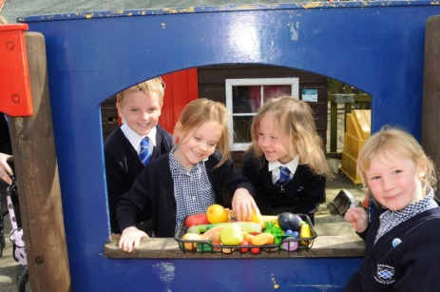

**KEY STAGE ONE – Year 1 and 2**

When children leave Foundation they enter Key Stage One. This stage lasts two years (year 1 & year and finishes at the end of Year 2 when the children are all seven years old. In May or June of their final year children are assessed by their teachers in English and Mathematics, using National tests. Results are reported to parents with the child’s annual report. Children in Key Stage One study the National Curriculum. Towards the end of year 1 children will sit a National Phonics Assessment.

# D:\CC9124F4FC.jpg

# LOWER KEY STAGE TWO – Year 3 and 4

Reading is a vital skill and should be well established as a habit by this time. Children are given opportunity to demonstrate their ability as readers and writers through a variety of activities. The aim is to make them effective communicators over a range of themes. They should be beginning to appreciate style in writing, acquire and employ a wide vocabulary and put ideas into their own words without close direction from an adult. Children should be sure of their number bonds to ten, twenty and one hundred and should be developing their knowledge of timetables.

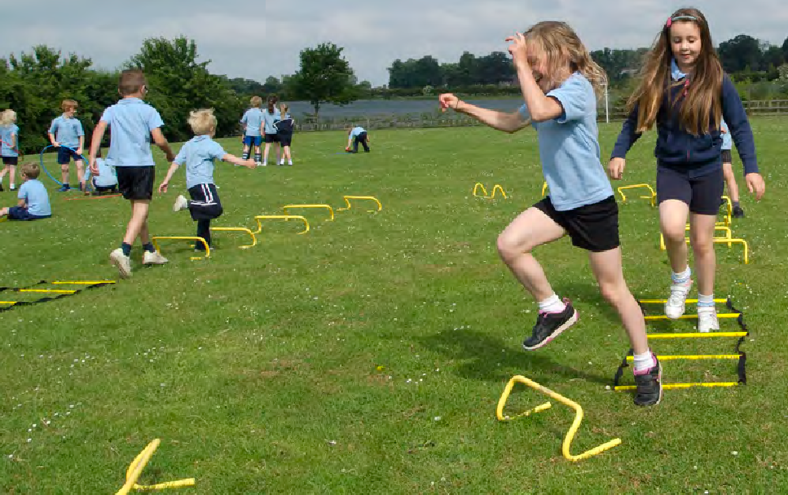

# UPPER KEY STAGE TWO – Year 5 and 6

The senior children are expected to be independent, self-assured and capable of expressing themselves clearly in both the spoken and written word. Children should be able to work in a co-operative way with others and have exceptional manners. They should also be able to respond properly to adults and see themselves as ambassadors for the school. No child should leave without feeling that they have shared a wide range of opportunities and responsibilities.

**Educational Visits**

During the school year children may visit places of interest, often in connection with a project or environmental work. Speakers or live theatre in school may also be arranged. We believe that these trips enhance children’s education and give them a unique opportunity to have a range of experiences with their friends. Under the requirements of the Education Reform Act 1988 we can only raise the cost of visits or activities by voluntary contributions and we hope all parents will support them. If there are any concerns about this then please do come into school and arrange a meeting to see how we can help.

01476 860315 www.buckminster.leics.sch.uk

**Sex and Relationship Education**

The governors have a policy for sex and relationship education, which is available on request. Children’s questions are answered frankly and accurately according to the age of the child. There are more formal lessons in Year 6 covering puberty and human reproduction. Parents are given the opportunity to look at all materials used before the lessons take place.

**Assemblies**

The school provides a daily assembly and hymn practice in the hall. Assemblies are a special time within the school day for the children to gather together, reflect on special occasions and key dates and celebrate each other’s achievements

We hold a number of services at St. John the Baptist Church in Buckminster, including, Harvest Festival, Christmas, Mother’s Day, Easter and a very special Leavers’ Assembly.

**Homework**

Parental support is vital to children’s learning. It is proven that children who establish an early homework habit, particularly those who learn with their parents, are more successful at school. However, it is important to remember the need to balance work and play activities. There must still be time for children to play, follow hobbies and other outside interests.

All children will be encouraged to read/share books. It is expected that every child will read, or be read to, for 10-20 minutes every day. Parents have an important role to play by encouraging reading at home and supporting our Home School reading partnership.

Allchildren will have a book to take home each day. This will be recorded in their home/school diary book. Older children will still be expected to read to themselves every day and will be given specific reading tasks from time to time. As children go through the school, they will receive more homework. The Home/School diary is a very useful communication link between school and home. The class teachers will make regular comment in them and it is expected that the parents do too.

**Extra Curricular Activities**

The school prides itself on the wide range of extra-curricular activities it offers. These activities change each term. We are keen to develop academic potential but not to the detriment of other areas of the curriculum. Some of the clubs on offer include; netball, football, rugby, cricket, rounders, athletics, tennis, cookery, computing, art, dance, music groups, gardening and drama activities.

**Annual Reports and Parent Meetings** Parents are very welcome to discuss any issues relating to their child’s education at anytime with either the Headteacher or the classteacher. However there are a number of formal opportunities throughout the school year when we will report back to you with regards to your child’s progress:

• October Parents’ Evening (settling in)

• February Parents’ Evening (progress)

• June Annual written Report to Parents

• July Parents’ Evening (report discussion)

**Finding out about your child** We welcome you as parents into the school and your interest and support are highly valued as is any help you may be able to offer. Parents are always welcome to come in and discuss any issues or concerns they may have. Working together, we can ensure all the children reach their full potential. If you would like information about your child’s progress, or anything else to do with their education and welfare, then please come into school and talk to us.

**Speaking to the Head teacher** Mrs Clarke is always pleased to see parents. For a quick visit it is perfectly all right to “pop in”. If she is not available, please make an appointment at the office. She is normally outside school at the beginning and end of the school day, if you wish to have a word at that time.

**Speaking to Teachers** In Foundation and Key Stage One there is time to give a quick message to teachers or teaching assistants in the ten minutes before class. In Key Stage Two, or if you wish to see a teacher for a longer time, please arrange a specific time before or after school with them, or contact the office for an appointment. In this way, the teacher can see you at a mutually convenient time and you will be free from interruption.

**Speaking to Governors**

If you wish to speak to a governor please leave your name and number at the school office and you will be contacted.

**Complaints**

If anything is bothering you at all, as above, please make an appointment to see the Headteacher. We find that in the vast majority of cases, things can usually be settled quickly, amicably and confidentially. If you wish to contact the Chair of Governors then please write to the Clerk to the Governors c/o Buckminster Primary School and the correspondence will be passed onto the Chair of Governors.

01476 860315 [www.buckminster.leics.sch.uk](http://www.buckminster.leics.sch.uk)

**School Routine**

All children need to register at 8.50 am and 1.20pm. Children can be dropped off at school in the mornings at 8.40 am when a member of staff is on the playground. Children should bring a note after any period of absence and parents are requested to make a phone call to the office on the first day to inform us of the reason for the absence. Please call by 9.15am so that we can ensure that your child is safe. Work can be sent home if a child is absent from the school for several days or longer.

School Timings

School Starts 8.50 am

Break 10.45 - 11.00 am

Lunch 12.15 - 1.15 pm

School Ends 3.20pm

Foundation children will only be released when their parents or their representative meets them in the playground. Any child below the age of seven (Foundation, Year 1 and Year 2) will be taken back into school if there is no one to meet them. No child can leave the school without permission. If you wish someone other than yourself to collect your child please inform the school in advance by letter or telephone.

Although we encourage punctuality we understand that for a variety of reasons it is not always possible to meet your child at the given time. Please do not worry as we will always ensure your child is safely looked after until alternative arrangements can be made.

All children in Foundation 2 and Key Stage One will receive a free hot meal from Sept 2014. Hot meals can then be ordered for other children from menus on the school website. If packed lunches are provided by parents, staff will make every reasonable effort to ensure children eat them. Children can bring a piece of fruit or similar snack to eat at morning break. All infant children receive a free piece of fruit and under fives receive free milk.

**Road Safety**

Buckminster Primary School is incredibly busy during dropping off and picking up times, so please follow these guidelines to avoid potentially dangerous situations:-

Please Don’t:

* Park on the yellow zig-zag lines (unless you hold a valid disabled badge)
* 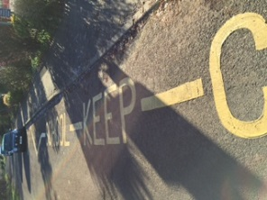Turn in the school car park gateway
* Perform three point turns outside the school
* Park on the pavement
* Park on the opposite side of the road to school
* Walk your child through the carpark

There are also bike racks available on the school site for children (and staff) to leave their bikes if they wish to cycle to school. Cycle proficiency courses will be available to Key Stage Two children during the summer term. If you require further information please do not hesitate to contact the school on 01476 860315.

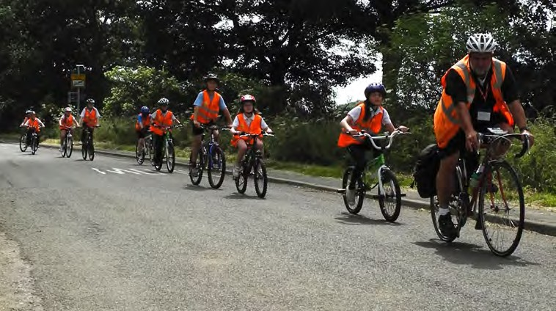

**Safeguarding your child**

At Buckminster Primary School all staff are committed to safeguarding children and promoting their welfare. Through assemblies and lessons, children are helped to understand what is and is not acceptable behaviour towards them. They are also taught about staying safe from harm and how to speak up if they have any worries or concerns including E-Safety.

Through our day to day contact with pupils and direct work with families, school staff have a crucial role to play in noticing indicators of possible abuse or neglect and have a legal duty to refer any concerns to the appropriate agency. Staff will generally seek to discuss any issue with parents before involving another agency.

**Equality of Opportunity**

All children regardless of race or gender will be treated with the same degree of care and attention. All pupils will have the same rights of access to age appropriate activities in all aspects of school life. Governors are updated termly of any incidents of racism or bullying if this ever occurs, and equal opportunities in practice are integral to the school’s on-going self-evaluation procedures. At Buckminster we have made a commitment that, wherever possible, children with physical disabilities will be educated in their local primary school. If required, adaptations to the building will be considered by the school to enable a child to attend our school.

**All staff are committed to safeguarding children and promoting their welfare**.

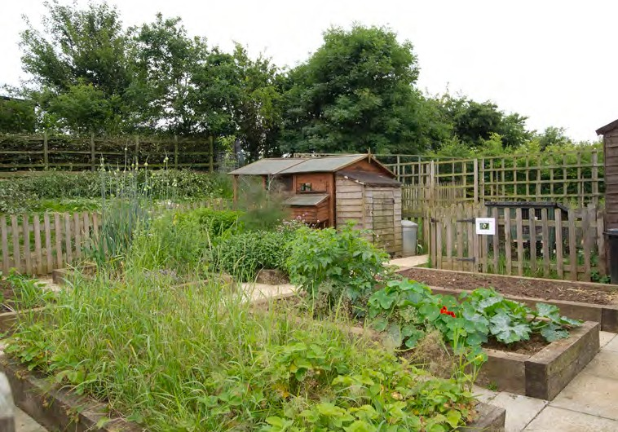

**Health and Safety**

Buckminster Primary School accepts that health and safety is an integral part of all activities and believes that the only effective approach to injury, ill health and loss prevention is one based on the active participation of everyone and the systematic identification of hazards and the assessment and control of risks. Appropriate health and safety standards will be applied to all activities. A Health, Safety and Safeguarding governors committee meet regularly throughout the year. The safety of our children is paramount and under constant review.

The following jewellery will be acceptable

• Watches

• Plain stud earrings (your child will need to bring some medical tape to ensure that these can be covered up during PE sessions and covered by a hat when swimming)

**Any items brought into school are the responsibility of the child. The school can take no responsibility for loss or damage.**

|  |
| --- |
| **After School Club and Breakfast Club**  We are delighted to be able to offer a Breakfast Club, starting at 7.40 every morning and an After School Club, which runs from 3.20 to 4.20 or 3.20 to 5.20 every afternoon. The current cost of each club per one hour slot is £3.50. Please see the school office for further details and a booking form.  **D:\9A480524AD.jpg**The Pre-school runs a Breakfast Club from 7.40 – 9.00 at £4 and an After School Club 3.30-4.30 and 4.30-5.30 at £3.50 an hour |

**Request for Leave of Absence**

All parents/carers are asked to complete a Request for Leave of Absence from (available for the office) if they wish to take their child out of the school during term time. The Headteacher considers each request for planned absences looking at; (a) The impact on the child’s education, (b) Previous absences, (c) The proximity to school assessments and SATs. Any absence not sanctioned by the Headteacher will be treated as unauthorised and could lead to a possible fine by the Local Authority

**Religious Education**

Religious Education is taught in accordance with the Leicestershire agreed RE Syllabus. Through religious education, the children will be able to:

(a)Learn about Christianity and about other principle religions represented in the United Kingdom, (b) Reflect on a range of human questions and experiences, (c)Ask, analyse and respond, (d) Explore the meaning of authority, celebration and the sacred, (e) Prepare for life as citizens of the world

**School Council**

The school council gives all the children an opportunity to contribute towards the running of the school. It has representatives from each class and they get voted in by the class every 6 months. The school council gives interested children the chance to be fully involved in the life of the school. Members of the school council represent their peers at meetings and other events and are involved in decision making about key aspects of school life.

**SEN and Gifted and Talented**

Some pupils may demonstrate exceptional performance within certain areas in or outside of school. We are committed to developing an ethos that supports and celebrates the learning needs of all children. Provision of more able children is an integral part of our teaching programme and we will endeavour to provide a variety of opportunities to cater for each pupils individual needs.

**Home School Agreement**

In line with government policy, the school has a Home/School agreement that parents are asked to sign when their child joins the school. It is also in the front of each of the Home School Diaries

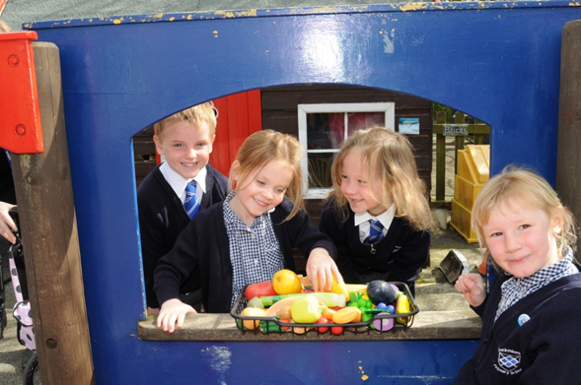

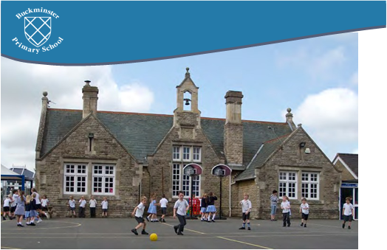

|  |  |
| --- | --- |
| **Autumn Term** | |
| August Bank Holiday | Monday 27th August 2018 |
| Teacher Training Days | Tuesday 28th and Wednesday 29th August 2018 |
| School Opens | Thursday 30th August 2018 |
| Mid Term Break | Monday 15th – Friday 19th October 2018 |
| School Closes | Friday 21st December 2018 |
| **Spring Term** | |
| Teacher Training Day | Monday 7th January 2019 |
| School Opens | Tuesday 8th January 2019 |
| Mid Term Break | Monday 18th – Friday 22nd February 2019 |
| School Closes | Friday 12th April 2019 |
| **Summer Term** | |
| School Opens | Monday 29th April 2019 |
| May Day | Monday 6th May 2019 |
| Mid Term Break | Monday 27th – Friday 31st May 2019 |
| Schools Close | Friday 12th July 2019 |

Term dates for 2018/19

APPENDIX 1: SCHOOL STAFF

**TEACHING**

Headteacher/ Special Needs Co-ordinator: Mrs Debbie Clarke

Assistant Headteacher and Foundation teacher Miss R Longley (3 days)

Mrs H Jackson – Foundation teacher 2.5 days

Mrs K Parkin – Year 6 teacher

Miss C Barrett – Year 5 teacher

Mrs K Hunt - Year 3/4 teacher

Mrs T Goddard - Year 1/2 teacher

Mrs C Floyd – Pre-School Leader

Mrs R Wood – Pupil Premium teacher

Mr Spear – Music teacher

Mrs Bidwell – Music teacher

**SUPPORT STAFF**

Miss L Clare

Mrs J Roberts

Miss P Darcey

Midday Assistants Mrs J Hayman + Mrs S Watkin

Mr W Watkin - Premises Officer

Mrs S Birch - Office Manager

Mrs S Holmes – Office Assistant

GOVERNORS

Chairman: Mr Jon Watchorn

Vice Chairman: Mr Stephen Vickers

Mr Richard Tollemache

Mr Chris Jinks

Mr Simon Hatchman

Mrs Rachel

Mr R Deardon

Mrs C Joint

Mrs C Smith

Mrs Parkin (staff)

Mrs Clarke (staff)

SCHOOL UNIFORM

We are extremely proud of Buckminster School and especially proud of the way the children look. We are particular about school uniform and we feel it is very important to ensure the children maintain a high standard of dress.

Please see below the Buckminster Primary School uniform for the academic year 2016/2017.

**UNIFORM**

White Shirt, School Tie (donated by the PTFA), School Jumper or cardigan, Grey Trousers or skirt , Black Shoes, Grey Shorts or Navy and white gingham dress

Long hair must be tied up at all times

**PE/GAMES**

PE Bag, White Polo Shirts / Sky Blue Polo Shirts, Navy Blue Sweatshirt, Navy Blue Shorts, Navy Blue Tracksuit trousers, Plimsoles, Trainers (for outdoors)

Long hair must be tied up at all times

**PLEASE ENSURE THAT ALL**

**ITEMS OF UNIFORM ARE MARKED CLEARLY WITH YOUR CHILD’S NAME.**

Jewellery, except for plain ear studs should not be worn in school for safety reasons and all ear studs should be covered for PE and swimming lessons. Jewellery may be worn for religious reasons.