**Early Years Foundation Stage**

**Curriculum Plan**

**Autumn 1.2**

**Once Upon a time**

[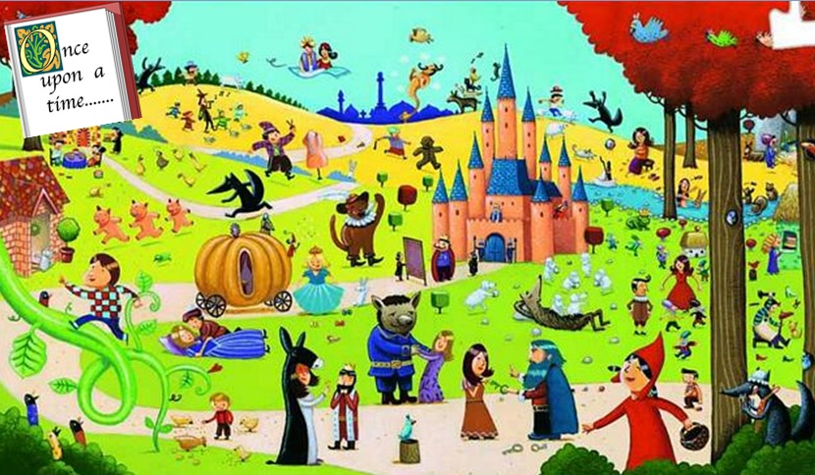](http://www.google.co.uk/url?sa=i&rct=j&q=&esrc=s&source=images&cd=&cad=rja&uact=8&ved=0ahUKEwjFzv6B7LnXAhWF2qQKHSoRAQsQjRwIBw&url=http%3A%2F%2Fblog.holy-infants.bolton.sch.uk%2Feyfs%2F2016%2F01%2F18%2Four-favourite-traditional-tale-characters%2F&psig=AOvVaw0gH4M1K2eaPdUnV_khYAbd&ust=1510603848475012)

**Mathematics**

Counting, recognising, ordering and writing numbers to 20

Adding and taking away

Learning names and describing 2D and 3D shapes

Understanding measure- height and length

**Reading and Writing**

Reading and writing simple sentences

Exploring different kinds of writing

Phonics and handwriting

Learning key words

Understanding story structure

Retelling stories

**Understanding the World**

Cooking and food tasting

Properties of materials

Gingerbread experiment

Water and sand exploration

Building and constructing

Growing a beanstalk

**Communication, Language and Literacy**

Speaking and listening to others

Responding to and asking questions

Making up own stories

Role play

Retelling stories

**Physical Development**

Disco Dough

Traditional Tales dancing

Fine motor development

Gross motor skills

Control and coordination

Dressing independently

Handling tools and equipment

**Personal, Social and Emotional Development**

Sharing and taking turns

Resolving disputes

Respecting other people and their things

Working as a team

Having a goat persevering

Co operation

|  |
| --- |
|  |

**Expressive Arts and Design**

Explore different materials, tools and techniques

Learn a variety of songs and dances

Explore different musical instruments

Act out traditional stories

Use imagination in art using a variety of different media