Early Years Foundation Stage Curriculum Plan Pre-School
Summer Term 1 Animals
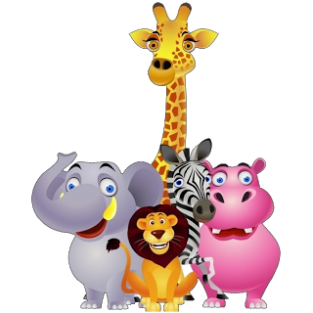

Understanding the World.
Looks closely at similarities, differences, patterns and change.
Shows interest in different occuptions and ways of life.
Shows care ad concern for living things and the enironments.
Can talk about some of the things that they hae obserwd such as plants, animals, natural and found objects.
Recognise and describes specil times or events for family or friends.
Personal, Social and Emotional.
Aware of own feelings and knows that some actions and words can hurt others’ feelings.
Can usually adapt behaviour to different events, social situations and other changes in routine.
Can select and use activities and resource with help.
Confident to speak to others about own needs, wants, interests and opinions.
Explains own knowledge and understanding and ask appropriate questions.
Aware of boundaries set, and of behavioural expectations in the setting.

Expressive Arts and Design.
Think back to the story of Mog and the Vet.
Ipad story of Mog and the Vet.
Bee-bops.
Beginning to move rhythmically.
Initiates movement in response to music.
Experiments to create different textures.
Explores how colours can be changed.

Communication, Language and Literacy.
Read the story of Mog and the Vet.
Look at books independently, holding them correctly and turning over the pages one at a time.
Initiates conversation, attends to take account of what others are saying.
Listen to stories with increasing attention and recall.
Beginning to understand ‘why’ and ‘how’ questions.
Listens to stories with increasing control attention and recall.
Re-tell the story of the tiger that came to tea.

Physical Development.
Develop large movement – climbing, balancing on equipment, large construction, bikes.
Develop fine motor kills – threading peg boards. and Disco dough.
Develop the use of tools – scissors, play dough equipment.
Ball skills – throwing, rolling, catching and kicking.
Dance moving like a cat.
Yoga.
P.E. with reception class.

Mathematics.
Using shapes for purpose.
Beginning to use mathematical names for ‘solid’ 3d shapes and ‘flat’ 2d shapes, and mathematical terms to describe shape.
Select a particular name shape.
Begin to use language of size.
Matching numbers with amount of animals.
Recognise numerals 1-20.
Realises not only object, but anything can be counted including steps, claps and jumps.
Can describe their relative position such as ‘behind or

‘

