Fine motor development- handwriting, daily tasks

Gross motor skills- ball skills, tennis, athletics

Control and coordination

Dressing independently

Handling tools and equipment safely

Understanding the importance of keeping healthy

Reading and writing simple and more complex sentences

Exploring different kinds of writing

Book reports, lists, stories

Information writing

Phonics and handwriting

Learning key words

Understanding story structure

Retelling stories

Painting and printing

Using imagination- role play, buildinh and making

Joan Miro- Spanish Artist

Clay models

Stone minibeasts

Paper crafts

Sewing, weaving

Addition and subtraction

Number bonds to 10

Understanding number- odd and even, counting in2’s, 5’s and 10’s

Place value

2D and 3D shape names and properties

Understanding money, recognising coins

Measure ordering according to size, weight, height and length

**Mathematics**

**Early Years Foundation Stage**

**Curriculum Plan**

**Summer 3.1 and 3.2**

**All creatures great and small**

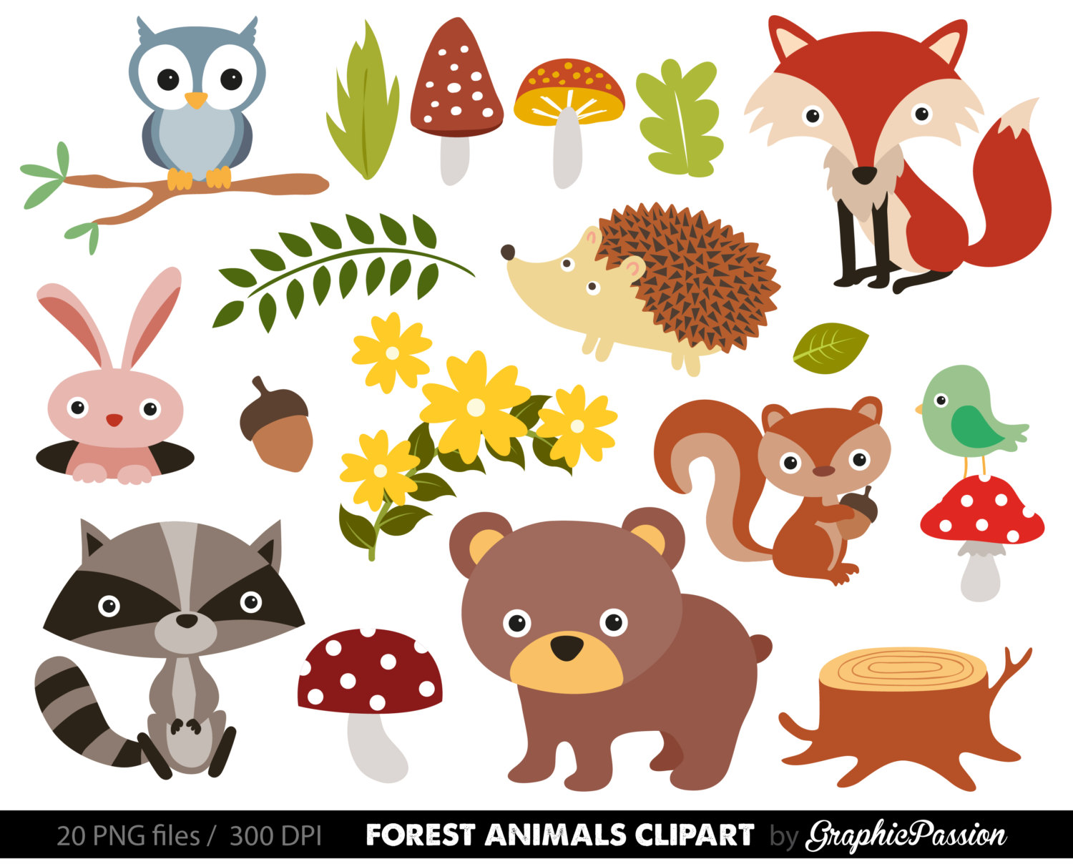

**Physical Development**

Listening to stories and retelling stories

Phonics

Mark making

Develop listening and attention skills

Talk partners

Individual reading

Role play- making up own stories

Being part of a group and community

Feeling of belonging to a whole school environment

To know who cares at school and who we can talk to

To know school rules

Changing classes

**Reading and Writing**

**Understanding the World**

Animals and their babies

Owls- types of owls

Nocturnal animals

Animal habitats

Animal produce

Life cycles

Minibeast homes

Minibeast identification

Minibeast factfiles

**Communication, Language and Literacy**

**Personal, Social and Emotional Development**

|  |
| --- |
|  |

**Expressive Arts and Design**