Reading and writing simple sentences

Exploring different kinds of writing

Book reports

Lists

Stories

Information writing

Phonics and handwriting

Learning key words

Understanding story structure

Retelling stories

Disco Dough

Fine motor development- handwriting, daily tasks

Gross motor skills- ball skills in PE

Control and coordination

Dressing independently

Handling tools and equipment safely

Understanding the importance of keeping healthy

Painting

D&T- make Walkie Talkies

Role play- Police station, Vets, Teachers

Weaving

Designing

Collage

Portraits

Using imagination

Cutting skills

Drawing simple pictures

Addition and subtraction

Numbers to 10

Number bonds to 5

Place value

2D and 3D shape names and properties

Understanding money, recognising coins

**Mathematics**

**Early Years Foundation Stage**

**Curriculum Plan**

**Spring 2.1 and 2.2**

**People who help us**

[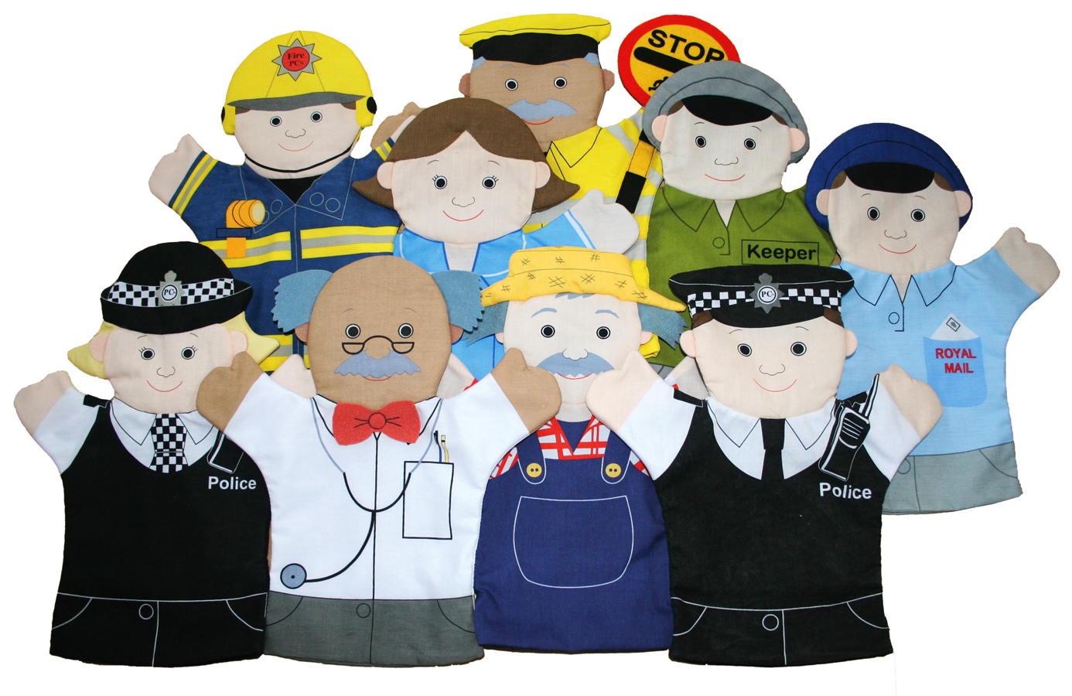](https://www.google.co.uk/url?sa=i&rct=j&q=&esrc=s&source=images&cd=&cad=rja&uact=8&ved=2ahUKEwjZ-LWZ_sHaAhVhDsAKHSi9BOYQjRx6BAgAEAU&url=https://www.spottygreenfrog.co.uk/People-Who-Help-Us-Glove-Puppet-Set/p-161-1404-793/&psig=AOvVaw0gRe2uUWYsVDsSzNoUq8mv&ust=1524077746530661)

**Physical Development**

Listening to stories and retelling stories

Phonics

Mark making

Develop listening and attention skills

Talk partners

Guided Reading & individual reading

Being kind and helpful

Stories from the Bible

Keeping safe- knowing right from wrong

Understanding differences

Being a good friend- friendship tree

**Reading and Writing**

**Understanding the World**

Jobs people do

When I grow up…

People and communities

Stages of growing up

Keeping Healthy

Science investigations

Investigating fire

Afternoon tea with grandparents

Using a programmable toy

**Communication, Language and Literacy**

**Personal, Social and Emotional Development**

|  |
| --- |
|  |

**Expressive Arts and Design**