Year 1 Common Exception Words Activity Grid
Spend 15 to 20 minutes a day.

Write 3 sentences using a different common exception word. | Say it  Spell it  Write it | Pick 5 words to write in your best handwriting.  Could you put them into a sentence? | How many common exception words can you write in 30 seconds?
Circle the word are in these sentences.  We are happy.  The horses are big  Are you going to play? | How many common exception words can you write in 60 seconds? | 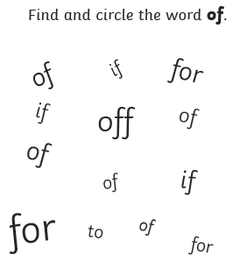 | How many common exception words can you read in 30 seconds?
Fill in the blanks to make the word school.  Sch_ _l  S_ _ool  _choo_ | How many common exception words can you read in 30 seconds? | Write 3 different sentences using the same common  exception word. | Say it  Spell it  Write it
How many common exception words can you write in 30 seconds? | 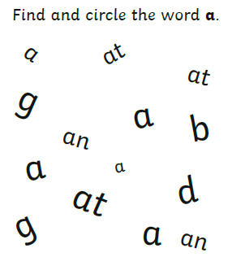 | Circle the word today in these sentences.  Today is a good day.  What day is it today?  We went there today. | Fill in the blanks to make the word there.  Th_r_  The_ _  _h_re

