Buckminster Primary School PTFA
Spring Update
As lots of new families have joined Buckminster Primary recently we wanted to remind everyone that the PTFA (Parent, Teacher & Friends Association) is always looking for more volunteers to help with events, organisation and ideas. Even if you can’t make every meeting or event, there are lots of other ways you can be involved.

Outdoor Learning!
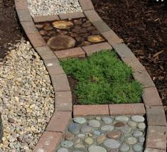
This year the PTFA have a new exciting project! We will be focusing our efforts and fundraising towards building a new Outdoor Classroom in the Spinney area behind school (next to the farm).
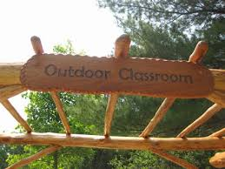
This is such a great project to be supporting. It links in with the school’s plans to have more active learning across the curriculum and improve wellbeing. We believe it will help to enrich the learning of ALL children at Buckminster.
We have already started planning activities for the rest of the school year and will let you know more details nearer the time. We are trying to spread events through the year and include smaller activities as well as the summer fete to ensure we aren’t constantly asking for donations and also so everyone can be involved – as much or as little as they choose. Every little bit will make a difference.
If you have any experience with outdoor classrooms, forest schools, building sheds, landscape gardening or anything else you think could help us to complete this project or any ideas to raise more funds we would love to talk to you. Either talk to one of us in the playground, ask Mrs Clarke or email us buckminsterptfa@gmail.com

Charity Status
The PTFA are currently involved in applying for charity status which will hopefully provide more opportunities to benefit from corporate gifting and grants. We will update you once it is completed and let you know how you can help raise more money just by shopping!

Why be involved in the PTFA?
- Connect with other parents
- Find out about important news and events happening in school
- Have a voice in the activities and events the PTFA supports – (we are always looking for new ideas)
- Learn more about how the children and staff at Buckminster Primary benefit from all the fund raising done by the PTFA
- Make a difference in the school community

And if you can’t make the meetings?
We realise lots of parents work during the week and so if you can’t make the meetings but still want more information or to be more involved contact the office for more details or email buckminsterptfa@gmail.com

