**Buckminster Pre School Prospectus**

**Foundation 1 and 2 Unit**

**2017-2018**



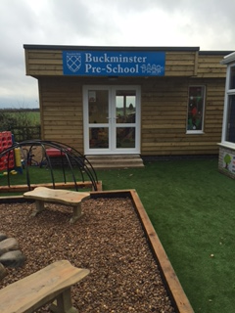

**Our Pre-School aims to**

*        Provide high quality care and education for children 3 -4 years old

*        Work in partnership with parents to help children to learn and develop

*        Add to the life and well-being of the local community

*        Offer children and their parents a service that promotes equality and values diversity

**We offer your child**

*        A secure, safe and stimulating environment in which to develop their full potential.

*        Individual care and attention.

*        Fun and friendship with children and practitioners.

*        Opportunities for you and your family to be directly involved in the group and in your child’s progress.

**Opening Times**

We are open for 38 weeks each year, in line with Leicestershire Council school term times.

Our opening hours are:

|  |  |  |  |  |  |
| --- | --- | --- | --- | --- | --- |
| **Monday to Friday** | | | | | |
| **07.40 – 09.00**  **Breakfast club. Max of 8 children** | **09.00 – 12.00** | **12.00 – 13.00** | **13.00 – 15.30** | **15.30 – 16.30**  **After school club. Max of 8 children** | **Extended to 17.30**  **After school club. Max of 8 children** |

**Please provide a healthy packed lunch and drink – please do not bring in any items containing nuts or peanuts.**

**Our early year’s practitioners:**

We are proud of our high ratio of adults to children in our group.  This helps us to:

*        Give time and attention to each child;

*        Talk with the children about their interests and activities;

*        Help children to experience and benefit from the activities we provide;

*        Allow the children to explore and be adventurous in safety.

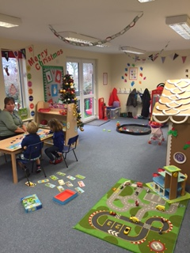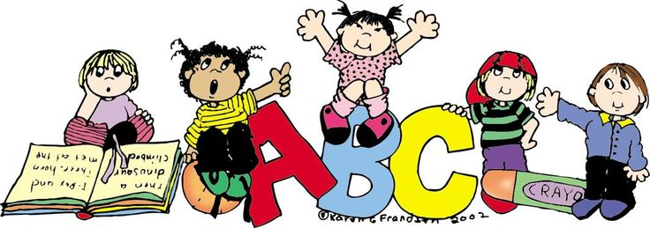

**Our staff:**

|  |  |  |  |  |  |  |  |  |  |  |  |  |  |  |
| --- | --- | --- | --- | --- | --- | --- | --- | --- | --- | --- | --- | --- | --- | --- |
| |  |  |  |  | | --- | --- | --- | --- | | Mrs Debbie Clarke | Head Teacher |  |  | | Mrs Becky Longley  Mrs Hannah Jackson | Assistant Head Teacher of the school  Teacher | Qualified teacher and Early Years practitioner  Qualified teacher |  | | Mrs Carole Floyd | Early Years practitioner | NVQ Level 6 in Early Years |  | |  |  |

Our staff members are first aid and child protection trained.  They are committed to continual development and they regularly attend courses, to ensure that we offer our children the best care and education.



**Parents**

Parents are regarded as members of our Pre-School who have full participatory rights.

These include a right to be:

*        Valued and respected;

*        Kept informed;

*        Consulted;

*        Involved.

**How parents can take part in the Pre-School**

Our Pre-School recognises parents as the first and most important educators of their children.  All staff see themselves as partners with parents in providing care and education for their child.  There are many ways in which parents can take part in making the Pre-School a stimulating place for children, such as:

*   Exchanging knowledge about their child’s needs, activities, interests and progress with the staff;

*   Helping at sessions;

*   Sharing their own special interests with the children;

*   Being part of the School’s PTFA

*   Taking part in events;

*   Joining in community activities in which the Pre-School takes part.

**Management of the Pre-School**

The Pre-School is run by the Head Teacher of the school and overseen by the Governing Body, which ensures that major decisions are made.

**Starting at the Pre-School**

**First Few Days:**

A child who is tense or unhappy will not be able to enjoy Pre-School life, so it is important for parents and staff to work together to help the child feel confident and secure in the group.  This takes longer for some children than others and parents should not feel worried if their child takes a while to settle, they are welcome to stay with their child for as long as necessary.

**Uniform**

Pre-School’s uniform enables the children to enjoy messy play without the fear of ruining their ‘special’ clothes.  It offers the children a sense of identity and belonging.

Pre-School’s uniform is made up of:

*        Indoor shoes – plimsolls or shoes (different to outdoor shoes)

*        Outdoor shoes – wellington boots (winter), trainers or hard soled shoes (summer)

*        Sweatshirt and polo shirt (blue with Pre-School logo) – these can be purchased through the school.

Please also provide:

*        Coats

*        A bag with a complete set of spare clothes

*        Sun Hat and Sun Cream when appropriate

**NOTE:  ALL ITEMS OF CLOTHING MUST BE NAMED**



**The session**

The Pre-School children will be part of the Foundation Unit and will mix with the Reception children throughout the day. We organise our sessions so that children can choose from, and work at, a range of activities and, in doing so, build up their ability to select and work through a task to its completion.  The children are also helped and encouraged to take part in adult-led small and large group activities which introduce them to new experiences and help them to gain new skills, as well as helping them to learn to work with others.  Outdoor activities contribute to children’s health, their physical development and their knowledge of the world around them.  The children have the opportunity, and are encouraged, to take part in outdoor child initiated and adult led activities, as well as those provided inside the Pre-School.  We give children the choice to free flow between inside and outside throughout the session.

**Snack Time**

Each morning we have a ‘rolling snack’ where children can come and have a snack with their friends.  We ask one or two children to help the staff cut the fruit and prepare the table, and together we count out the plates, cups and number of children coming to snack.  We provide milk or water to drink at snack time, as well as fruit or vegetables.  The cost of the fruit will be included in the price of the session.

**Children’s development and learning**

The provision for children’s development and learning is guided by The Early Years Foundation Stage Statuary Framework 2014

Educational programmes must involve activities and experiences for children, as follows.

• **Communication and language** development involves giving children opportunities to experience a rich language environment; to develop their confidence and skills in expressing themselves; and to speak and listen in a range of situations.

• **Physical development** involves providing opportunities for young children to be active and interactive; and to develop their co-ordination, control, and movement. Children must also be helped to understand the importance of physical activity, and to make healthy choices in relation to food.

• **Personal, social and emotional development** involves helping children to develop a positive sense of themselves, and others; to form positive relationships and develop respect for others; to develop social skills and learn how to manage their feelings; to understand appropriate behaviour in groups; and to have confidence in their own abilities.

* **Literacy** development involves encouraging children to link sounds and letters and to begin to read and write. Children must be given access to a wide range of reading materials (books, poems, and other written materials) to ignite their interest.
* **Mathematics** involves providing children with opportunities to develop and improve their skills in counting, understanding and using numbers, calculating simple addition and subtraction problems; and to describe shapes, spaces, and measures.
* **Understanding the world** involves guiding children to make sense of their physical world and their community through opportunities to explore, observe and find out about people, places, technology and the environment.
* **Expressive arts and design** involves enabling children to explore and play with a wide range of media and materials, as well as providing opportunities and encouragement for sharing their thoughts, ideas and feelings through a variety of activities in art, music, movement, dance, role-play, and design and technology.

**The aims of our curriculum are:**

*        To provide quality learning experiences for all children. These will be flexible, adaptable, balanced and relevant to the individual child.

*        To ensure that each child has positive experiences at his/her own level in order to promote confidence and self-motivation for learning in the future.

*        To provide a curriculum that takes account of, and responds to, the children’s developmental needs, allowing them to progress according to their differing abilities.

*        To provide a curriculum which promotes the Early Years Foundation Stage principles identified within the framework.

*        To create a partnership with families, recognising the importance that families play in the education of their child.  Pre-School staff support families as educators.

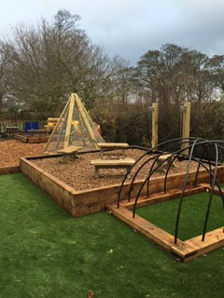

**Record Keeping**

The Pre-School keeps a record of achievement for each child.  These are called their Learning Journeys.  It enables Pre-School to celebrate achievements, and plan for progress. The record will be made up of observations, assessments, pieces of the child’s work and photographic evidence.

**Policies**

All our policies and procedures are designed to offer the best possible experience for the children and families in the group. Our policies and procedures are reviewed on a regular basis. A copy of our policies and procedures is also available on our website.

**Special Needs**

As part of the Pre-School’s policy to make sure that its provision meets the need of each individual child, we take account of any special needs a child may have.  The Pre-School works to the requirements of the 1992 Education Act and The Special Educational Needs Code of Practice (2014).

We are experienced in working in close liaison with professionals across the range of special needs. If you would like to discuss the group’s ability to meet your own child’s needs, please talk to the Head Teacher.

**Community Links**

The Pre-School endeavours to maintain close links with the local community.

**Fees**

Fees are payable half-termly, in advance.  Fees continue to be payable if a child is absent without prior notice or for a short time.  In cases of prolonged absence, families should contact the Head Teacher.  Your child’s attendance at the Pre-School is conditional upon continued payment of any necessary fees and/or Government Funding.

Once children are eligible for the government funding (the term after their third birthday), parents choosing to use the grant elsewhere will be charged the equivalent value for their child’s Pre-School session.

Should you have any queries regarding fees/payment please contact our Finance manager at [F.Hart@buckminster.leics.sch.uk](mailto:F.Hart@buckminster.leics.sch.uk)

**Fees**

**£4.00 an hour for school hours (9.00 – 3.30) £4.00 for the entire breakfast club (7.40 – 9.00) £3.50 an hour for after school club (3.30 – 4.30/5.30)**

**Procedure for Payment:**

You will receive an invoice for fees at the beginning of each half term.  Payment must be made within 7 days from date of invoice.  Payment can be made via the school’s online system details of which will be available at the time of starting.

**Absence and Holidays:**

Please notify the School of any planned holidays. If your child is absent from Pre-School, your fees will still need to be paid, as you may appreciate the running costs remain the same.

**Medicine and Illness**

With regard to illness, please consider keeping your child at home if they are feeling unwell.  Families are asked not to bring their child to Pre-School, if they have been vomiting or have had diarrhea, until 48 hours have elapsed since the last attack.

**Notice Period**

If your child is no longer to attend Pre-School we require 4 weeks written notice.

If you fail to give notice you will be charged for fees for four weeks.

Written notice is not required if your child is leaving Pre-School to attend school.



Booking form *Please highlight sessions you require*

|  |  |  |  |  |  |  |
| --- | --- | --- | --- | --- | --- | --- |
| Week beginning  24th October | Breakfast Club 7.40am – 9.00am  £4.00 in total | 9.00am – 12.00am  £12.00 in total | 12.00noon - 1.00pm  £4.00 in total | 1.00pm – 3.30pm  £10.00 in total | After School Club | |
| 3.30pm 4.30pm  £3.50 | 4.30pm 5.30pm  £3.50 |
| Monday |  |  |  |  |  | |
| Tuesday |  |  |  |  |  | |
| Wednesday |  |  |  |  |  | |
| Thursday |  |  |  |  |  | |
| Friday |  |  |  |  |  | |