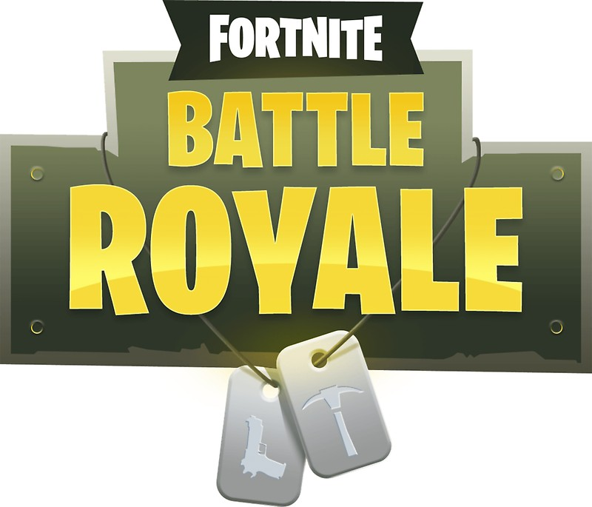
Parents guide to Fortnite: Battle Royale

Recently we have noticed an increasing number of young people talking about the game ‘Fortnite’. We are giving guidance to parents about Fortnite, looking at what the game is and some of the things to be aware of.

What is Fortnite?
Fortnight is an online game, which includes Battle Royale, where players do not have to pay to play. In Battle Royale, 100 players compete against each other to be the last person standing in player vs player (PVP) combat.

Users play against people of different ages from across the world, and can talk and interact with each other as they play through the in-game chat feature.

What age rating is Fortnite?
Fortnite has an age rating of 12. This game has mild violence and children under the age of 12 should not play this game.

What do I need to know?
You need to create an account
In order to play Fortnite you have to create an account. To create this account you need to provide an email address (which you will have to verify) and display/user name. However you are not asked your age in order to create an account.

You are playing against other players
As Fortnite is an online game you will play against players of different ages from across the world. You cannot turn the in game chats off or choose who you play against.

You can make in game purchases
Although Battle Royale is free to play, other aspects of the game are not. There are packs which give you different access to the full game and extensions, bonuses and weapons. These start at £34.99 and go up to £119.99. The game does ask players to make additional in-game purchases whilst playing, though these are not required to play the game.

There is animated violence
Fortnite does feature violence when players are in combat with each other, the animation of the game is very cartoonish, and the violence isn't bloody or gory. However, it is worth noting that the aim of Fortnite is to defeat other players by fighting against them.

Where you can play
Fortnite is currently available on PC, Mac, PlayStation and XBox , and will soon be available on IOS (apple products). It is downloadable from the Fortnite website, this download gives access to both the free and paid for versions of the game.

Our advice
- Have an open and honest conversation with your child
It’s important to involve yourself in your child’s online life and a simple and effective way to this is by talking to them about their life online. Try to maintain an open dialogue with your child and find opportunities to talk to them about what they love to do online. Parents can help children access the amazing resources the internet has to offer whilst keeping them safe online at the same time.
Asking your child about how they play Fortnite and what they like about it is a great way to start a conversation

- Play with them
It may seem daunting, but one of the best things that you can do is to engage with the gaming environment and begin to understand what makes Fortnite so attractive to young people, as well as giving yourself an idea of the reporting tools available within the game.

- Know how to make a report
On Fortnite you can report players who are behaving inappropriately by using the in-game feedback tool located in the game Main Menu, you can also make a report by emailing the creators of Fortnite.

- See what other people think of Fortnite
Common Sense Media allow parents and young people to give their reviews of games that they have played. They have created a very useful video guide to Fortnite with footage of the gameplay involved.

