Initiative / Services | Description | Impact
Inspire+ Ambassadors
Sam Ruddock | Sam visited all Inspire+ Primary Schools, giving a detailed insight into his preparations for the Rio Paralympics. Sam was able to link his examples of training and preparations to those that the children should think of for tests and their own sports competitions.  At the end of each assembly Sam signed a contract along with the school’s Bronze Young Ambassadors with the contract stating that he would do everything possible to give him the best opportunity to success in Rio 2016 and in return for the school to pledge to be more physically active and lead healthier lifestyles. | - 40 Inspire+ Primary Schools were visited. This resulted in around 8,000 young people being engaged and inspired.  “The assembly was absolutely brilliant. Everyone was really buzzing, both staff and children. The children were soooo excited, they were whispering in the hall ‘he’s here…I just saw him’ some of their faces were brilliant, talk about awe and wonder! Staff were very complimentary. Thank you.” | 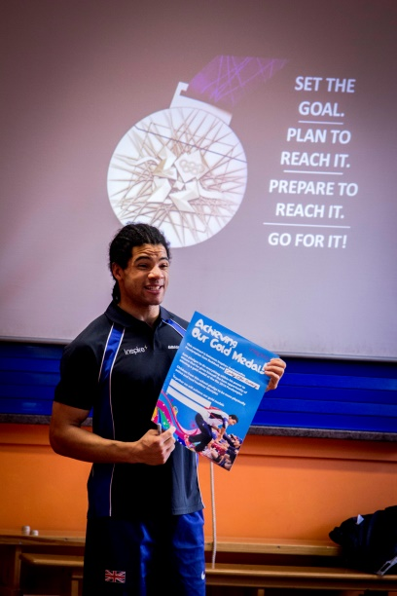
Sarah Outen MBE | Following Sarah’s live satellite calls to our schools during her London2London via the World adventure, Inspire+ took a coach of 56 primary school pupils & staff down to Tower Bridge London to welcome Sarah back as she finished her journey and to present her with the signed rowing oar from all our schools with messages of congratulation from each school.  “The schools engagement through Inspire+ has been one of the greatest prides with my London2London:Via the World journey. Out in the tent in the North American winter or through storms on the ocean, the support and contact with schools was motivating and inspiring for me - I gained a lot of good energy from those calls and video links. It is wonderful to be touring the schools in the Inspire+ partnership now and sharing tales from the expedition, encouraging youngsters to dream big, take risks and persevere. I am really proud of my Ambassador role for Inspire+.” Sarah Outen. | - 56 primary school children from Grantham & Stamford taken to London for the day. They welcomed Sarah home, met her & had a trip around the London Bridge experience. 6 of the children also got to attend Sarah’s VIP reception in HMS President.  - Sarah visited & gave her assembly to 40 Inspire+ Primary Schools and 2 Secondary schools followed by 2 evening presentations for a more in depth insight into the London2London adventure.  “On Wednesday the 24th of February 2016 the excitement was mounting as the children of Allington with Sedgebrook Primary waited the arrival of the amazing explorer Sarah Outen. She was spotted before even reaching the building by eager children chanting her name from the playground. Sarah’s assembly was nothing short of inspirational. Children from 4 to 11 sat, transfixed, as they listened to her adventures and watched clips showing the highs and lows of her brave and exciting journey across the world. We have kept track of Sarah’s progress constantly but seeing her in the flesh brought her achievements to life. Sarah has inspired our children in many ways but perhaps the most poignant thing she said was demonstrated clearly by one of our younger children at Gym Club that same day. ‘I’m nervous about the competition coming up but as Sarah said it’s ok… you can still do it’. Sarah had a fantastic, sunny way of presenting and our children loved the experience. Thank you to Sarah and the brilliant team at Inspire +.” Leanne Barr, Head Teacher. | 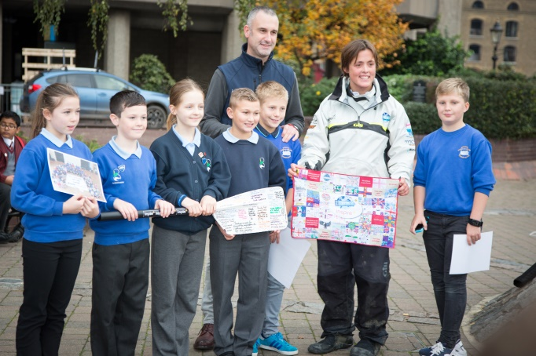  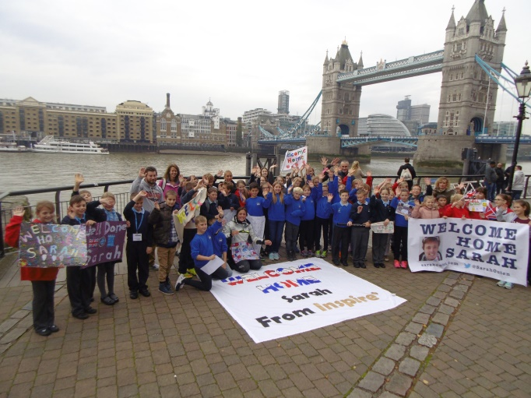
Ben Smith | On the 1st September 2015 Ben began one of the most challenging and rewarding experiences of his life. Ben is undertaking the attempt which will see him run 401 marathons in 401 consecutive days around 309 different locations of the UK mainland.  The challenge is aiming to raise both awareness of the issues of bullying in our society along with £250,000 for two amazing charities dedicated to tackling bullying. The two charities are called ‘Stonewall’ and ‘Kidscape’. Both these charities work tirelessly to support award winning initiatives which really get to the heart of bullying in our UK schools and society in all its forms. The £250,000 raised through generous donations from UK business’ and the public will help support both these charities carry on the amazing work they do.  www.the401challenge.co.uk | Ben held 2 of his marathons around our schools:  - 13th April – 4 Stamford schools  - 4th May – 20 Grantham schools  At each school Ben did a lap of the playground with the school’s Bronze Young Ambassadors while the rest of the school provided a guard of honour for him.  Members of local athletics clubs ran with Ben on the day plus the addition on the Grantham route of our CEO Vincent running his first full marathon!  From the 2 days, schools fundraised for Ben’s charities through non-uniform and selling 401 challenge wristbands. From the Inspire+ schools we raised £2102.16 for Ben. | 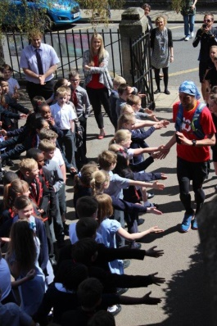  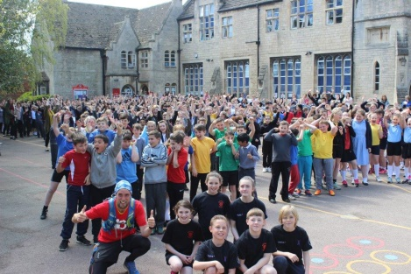
Legacy Tour
Inspire+ Legacy Tour 2015/16 | This year’s Legacy Tour was based around the Rio 2016 Olympic and Paralympics Games.  All member schools and all schools in South Kesteven were offered the opportunity to be part of the Inspire+ Legacy Tour.  With there being a number of new sports at Rio 2016, every school got use of Tri-Golf equipment (one of the new sports) for the day along with support of a golf coach. This tour was sponsored by South Kesteven District Council. | As part of the tour we ran a competition for children to design a Legacy Tour Torch, we received around 150 designs which were then all looked at by Inspire+ staff and our Young Ambassador Steering Group to choose a winner. The winning design was then made into a 3D torch.  A total of 43 schools received the Legacy Tour, that’s approximately 8500 young people engaged!  "Once again it was a privilege to be involved in the Legacy Tour. Our Bronze Ambassadors found it valuable to be involved in the assemblies and torch hand-overs. Leading the tri-golf activity was also a fun experience for them and helped them become confident leaders working with children of all ages." Jon Clack, Great Ponton Head teacher. | 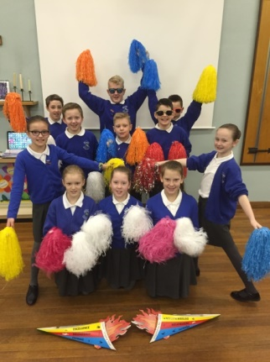  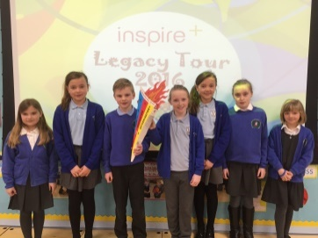
Leadership
Young Ambassadors (YAs) | After the hugely successful introduction of Bronze YAs in recent years Inspire+ & Platinum YAs facilitated training events designed to inspire Bronze YAs.  Bronze YAs were responsible for supporting the London 2012 legacy aspirations of ‘Inspiring a new generation’ through our bespoke Legacy Challenge resource. This initiative supported whole school outcomes.  This programme is aimed at pupils in years 5&6. | We have seen an increase in the number of Young Ambassadors at all levels within our area. We have trained 100 Bronze Young Ambassadors which have then gone on to help lead on programmes such as the Legacy Challenge, Legacy Tour and the Mini Olympics.  The senior Young Ambassadors have also been busy helping out by organising the Legacy Tour, Mini Olympics and other events throughout the year. | 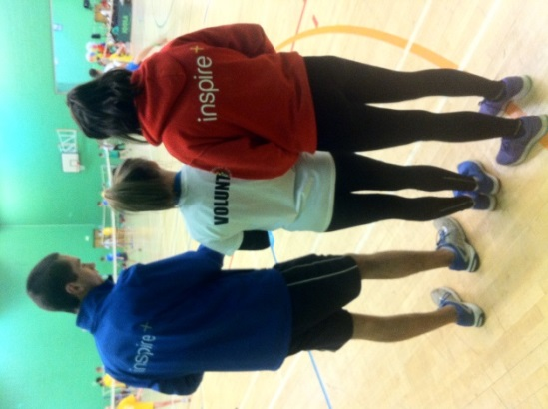
Playground Leaders | The charity changed the way it delivered the training by taking it to schools. | 15 schools accessed training on their school site. As a result over 100 pupils were enabled to support their peers be more physically active. | 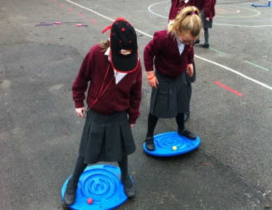
Developing School Staff
PE & Sport Conference | The Inspire+ organised conference provided the platform for teachers to develop PE, Sport and Leadership provision.  Workshops were run by national and local facilitators. Inspire+ Ambassador and Paralympian Sam Ruddock was our special guest along with Matt Hampson. | Teachers again believed that the conference gave them the opportunity to effectively plan the year ahead to maximise the impact of the Inspire+ services. | 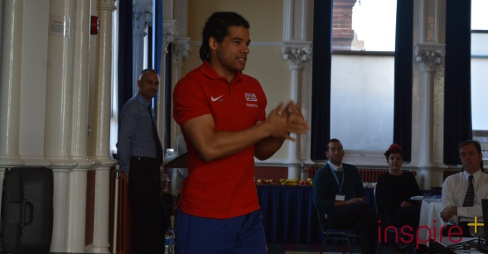
CPD Courses | A comprehensive programme of primary school courses, delivered locally, were coordinated for member schools. Courses were aimed at supporting all school staff deliver high quality PE and Sport.  Implementation of real PE was the focus this year. | - 44 CPD courses have been facilitated  - A total of 460 staff members applied for places on the courses  - 100% of attendees agreed or strongly agreed that the course equipped them to make an impact on their practice  - Comments from the course evaluations that were mentioned:  "I have really enjoyed this course and found it very informative"  "Start to Move + Eyrs Training together- the two appear to go together"  "Thank you so much for the training! Great pace!” | 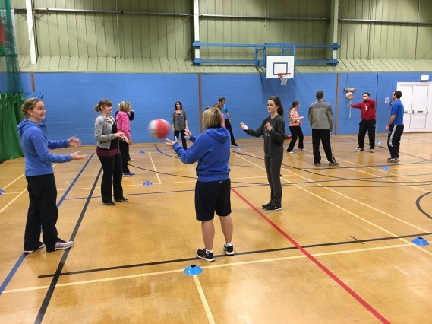
Parent Volunteer Programme | Inspire+ provided an induction event for parents giving them access to basic sports training to enable parents to assist sports clubs at their child’s school. This can also be an opportunity for parents to progress into paid job roles. | - 17 parents from across member schools signed up and attended the induction for the parent volunteer programme. Over half of these have been actively involved in their school, assisting to run clubs, help with trips and attend our CPD courses. | 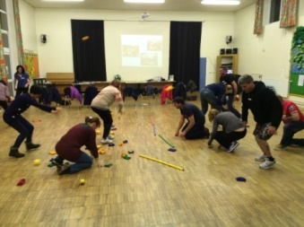
Gifted & Talented
KS1 | A new initiative for Inspire+ in 2015/16 was a gifted & talented programme for KS1 pupils, delivered by our extremely experienced athletics and FUNdamentals coach.  Each course consisted of 6 sessions and parents were invited to stay with their children to view the sessions, assist their children and learn about the importance of FUNdamental movements.  The programme is based around a set of 12 core activities which are designed to test and develop a child’s ability in the following important areas (as well as others): Balance, Control and stability, Leaping and landing, Coordination and rhythm, Single arm throwing, Speed, Foot-Eye coordination, Hand-Eye coordination, Spatial awareness, Two arm throwing, Agility. Sporting values of Teamwork, Respect, Honesty, Pasion, Determination & Self-belief will also be explored and celebrated. | - Two cohorts sets of the programme were held throughout the year. One at Linchfield Primary for our south schools and one at Belton Lane for our schools in the north.  - 20 children took part in the Belton Lane sessions and 18 at the Linchfield sessions.  - All the children showed noticeable improvement and the parents really appreciated understanding the reason and science behind the activities. | 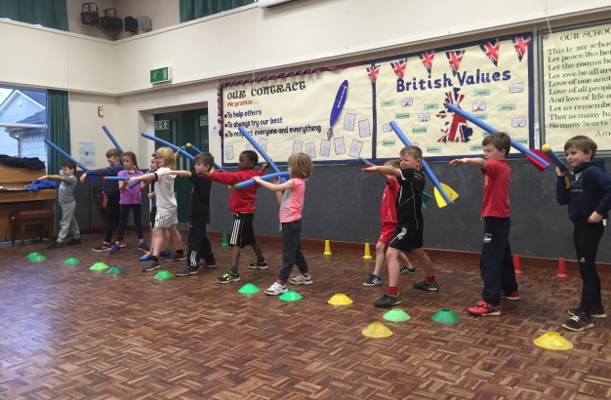  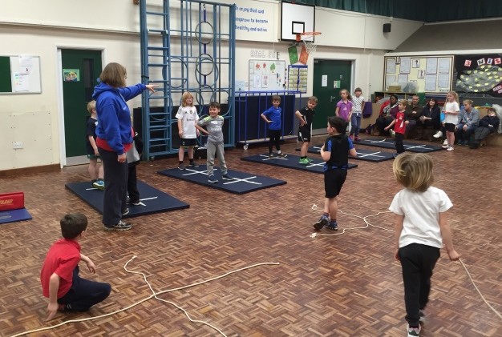
Years 3&4 | Children that were identified by their school as being gifted and talented in sport were able to access termly sessions in Grantham and Stamford.  The 6 sessions focused on:  - Communication  - Team Work  - Diet & nutrition  - Psychology  - Fitness & exercise  - Game play  Sessions were practical with theory built in and tasks to take away and complete between sessions. Parents were able to stay and watch the sessions and hand outs were also provided with the information from the sessions for children to take home with them.  All the sessions were led by Inspire+ Ambassador, Olympic Swimmer Sophie Allen. This was a fantastic opportunity for all the children getting to learn from and hear the experiences of a local Olympian! | - 22 children attended the Stamford area sessions  - 41 children attended the 2 Grantham sessions.  “I would like to say a huge thank you to you on behalf of Stanley. He has enjoyed the experience immensely and what an amazing opportunity you have given him. He continues to love all sports and once again we cannot thank you enough for giving him a glimpse into the wider side of what a sporting career entails.” | 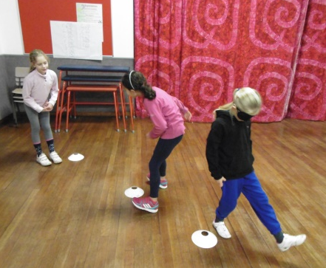  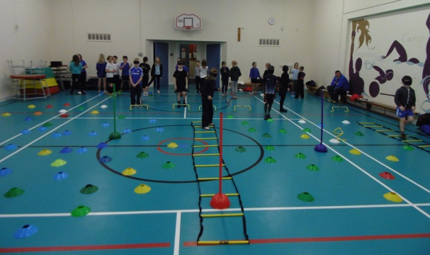
Years 5, 6 & 7 | This programme was run in partnership with the University of Lincoln. The programme consisted of three trips to the University throughout the year with tasks being set for the children to complete between the visits.  The sessions included:  - Psychology  - Biomechanics  - Strength & conditioning  - Adaptive game play  - Diet & nutrition  - Fitness testing  Children accessed the University’s high quality equipment and facilities. This gave them an early insight into Universities and to meet University students and lecturers. | - 53 children from years 5, 6 & 7 at Inspire+ Primary and Secondary schools attended the sessions.  - 53% of the children strongly agreed that they had learnt something new from the training.  - 31% of the children were confident they have continued using techniques learnt from the University to aid their own sporting development.  - 73% of the children agreed their sporting performances have improved thanks to the impact of the University’s workshops. | 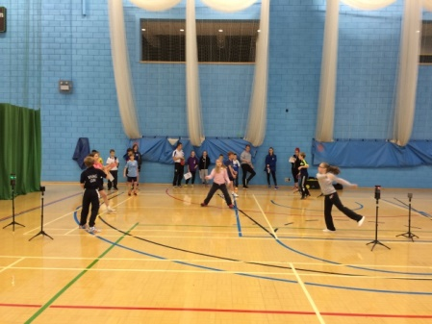  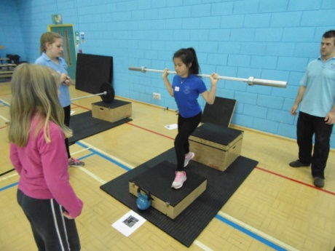
Gifted and Talented Grant Scheme | Inspire+ supported pupils identified by the school as Gifted and Talented, if kit, transport, or club membership fees were a barrier to reach their potential. | During the year, 4 schools submitted 8 successful applications.  The total amount awarded was £1020. | 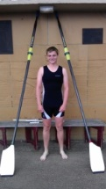
Swimming support
TOP Swimming | This initiative funds 50% of an additional qualified school Swim teacher to work with non-swimmers to ensure children meet the KS2 requirement. | Schools continue to access this programme that is proven to support the development of targeted pupils.  7 staff attended the swimming qualification course.  This has helped to ensure the highest quality teaching on poolside.
Teacher swim qualification | ASA swimming teachers courses were organised to support the development of staff that teach on poolside.
Transport
Mini Bus | Inspire+ secured access to a mini-bus to ensure pupils can access sports fixtures/events. | 1 school accessed this support.
Funding
Workshops / Advice in writing & preparing applications | Inspire+ are supporting schools with the application process. Applications can be submitted by the school or constituted parents groups/associations linked to the school. | Seven schools have secured approximately £70,000 funding to date to improve their facilities. Projects include trim trails, a community library, astro turf, a tree house and play equipment.  Further applications have been submitted and are awaiting decisions. | 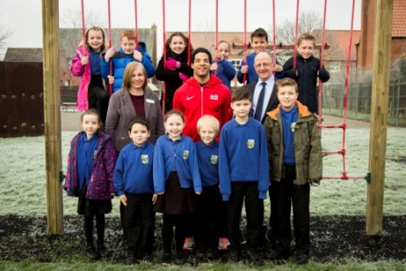
Community Sporting Opportunities
Olympic Sports Holiday Camps | Holiday sports camps aimed at introducing young people to Olympic and Paralympic Sports. Giving children opportunities to be active during half-term in a structured and fun environment.  Over the 2015/16 academic year Inspire+ ran 30 camp days, held at:  - Belton Lane Primary School, Grantham  - Huntingtower Community Primary Academy, Grantham  - Baston Primary School, Baston  - Linchfield Primary School, Deeping St James  The charity have increased the amount of sports they deliver to include:  - Wheelchair basketball  - Lacrosse  - Tri-golf  - New age curling  - Tchoukball  - Olympic tournaments  Our camps follow Ofsted guidelines and we pride ourselves on the quality we provide for the participants. The camps also give our Young Ambassador and Sports Leadership Academy volunteers the chance to gain valuable experience working with young people in a sports camp environment. This includes group management and assistant coaching. | 30 days of camps over the academic year have been provided in every school holiday with the exception of Christmas. This has resulted in over 1000 places taken.  “I just want to say how fantastic this camp is, my children (William and Lily) absolutely love coming, so you are clearly doing a GREAT job! :) Thank you”  “I just wanted to say thank you for the sports camps provided this half term which have been very professionally run and the staff and helpers are all very friendly and lovely.  As he is 10 it gets harder to find child care for Jack that isn't aimed at younger children or is boring.  He's had a fantastic time every day that he's been and has been tired at the end of it which is a great bonus so you have obviously got it absolutely spot on.  I just wish his school was involved with you as I think they're missing out not being a part of what you do  Many thanks once again and he will be there next half term.” | 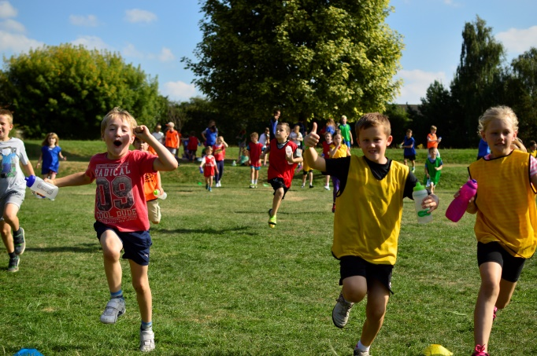  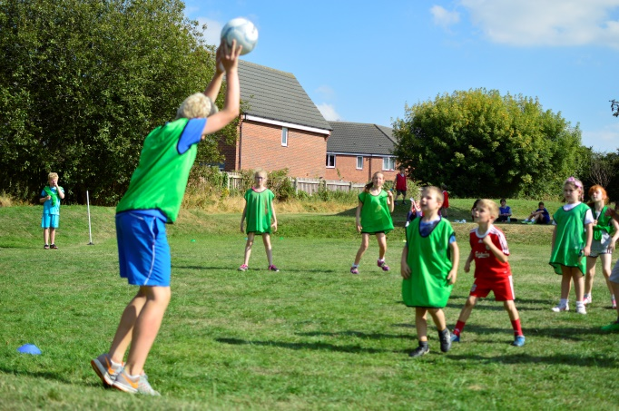
Encouraging pupils to be more physically active and lead healthier lifestyles
Inspire+ Legacy Challenge | Launched in 2012 with the support of Lord Coe, pupils embark on a series of challenges created to realise the London 2012 pledge of ‘inspiring a generation’.  The Legacy Challenge is totally bespoke and designed by the charity to encourage our young people to be inspired towards a lifetime of sport, culture and healthy living.  The Legacy Challenge was used by schools throughout the whole year or as a condensed project.  The Inspire+ Legacy Coordinator supported schools to embed the resource in schools. | - New design of passports that focused on ‘Road to my Games’ that inspired children to follow in the footsteps of GB athletes on their own road to Rio 2016.  - Lincolnshire Sport funded the legacy Challenge to be a free resource available to all primary schools in Lincolnshire.  - Trained over 200 bronze Young Ambassadors to lead and promote healthy lifestyles to their fellow pupils  - 55 Schools engaged throughout the county  - 70 teachers trained to embed the programme within their schools  - 0ver 13,000 pupils engaged in the Legacy Challenge  “Through pupil voice, displays (photos and evidence), the website and the ethos of the school in general, our inspector was very impressed with how the Legacy Challenge and the enthusiasm of the Bronze Ambassadors seemed to be affecting the general atmosphere in the school. As many of our children spoke with such passion about their roles in school, leadership and volunteering and the challenges they set themselves through the Legacy Challenge the inspector ended up asking for a copy of the Legacy Challenge and has made reference to it in our final report.  He could see there was a clear link between the children’s general behaviour and attitude to work and the work we do with them through the Bronze Ambassador training and the Legacy Challenge. The inspection process does now look very closely at SMSC in schools and the Legacy Challenge appears to have ticked a box for them in my school.  Thanks again for this wonderful toolkit and producing something that addresses a large number of SMSC areas through sport, healthy lifestyles and values.”  Mr Clack, Headteacher, Great Ponton Primary School. | 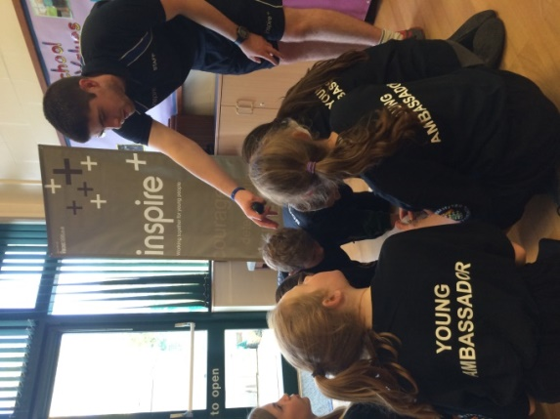  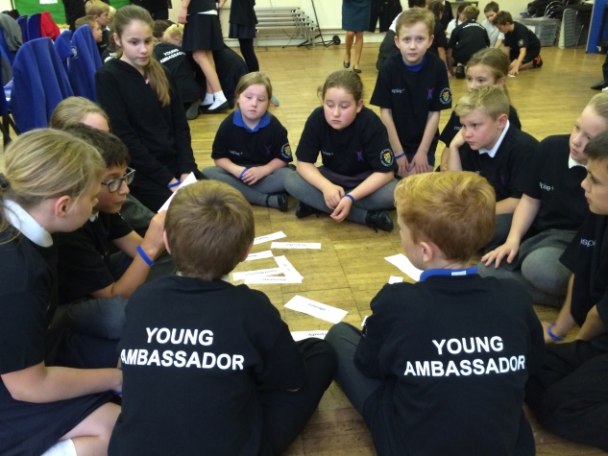  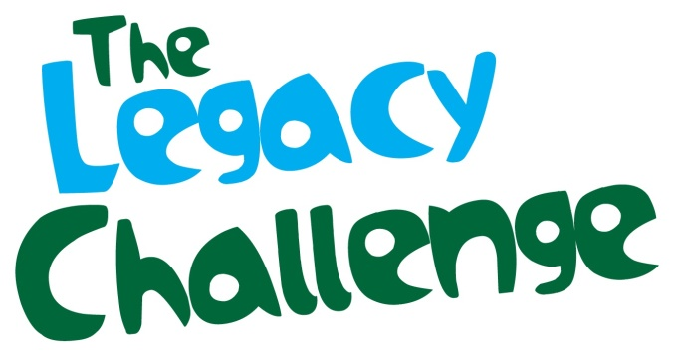
Learning through OAA
PGL Half day access | Schools had the opportunity to take pupils to PGL Caythorpe.  Emphasis was placed around extending PE opportunities (OAA) and giving pupils access to outstanding facilities and instructors. | - 21 member schools accessed PGL Caythorpe for at least half a day. Normally schools would not be able to access PGL for only half a day, this is thanks to their Inspire+ membership.  - As a result, 353 pupils got to visit PGL Caythorpe to experience the great outdoor adventure facilities they have. | 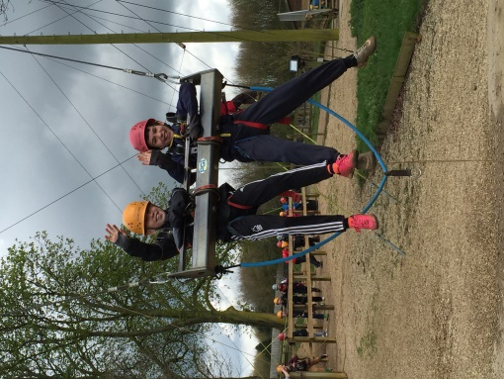
PGL Access Weekend (year 6-7 transition) | Schools had the opportunity to select pupils to attend a special weekend at PGL, staffed by Inspire+.  Schools had the discretion on which pupils they chose, ranging from being a Young Ambassador, attainment, good behaviour, students who have low self-confidence or students who have never experienced outdoor education before, which may have been due to may have been due to financial restrictions.  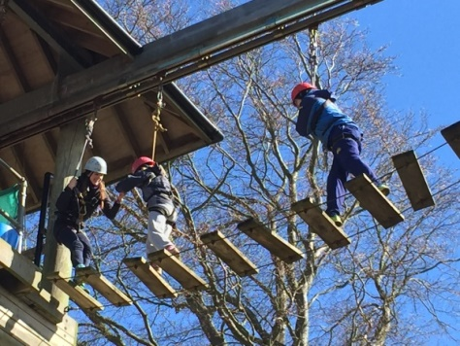  Aimed at pupils in year 6. The weekend also supported transition from primary school to secondary school.  This year saw parents able to buy places if they wished. We also had 12 of our top Leadership Academy members attend to help develop their skills and training. | - 96% children enjoyed the weekend experience  - 80% agreed or strongly agreed that they achieved something positive  - 96% of children made new friends  - 62% indicated that the weekend had helped them meet new friends that they will go to secondary school with in September | 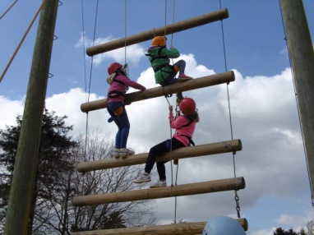
Specialist Coaches
Specialist coaches | Inspire+ help to provide quality coaching at schools through a comprehensive range of sports, to support increased OSHL and support the upskill of teachers delivering PE curriculum. | - A total of 36 Primary Schools and 2 Secondary Schools have accessed the specialist coaching service, normally receiving a minimum of two terms worth of sessions free as part of their Inspire+ membership.  - Schools consistently and regularly request additional coaching services. This year over 100 requests were made.  - Our specialist coaches provide teachers with the knowledge and guidance to improve and upskill their current PE experience.  - School Feedback:  “The sessions have been brilliant, the…group have thoroughly enjoyed them. No matter the weather they have smiled the whole way through.”  "…athletics…was brilliant and really motivating. Thoroughly enjoyed our sessions… so thank you." | 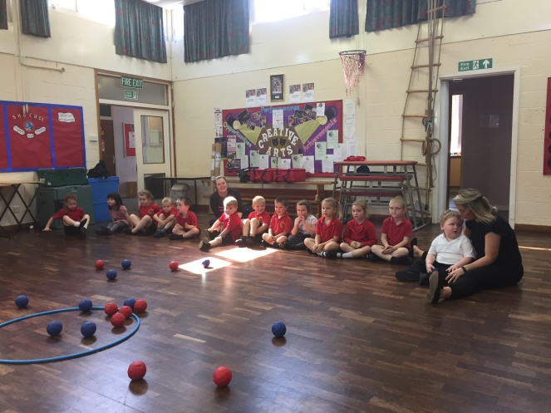
Inspire+ mentor programme | Our mentors provided support and guidance to young people with the aim to help remove barriers to learning in order to support effective participation, enhance individual learning, raise aspirations and achieve full potential.  The mentoring programme is first and foremost for young people who have a genuine interest in sport. Schools identified young people who are not maximising their potential specifically in the following areas:  - Not applying themselves academically  - Gifted and Talented  - Young people with behavioural issues  Our mentors then hope to help address these issues and engage with the young people through sport.  Schools had the option of 3 mentoring session for one term. Or one contact session per term over the academic year and pupils could contact their mentor via email under adult supervision. | - 20 Inspire+ schools accessed the mentoring programme.  - 64 primary school pupils engaged.  “Just wanted to send you a quick email to say a big thank you to inspire plus.  As you know Harvey has always been a shy and timed boy and if someone would have said to me last year that Harvey would do a dance with pom poms in front of his school, and also talk in an assembly in front of a different school, I would have never believed them.  Inspire plus has given Harvey the opportunity to grow in confidence with all the activities you provide. Harvey said the mentoring programme he is doing with Sophie really helped when he starts to feel nervous and that just shows with what he has completed over the last couple of days.  Big thank you again” | 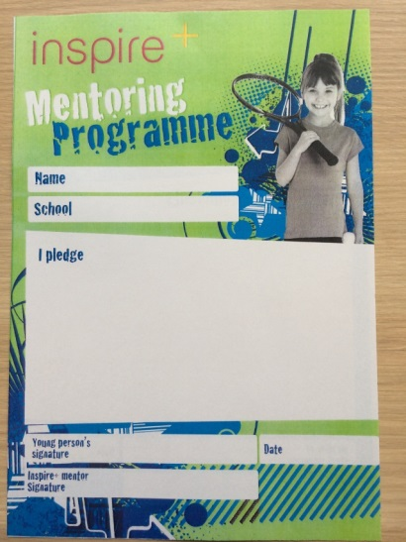
PE Development-Disability Awareness
Wheelchair Sports | Working alongside Lincolnshire Sport, schools can access wheelchairs and training that can be utilised in PE and OSHL setting. | Two schools accessed the wheelchairs this year. This supported the breadth and diversity that these children experienced in the curriculum. | 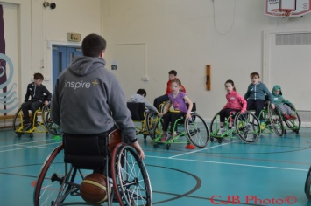
Mini Olympics | The 9th Mini Olympics took place on Thursday 23rd June at the South Kesteven Athletics Stadium in Grantham. The event was attended by Inspire+’s primary schools and was themed on Rio 2016 and international Olympic day.  Samba bands, carnival dancers and freestyle footballers brought the Rio theme to life whilst local sports clubs and coaches ran the activity stations for the day.  The day is a huge celebration for the charity’s schools, leaders, trustees and partners to come together for an inspirational day and for the year 3 & 4 children taking part to experience for a lot of them their first big sporting event. The event includes its own opening parade and closing ceremony with mass dance. | - 34 Primary Schools attending, totalling 70 teams taking part.  - Over 1200 Primary School children attended the day including the 70 teams and schools’ Bronze Young Ambassadors.  - 80 of the charity’s secondary school Sports Leadership Academy students and Young Ambassadors helped to plan, organise and run the event.  - 14 sports zone for the children to take part in throughout the day including Dance, Golf, Badminton, Boccia and Wheelchair Basketball.  - Celebrities: Sam Ruddock, Sophie Allen, Jonathan Edwards Broom and Liz Cann.  - Over 40 VIP’s came to watch the day and soak up the atmosphere.  Wow! What an event that was! It was absolutely brilliant, the children loved it and have been given such fantastic opportunities to try new things and meet more athletes. Loved the carnival atmosphere and the group dance at the end too! Kids were exhausted on the way home.  Thank you, all, for all the months of hard work, planning and time spent on organising such a great event for our children and to your supporters who have enabled it too.  Looking forward to next year already! | 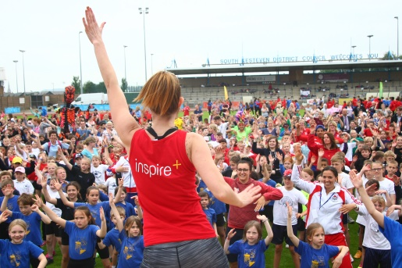  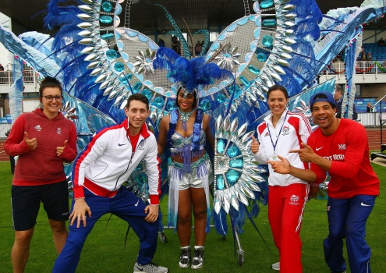  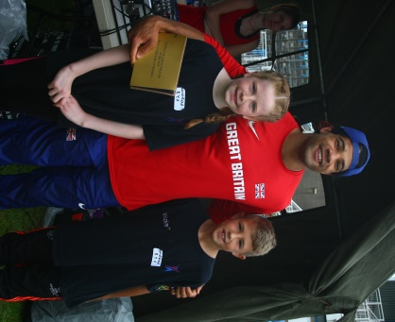
Specsavers | Continued business sponsors of Inspire+, Specsavers Grantham, offered schools their interactive assembly to educate the child on the importance of their eye health, caring for their eyes and having regular eye tests.  As part of the assembly, the children got to try equipment used in eye testing and schools also received a number of educational resources for teachers and parents.  Specsavers have also been able to offer schools free eye test screening equipment for their school which Specsavers would help install and show how to use.  In addition to their primary school offer, Specsavers have been able to offer Inspire+ secondary schools with talks on the careers and the science in eye care. | - Seven Inspire+ Primary Schools accessed the assembly throughout the year. Four of these schools have received the eye screening test equipment to use with their pupils.  - Two Inspire+ secondary schools received careers and science talks to their pupils. From one of these talks a student went on a very successful work placement with Specsavers. | 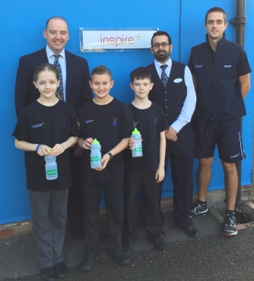  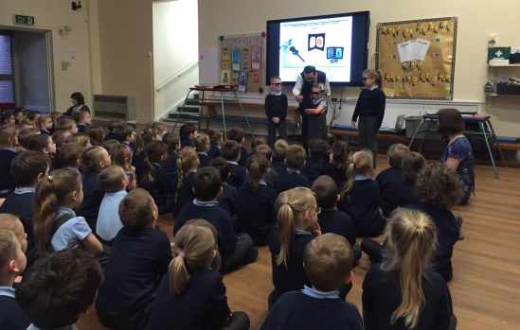
Real PE | New scheme of work from Create Development that works on building children’s skills in agility, balance and coordination through a set of 12 skill based cards that progress in difficulty from yellow to black. These skills are then implemented through non-traditional games to further progress the children’s skill level. | - 34 schools accessed Real PE over the 2015-2016 school academic year over two cohorts.  - With all schools accessing Mike Hale for in school support, approximately 150 staff have been upskilled through the Real PE scheme of work.  - Teachers have stated that the scheme of work has had a massive impact on the children’s abilities and learning in PE.  - Several teachers stating that this has been the best PE scheme of work they have seen. | 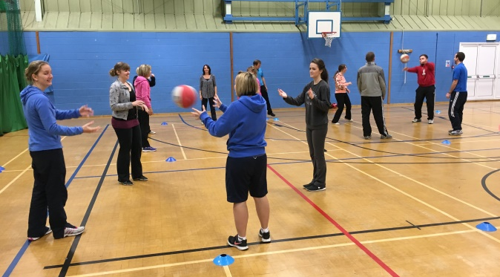
Website | New website created in the summer of 2014. The website contains information about all Inspire+ services and initiatives.  Schools can inform parents of their PE and Sport provision to pupils by linking the Inspire+ website to the schools website.  www.inspireplus.org.uk | - Online booking for activities such as our sports camps have been up and running for almost a year and have proved popular with parents.  - We are now looking at moving our CPD booking process to our online portal. This will allow teachers to directly book onto the courses that they wish to attend.  - 2016/17 will be the first year this will be available and we hope that by 2017/18 teachers will solely use the online booking for CPD courses. | 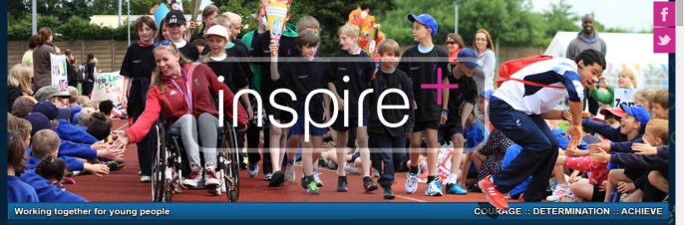
Secondary School Provision
Sports Leadership Academy | The Sports Leadership Academy has been running for 9 years and enables the leaders to make a real impact in their schools and local community. By working very closely with the local School Games Organisers we are able to provide these leaders great opportunities to impact sports within their schools and the local community.  We coordinate and run National Governing Body sports courses, which will help introduce them to those sports and enable them to coach, officiate and lead a group in that chosen sport.  Throughout the year we offer a wide range of volunteering opportunities for the leaders to assist and play a part in, these include local school festivals, Inspire+ sports camps, local sports clubs’ programmes and other community events. | This year has been the busiest year to date for the SLA and this has shown in the number of sports leaders that we have kept engaged and the number of hours that have been logged. Here are some key facts from the academic year 2015/16:  - 0ver 3,800 hours logged, with many more unrecorded.  - Over 60 volunteering opportunities throughout the year, ranging from festivals to community events.  - 120 Leaders were trained.  - 15 different sports courses were run, of which 5 were new courses.  - 60% of leaders logged hours.  - All secondary schools were engaged.  This year has been the most successful year we have had for the SLA and this is down to the leaders being proactive and the support that the schools have given to the programme. | 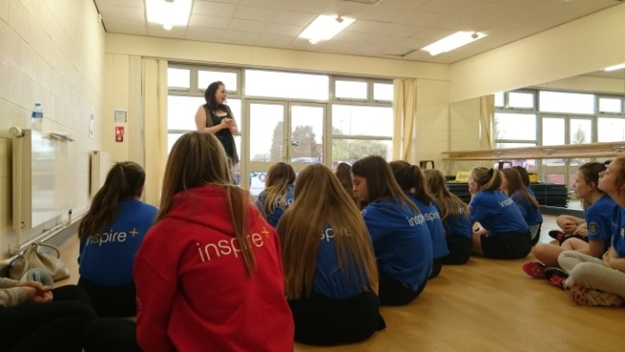  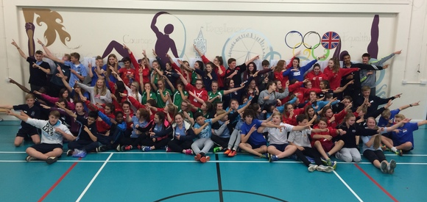
Young Ambassadors (YAs) | After the hugely successful introduction of Bronze YAs in recent years, Inspire+ & Platinum YAs facilitated training events designed to inspire Bronze YAs.  Bronze YAs were responsible for supporting the London 2012 legacy aspirations of ‘Inspiring a new generation’ through our bespoke Legacy Challenge resource. This initiative supported whole school outcomes.  This programme is aimed at pupils in years 5&6. | The Young Ambassador programme was available to all of the secondary schools in the Grantham and Stamford area. We have a total of 12 Silver, 21 Gold and 13 Platinum Young Ambassadors from all schools which have been active throughout the year.  The Gold and Platinum Young Ambassadors come together to create the South West Lincolnshire Young Ambassador Steering Group, who work with Inspire+ and the Local School Games Organiser to support local community events, such as the Mini Olympics.  The Young Ambassador steering group were once again invited to the Inspire+ conference to work with a visiting sports ambassador, with this year Paralympian Sam Ruddock welcoming the new members to the group. | 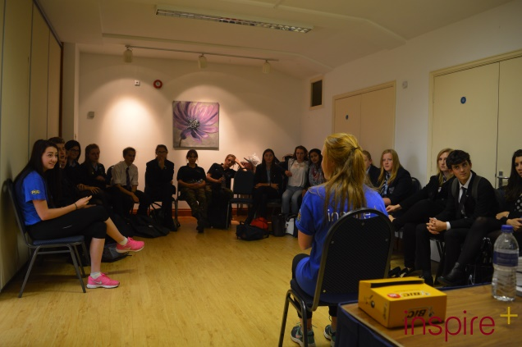
PGL Reward Trip | Linked to the Sports Leadership Academy, this year we were able to offer 12 leaders the opportunity to attend PGL as a reward for their hard work volunteering within the community. | 12 Sports Leaders were chosen from those that had applied to attend PGL Caythorpe as a reward for their hard work volunteering. Each leader had  volunteered and logged at least 50 hours with the majority logging over 100 hours.  We saw the value in rewarding these leaders for their commitment to the SLA and working within the community. | 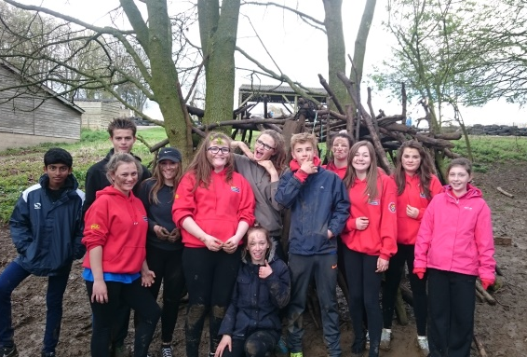
PGL Confidence Sessions | Secondary schools were able to target pupils that were lacking in confidence/self-esteem and engage them in four twilight sessions at PGL Caythorpe specially designed to support the students. | Accessed by Priory Ruskin Academy, Stamford Welland Academy & Walton Girls. The schools were also supported by volunteers from Totemic.  Children engaged by the programme showed great gains, particularly in confidence and team work. | 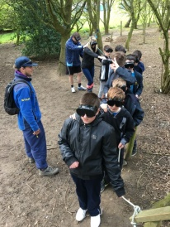
Gifted and Talented Grant Scheme | Inspire+ supported students identified by the school as Gifted and Talented in sport if kit, transport, or club membership fees were a barrier to reaching their potential. | Inspire+, supported by local company Totemic, were delighted to launch an exciting new sporting awards scheme open to member secondary schools in 2015/2016.  Nominations were received from four academy schools, Priory Ruskin Academy, Stamford Welland Academy, West Grantham Academy (St Hughs) and Kesteven and Grantham Girls’ School; resulting in 14 talented students from 8 different sports being awarded a magnificent total of £2490 by the awards panel. This funding has helped towards the cost of equipment, coaching, training and travelling.  The successful applicants with the name of their sport and competition level were:-  Naya Patel, Water Polo, National Caitlin Stendall, Kick Boxing, National  Cain Stendall, Kick Boxing, National  Frazer Winfield, Table Tennis, Regional  Victoria Tomlinson, Swimming/Life Saving Qualified in Royal Lifesaving Awards  Abbie Phillips, Swimming, Regional  Kelsi Ellis, Athletics, County Kate Davis-Bavin, Touch Rugby, National Sophie Robertson, Short Track Speed Skating, National  Molly Colbert, Swimming, National Freya Colbert, Swimming, Regional George Railton, Badminton, County Performance Centre  Lewis Davey, Athletics, Regional Gytis Vysniauskas, Badminton Club  Head Teachers, Susan Dench from West Grantham Academy and David Scott from Kesteven and Grantham Girls’ School, writing to thank Inspire+ for the awards for their students, also acknowledged the many opportunities and support the Charity provided for their students.  Examples of testimonials received from the athletes’ parents so far are; “The financial help provided by Inspire+ in covering some of our daughter’s swimming costs has been a tremendous help” and  “Thanks to the financial support provided by Inspire+ we have been able to use the funding to purchase on field players kit and off field training kit for our daughter who is in the GB under 18 Touch Rugby Squad”. | 