Initiative / Services | Description | Impact
YOUNG PEOPLE
inspire+ Ambassador Sam Ruddock | Sam’s visits to our primary schools have been focused on delivering workshops around physical literacy, emotional intelligence, critical thinking, resilience and teamwork. Teachers have been able to select the workshops that would have the most impact on their children.  Towards the 2019 spring and summer term, Sam also offered NFL Flag Football classes, which were incredibly popular as a way of introducing a new sport into school.  Finally, Sam piloted a new programme called “Aspire to Inspire”, an intervention that will be launched in 2019/2020. It has been created to help those that are struggling in school, to positively change behaviour, attitudes, emotional well-being and self-esteem in Key Stage 3 and Key Stage 4. | 50 primary schools have been engaged with Sam this academic year, totalling around 7,000 children!  “The children have spoken really positively about their sessions and in my afternoon PE session some of the children were teaching the rest of the class what they had learnt, which was great to see.”  “Children are still buzzing from your visit and everyone was very complimentary about what an inspiration you are (despite the James Brown songs!!!)”  “Thank you so much for an incredible afternoon. The children that went from my class came back thrilled and full of tales of the fun they had with you.”  About ‘Aspire to Inspire’ -  “I would highly recommend these sessions and found them engaging and thought provoking to all. Pupils are still asking me when Sam is coming back which obviously says it all!!”  “I think just simply having the time to reflect about ‘what they think of themselves’, ‘what their friends think…’, and ‘what their teachers think…’ was a great concept to them actually seeing themselves from a different perspective.” | 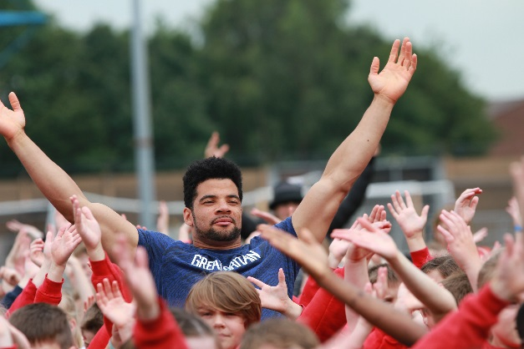  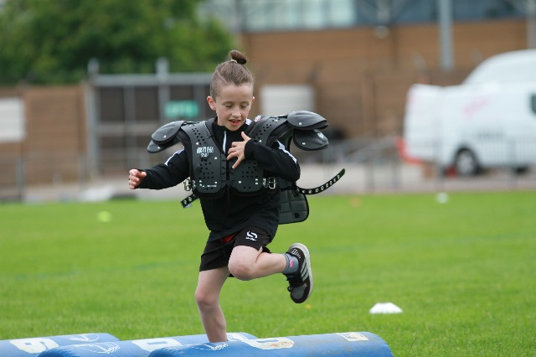
inspire+ Ambassador Sophie Allen | This year, Sophie visited our newer core schools. Each school received a half day session which was focused on Girls in Sport, Achieving your Goal, Communication, Teamwork, Diet & Nutrition or Psychology.  Schools made the choice on what topic they wished Sophie to present on their half day, depending on the needs of their school and pupils.  Sophie has led on the inspire+ Gifted & Talented programmes alongside the inspire+ mentoring programme(s) working with specific groups of children.  Sophie also launched the fitness mentoring programme, focusing on components of fitness to get children active. This programme involved one visit per term for 6 children of the school’s choice. | Sophie visited 10 of our core schools on half day visits this year.  She also led 21 schools through the Fitness Mentoring programme totalling 126 children participating in the programme. As well as 7 schools through the Well-Being mentoring programme, totalling 49 pupils.  The Gifted & Talented programme saw 299 pupils from year 1 through to year 7 gain access to Olympic and Paralympic values and insights into being a successful sporting athlete. | 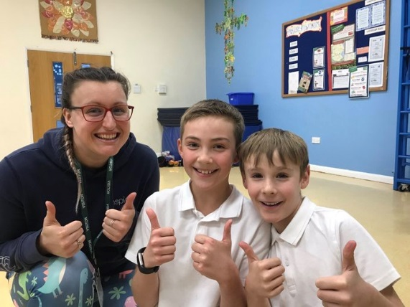  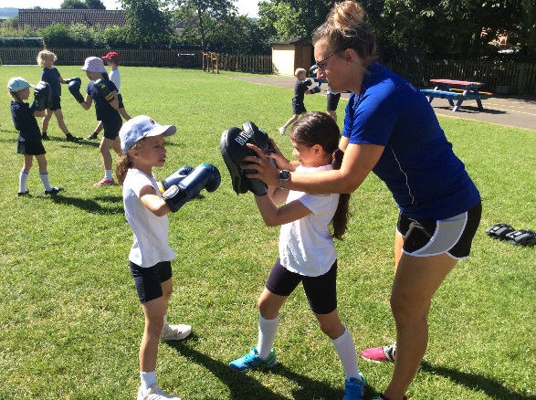
inspire+ Ambassador Ben Smith | On the 1st September 2015, Ben began one of the most challenging and rewarding experiences of his life. Ben ran 401 marathons on 401 consecutive days around 309 different locations of the UK mainland. This also included 2 marathons around inspire+ schools.  Ben undertook this challenge to raise money for 2 anti-bullying charities, whilst also highlighting the issues around bullying and mental health.  Ben is currently training to run a marathon in each of the 50 states of America next year, an adventure which our member schools will be allowed to join in through live video links! | Ben visited 20 schools in his assembly tour this year, speaking to and engaging with over 6,500 children!  Ben’s theme was focusing on antibullying and the benefits of physical activity to boost a person’s mental well-being.  “Hi Ben  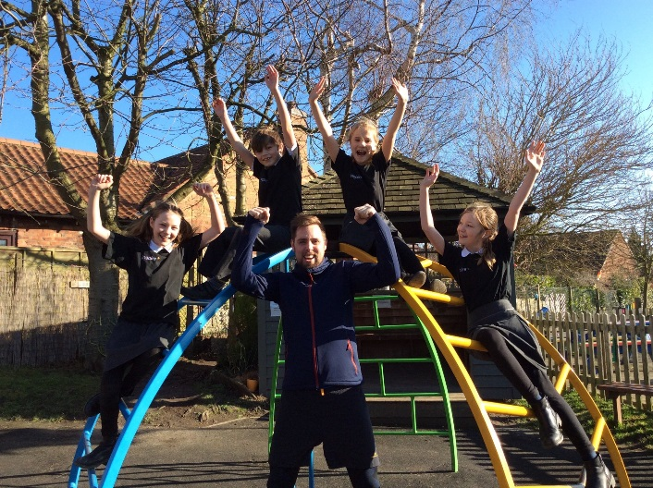  Thanks for visiting school this afternoon (and signing my book 😊 ). I was really pleased last year when we managed to get you to come in as you weren't originally included in our package..... I know! haha. So I asked Chris to extend your visit to the whole afternoon this year because I have found your story incredible - this part is obvious, I mean who wouldn't, right? I am in a slightly privileged position of being able to organise things like your visit and seeing how my daughter reacts - not every parent gets that pleasure. Molly was transfixed by you and has not stopped talking about her afternoon. I am so, so pleased that you have had this impression on her because the way you describe yourself as a child in your book strikes a chord with me when I look at her - her personality, naivety, her make believe play, the security she feels from family - so many things which you describe in your description of you, I see in her. She has struggled socially because she sees the good in everyone and can’t understand why some people like to upset others and is more emotionally in-tune than many of her peers who go out of their way to upset each other all of which makes her very sensitive to negative influences. I am pleased that you are such a positive role model and that she seems to connect to you. I have looked at some of the pictures from the day and she is absolutely captivated listening to you.  Thank you for coming in and just being you! She is adamant that she is going to hit her goal of running every day until Easter” | 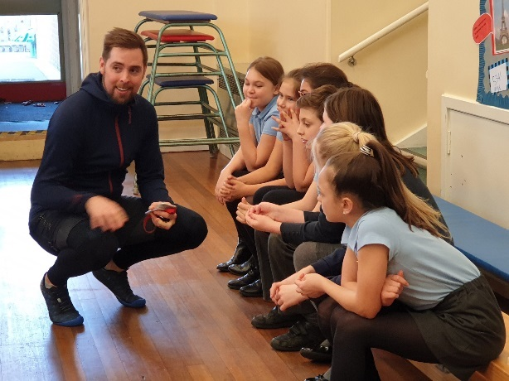  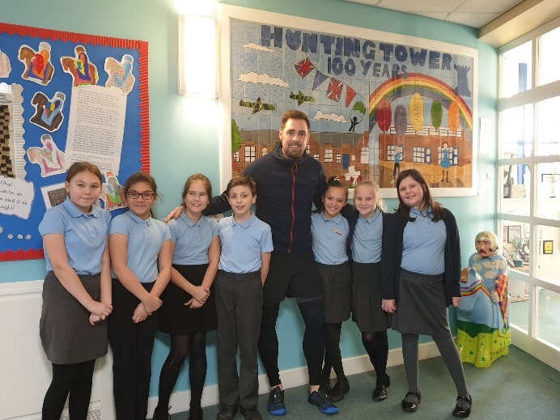
inspire+ Ambassador Sarah Outen MBE | Sarah returned to visit inspire+ schools this year giving them a choice of assemblies:  - Goal setting  - Well-being  - Having your own adventures & being adventurers  All of these assemblies linked to Sarah’s London2London adventure and were brought to life with fantastic pictures & videos. | Sarah visited 48 schools in 2018/2019, using her assemblies about her London2London expedition and mental well-being to enthuse and inspire around 14,700 children.  “Sarah has an amazing impact on the children, she has a very natural way of connecting with the children and capturing their attention, she has them in the palm of her hand.” | 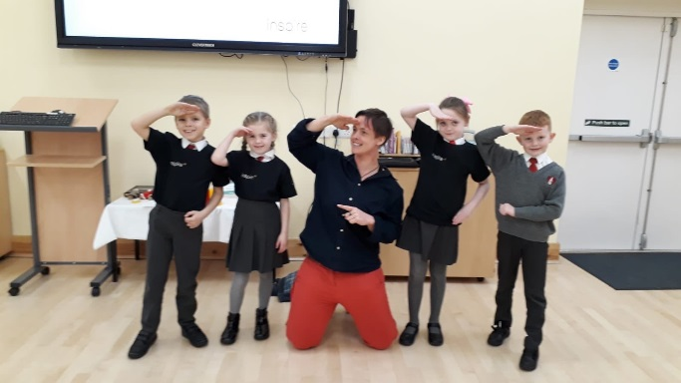
inspire+ Ambassador Jonathan Broom-Edwards | During his assembly tour in 2018/2019, Jonathan updated the children on his preparations for Tokyo 2020, as well as telling them of the importance in managing their emotions and how to stay calm in challenging and difficult situations to benefit their mental well-being. This included practicing breathing and calming techniques. | Jon visited 52 schools in this academic year, totalling an incredible 16,000 children in whole school assemblies.  “Thank you so very much to the inspiring Jonathan! We thoroughly enjoyed his assembly and will use the calming breathing and visualisation techniques he has taught us. Thanks again Sarah Banfield and all at Barrowby” | 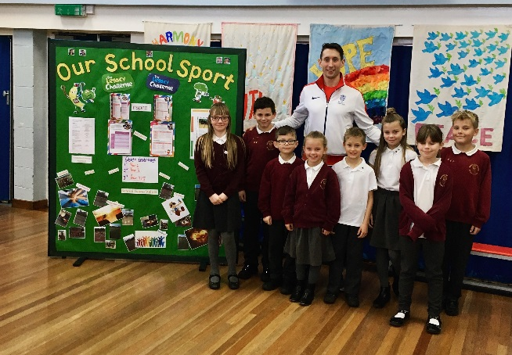
Young Ambassador  Programme (YAs) | The Young Ambassadors programme originates from the success of The London 2012 Olympics and wanted to continue the inspirational games with the ‘inspire a generation’ ethos.  The Young Ambassador Programme is a country wide initiative, which ranges from Bronze YA’s in Key Stage 2 through to Platinum YA’s in Key Stage 5.  We are proud to deliver all aspects of this programme, which actively engages young people from Year 5 all the way through to Year 13. | We have seen an increase in the number of Young Ambassadors at all levels within our area. We have trained over 120 Bronze Young Ambassadors which have then gone on to help lead programmes, such as: The Legacy Challenge, Legacy Tour and The Mini Olympics, amongst helping out within their schools.  The senior Young Ambassadors have also been busy helping by organising the Legacy Tour, Mini Olympics and other events throughout the year. | 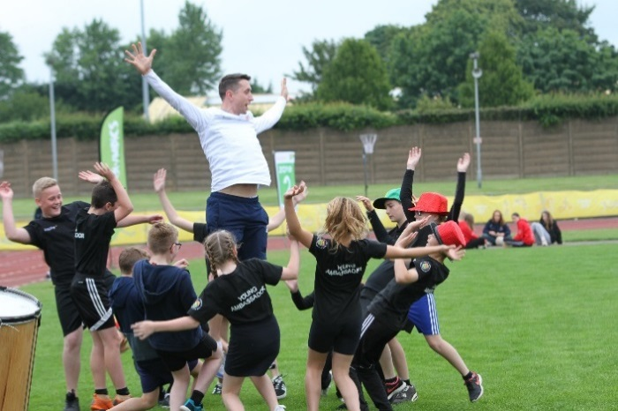
inspire+ Legacy Challenge | Launched in 2012 with the support of Lord Coe, pupils embarked on a series of challenges, that were created to release the London 2012 pledge of ‘inspiring a generation’.  The Legacy Challenge is totally bespoke and designed by the charity to encourage our young people to be inspired towards a lifetime of sport, culture and healthy living.  The Legacy Challenge was used by schools throughout the whole year or as a condensed project.  The inspire+ Legacy Coordinator supported the schools to embed the resource in schools. | - New design of logbooks that focused on the inspire+ Ambassadors, this was to encourage the children to aspire to be like the ambassadors and achieve great things.  - Active Lincolnshire funded the Legacy Challenge to be a free resource available to all primary schools in Lincolnshire.  - Trained over 350 bronze Young Ambassadors to lead and promote healthy lifestyles to their fellow pupils.  - 95 Schools engaged throughout the county.  - Over 130 teachers were trained to embed the programme within their schools.  - 0ver 18,000 pupils engaged in the Legacy Challenge.  ‘Through pupil voice, displays (photos and evidence), the website and the ethos of the school in general, our inspector was very impressed with how the Legacy Challenge and the enthusiasm of the Bronze Ambassadors seemed to be affecting the general atmosphere in the school. As many of our children spoke with such passion about their roles in school, leadership and volunteering and the challenges they set themselves through the Legacy Challenge the inspector ended up asking for a copy of the Legacy Challenge and has made reference to it in our final report.  He could see there was a clear link between the children’s general behaviour and attitude to work and the work we do with them through the Bronze Ambassador training and the Legacy Challenge. The inspection process does now look very closely at SMSC in schools and the Legacy Challenge appears to have ticked a box for them in my school.  Thanks again for this wonderful toolkit and producing something that addresses many SMSC areas through sport, healthy lifestyles and values.’  Head of School/PE Lead | 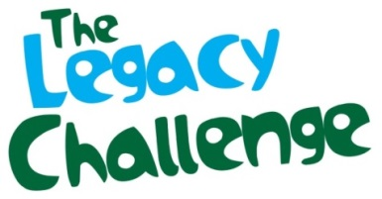  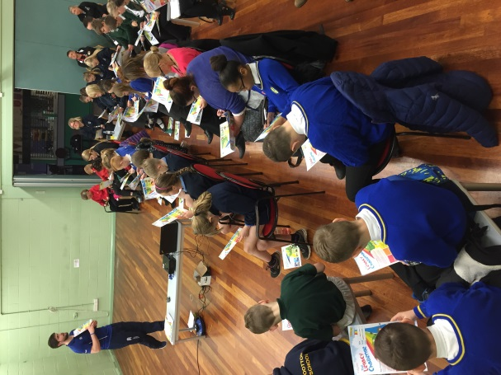  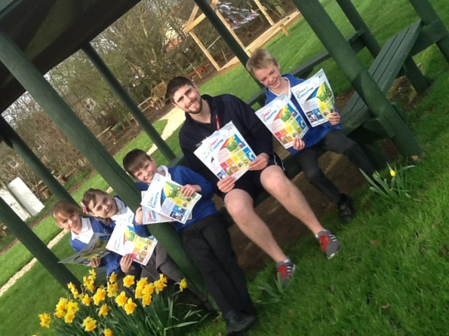
KS1 Gifted and Talented Programme | The third year of the Gifted & Talented Programme for KS1 pupils, delivered by our extremely experienced athletics and FUNdamentals coach, was held in three locations to provide opportunities to as many children as possible.  Each course consisted of 6 sessions and parents were invited to stay to view the sessions, assist their children and learn about the importance of FUNdamental movements.  The programme is based around a set of 12 core activities which are designed to test and develop a child’s ability in the following important areas (as well as others): Balance, Control and Stability, Leaping and Landing, Coordination and Rhythm, Single Arm Throwing, Speed, Foot-Eye Coordination, Hand-Eye Coordination, Spatial Awareness, Two Arm Throwing, Agility. Sporting values of Teamwork, Respect, Honesty, Passion, Determination & Self-Belief are also explored and celebrated. | Lisa Ashcroft led the KS1 Gifted & Talented Programme across 3 venues this year – Grantham, Peterborough & Stamford.  In total 53 pupils attended across the 3 venues focusing on the FUNdamental movements. Parents of the children were also invited to stay and learn, getting involved with their youngsters! | 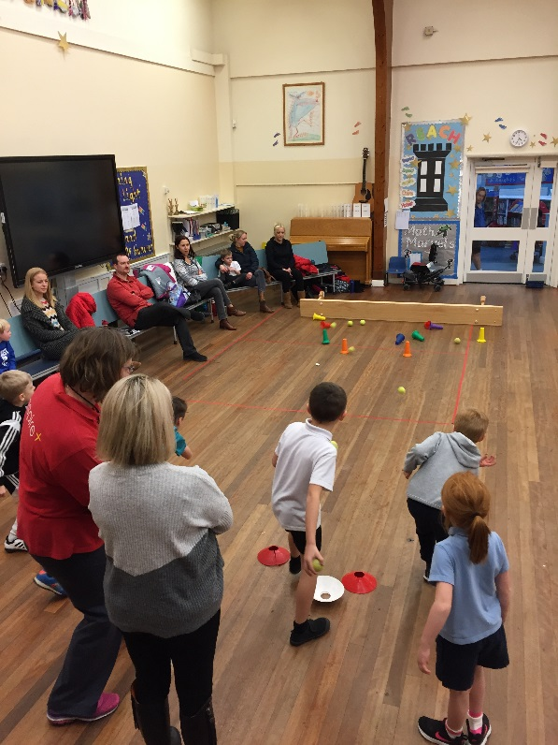  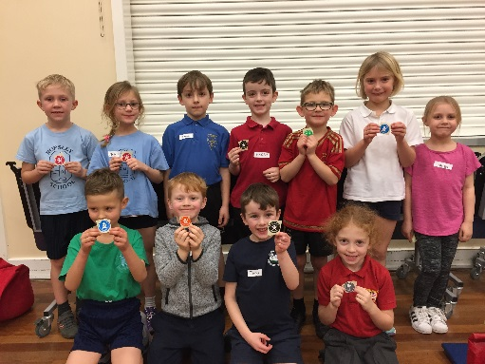
Years 3 & 4 Gifted & Talented Programme | Children that were identified by their school as being Gifted & Talented in sport were able to access termly training sessions.  The 5 sessions focused on: Communication, Teamwork, Diet & Nutrition, Psychology, Fitness & Exercise and Game Play.  Sessions were both practical and theory based. Parents were able to stay and watch the sessions, and handouts were provided with the information from the sessions for the children to take home. | The year 3 & 4 programme was led by both inspire+ ambassadors; Sophie Allen & Sam Ruddock across 4 venues, Grantham, Peterborough, Stamford and Long Sutton.  In total 181 pupils accessed the programme. The charity saw its highest ever number of children retained throughout the duration of the programme giving huge impact to the participating children. | 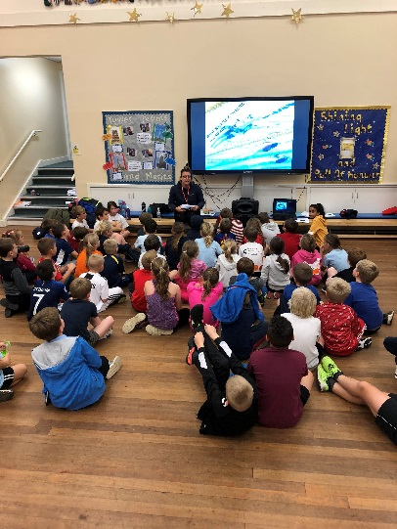
Years 5, 6 & 7 Gifted and Talented Programme | This Gifted and Talented Programme follows a similar format to what is offered to Year 3 & 4, with the content being delivered to a standard that is engaging yet challenging for participants.  The sessions included: Psychology, Biomechanics, Strength & Conditioning, Adaptive Game Play, Diet & Nutrition and Fitness Testing. | This programme was again led by both inspire+ Ambassadors, Sophie Allen & Sam Ruddock across 2 venues, Grantham and Stamford. In total 65 pupils accessed the programme.  The 3rd and final session saw a full day trip during February half term at Walton Girls School, Grantham. Roots to Food delivered a cookery lesson, focusing on nutrition for sport, followed by a physiology workshop in the afternoon, using British Cycling testing equipment, such as speed gates and counter-movement jump mats.
Gifted and Talented Grant Scheme and Get Active Grant Scheme | inspire+ supported pupils identified by the school as Gifted and Talented. If kit, transport, or club membership fees were a barrier to reach their potential then schools were able to access funding support for the child’s family to help get them physically active and achieving their potential. | This year, 4 pupils accessed the gifted & talented grant scheme to help with sporting equipment, club fees and transport to competitions. | 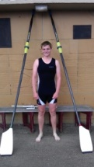
Paralympic Half-days | Each new school received a half-day of coaching from our disability sports expert.  Schools have utilised this to give classes a flavour of all-inclusive sports for their children and up skill their staff to be able to continue the delivery of the sports.  Schools have the option to book extra sessions after their taster session. This can be arranged by contacting the inspire+ office. | This year a total of 6 half days and 1 full day of Paralympic sport has been delivered to our members.  This is set to increase in the academic year of 2019-20. | 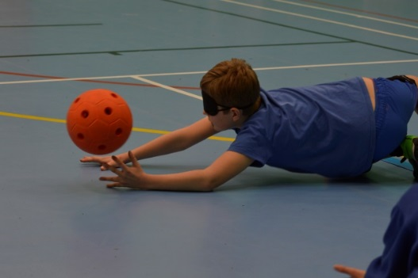
Mini Olympics | The 12th Mini Olympics took place on the 19th, 20th & 21st June 2019 at the SKDC Stadium in Grantham. Our biggest ever event was attended by our primary school members. Our theme of “The Greatest Sports Show” was particularly well received!  The East Midlands Carnival Art Network provided a lively, big top atmosphere for the children, with a full Opening and Closing Ceremony, whilst local sports clubs and coaches ran the activity stations for the day.  Each day is a huge celebration for the charity, driven by nearly 100 sports leaders from our secondary school leadership programme, that volunteer to ensure the fun never stops for our young Mini Olympians!  The day allows the charity’s schools, leaders, trustees and partners to come together for an inspirational day, with many children experiencing their first big sporting event. | The Mini Olympics in numbers:  - 134 teams from 55 primary schools took part  - This equalled over 1500 primary schools taking part either in the teams or as the schools Bronze Young Ambassadors taking part  - Over 70 of our secondary school Sports Leadership Academy students volunteered each day helping to run the sports and look after the schools  - 14 Olympic & Paralympic sports were delivered each day  - 4 of the charity’s athlete ambassadors supported each day  - Over 100 VIP’s and parents attended to view the Games  “Thank you for such a fantastic day out. Our students thoroughly enjoyed themselves – one child even telling me it was the best day of their life! Bless them 😊”  “I also had a parent ring me after our children had been to say what a terrific day it was and how well organised, thank you.”  “Thank you for such an amazing day last Wednesday. The children, and staff, thoroughly enjoyed themselves and came back buzzing!” | 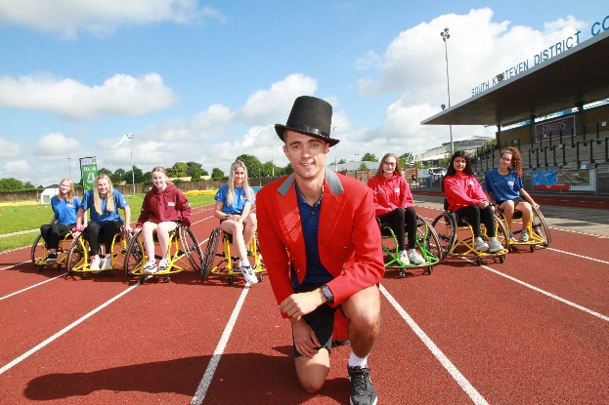  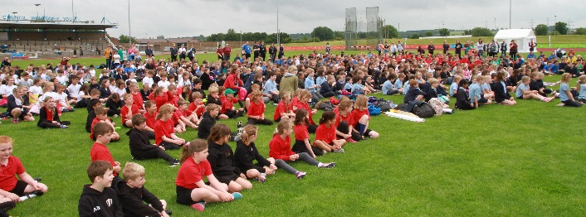  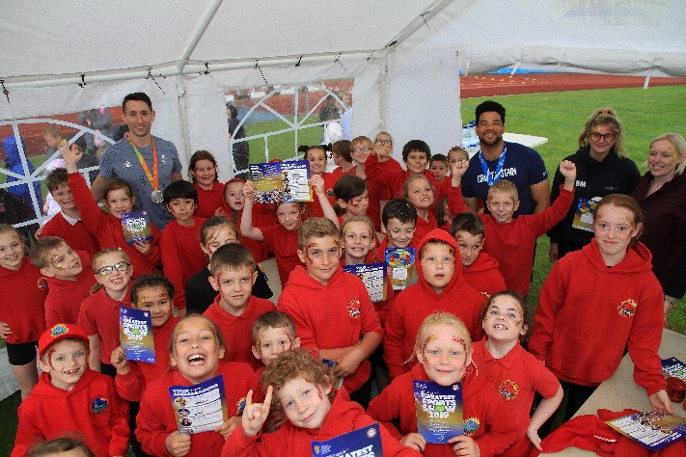
inspire+ Mass Participation Event | Schools have the opportunity to take part in this annual event. This event is a fun way to get children active.  This year’s event challenged schools to complete a fitness video filmed by the charity’s ambassadors. The aim -for all schools to complete this on the same day.  Crucially, our Mass Participation workout videos are now on YouTube for schools to access, meaning classes can have a quick 20-minute blast of exercise, whenever they wish. This allows our teachers to emphasise physical activity throughout the school day and not just in allocated PE time. | This year’s mass participation event has been the biggest event since inspire+ broke a world record in 2013!  39 Primary schools took part, meaning over 5850 children got active and took part in the video.  The video had 3 levels to each exercise filmed. Children could choose the right level for them and then repeat the video to try and progress. | 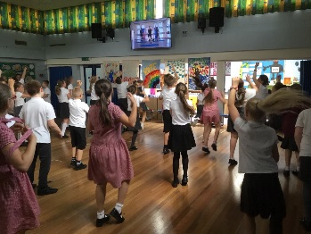  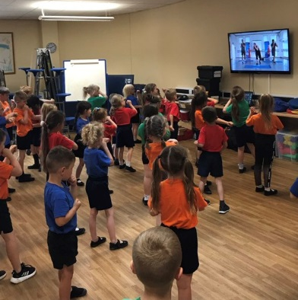
PGL Half day access | Schools had the opportunity to take pupils to PGL in Caythorpe.  Emphasis was placed around extending PE opportunities (OAA) and giving pupils access to outstanding facilities and instructors. | 20 schools accessed PGL Caythorpe for at least half a day. Schools would not normally be able to access PGL for half a day, this is thanks to their inspire+ membership.  As a result, 333 pupils got to visit PGL Caythorpe to experience the great outdoor adventure facilities they have.  A lot of schools used this programme to reward children for attainment, good work, behaviour or to support children develop skills such as teamwork, communication and increase confidence. | 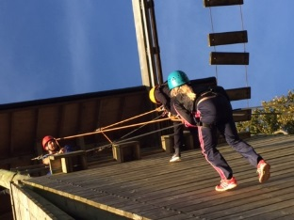
PGL Access Weekend (year 6-7 transition) | Schools had the opportunity to select pupils to attend a special weekend at PGL, staffed by inspire+. The weekend is aimed at pupils in year 6 to help aid transition from primary school to secondary school.  Schools had the discretion on pupils chosen, with reasons ranging from being a Young Ambassador, attainment, good behaviour, students with low self-confidence or students who have never experienced outdoor education before, which may have been due to financial restrictions. | 36 Primary School children attended the weekend from across our core schools.  Parent feedback:  “I've been meaning to write for a few weeks just to say thanks so much for the PGL Access weekend that you organized on 27/28th April. Our daughter really enjoyed herself and got a lot out of it.”  “Thanks to all of you at inspire+ for the work you do. It really makes a difference.”  Pupil Feedback suggested that 100% of pupils enjoyed themselves on the trip and mentioned things like:  “It made me feel more confident.”  “It helped me to make new friends I will go to school with and made me less worried about going as I know more people.”  “This is the best place ever and I love it!” | 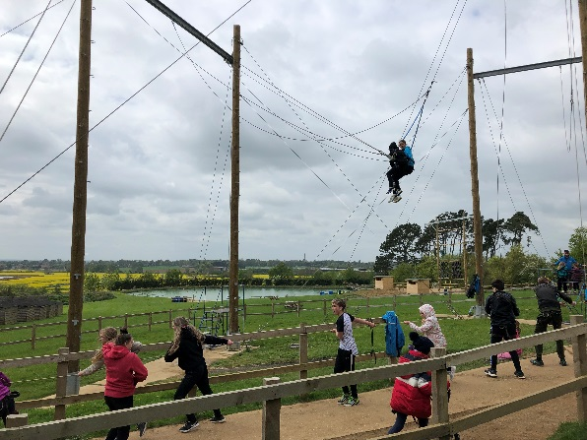  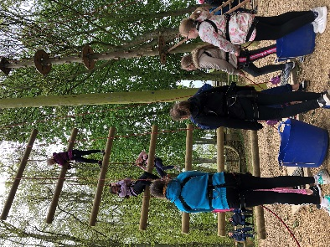
Balance Bikes | Aimed at reception and key stage 1, balance bikes give children the opportunity to learn to ride a bike without the need for stabilisers.  Each school received 10 fantastic balance bikes, helmets and resources. Staff training was also provided. | 22 schools engaged in the programme. Around 1000 reception and key stage 2 children were engaged across the academic year.  Schools used the balance bikes in numerous ways including;  - PE lessons  - Extra-curricular clubs  - Intervention  - Rewards  - Playtime  A successful balance bike festival was organised by the School Games Organising team that allowed children to show off their newly acquired skills and was a fitting way to cap off a very positive year! | 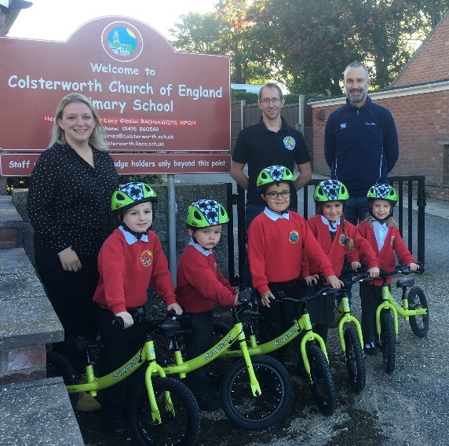  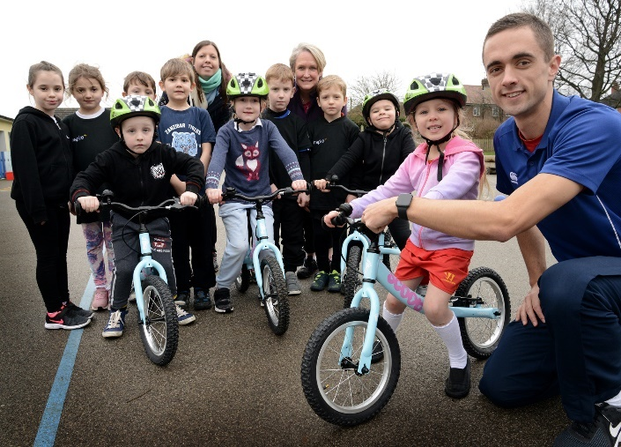
TEACHING STAFF
PE, Sport and Leadership Conference | inspire+ organise an annual conference, which provides the platform for teachers to develop their PE, Sport and Leadership provision.  The conference launches the charity’s programmes to the schools for the year with teachers receiving all the relevant documents they require. | Last year’s conference was moved to the new venue of Belton Woods Hotel to allow for the increase in schools that the charity now serves.  Over 95% of the charity’s schools attended with most bringing their PE Leads and Head Teachers.  The conference was opened by guest speaker, GB bobsledder Nicola Minichiello.  Workshops that were delivered included, Roots to Food, Youth Sport Trust and the charity’s Education Team. | 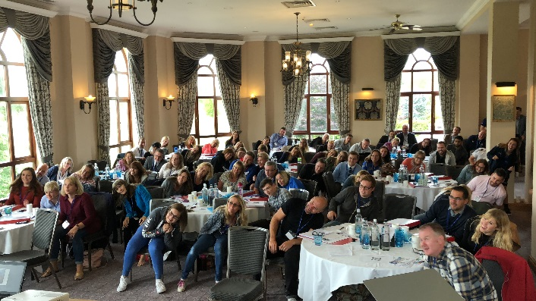
CPD Courses | A comprehensive programme of primary school courses delivered locally and nationally, were coordinated for member schools. Courses were aimed at supporting all school staff to deliver high quality PE and Sport in their schools. | 40 CPD courses were facilitated throughout the year.  A total of 337 staff members applied for places on the courses.  Following on from previous years several more Reception/KS 1 courses were facilitated including FA active Literacy and MOVE with Zip Active  FRIENDS mental wellbeing programme was delivered to 60 members of staff across Grantham, Stamford, and Peterborough  Comments from the course evaluation forms include:  "Great course, well delivered"  "Was very informative. Thank you" | 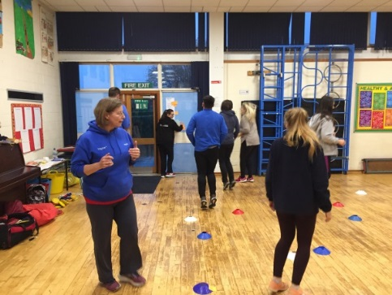
Real PE | Scheme of work from Create Development that works on building children’s skills in agility, balance and coordination. | 7 schools accessed curriculum team teaching support to embed Real PE in school. | 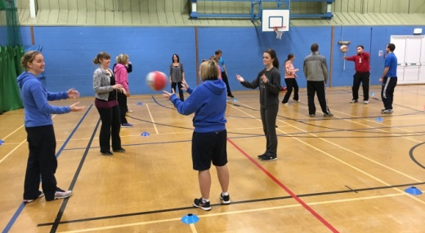
Real GYM | Another scheme of work from Create Development which is a new and holistic approach that makes gym relevant, meaningful and challenging for every child. | 2 schools accessed curriculum team teaching support to embed Real GYM in school. | 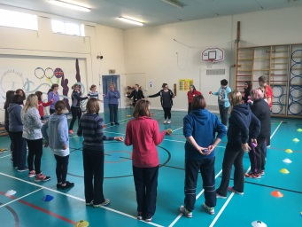
SCHOOL
Minibus | inspire+ secured access to a minibus to ensure pupils can access sports fixtures/events. | 2 schools accessed this support to provide transport to a sporting event. | 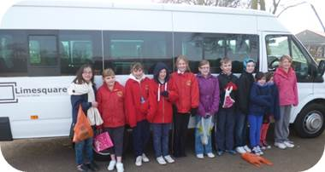
TOP Swimming | This initiative funds 50% of an additional qualified school swim teacher to work with non-swimmers to ensure children meet the KS2 requirement. | Schools continue to access this programme that is proven to support the development of targeted pupils.
Parent Volunteer Programme | inspire+ provided an induction event for parents giving them access to basic sports training, enabling parents to assist sports clubs at their child’s school. This can also be an opportunity for parents to progress into paid job roles. | 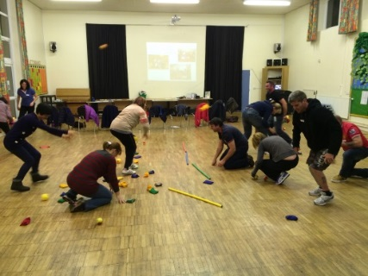  The parent volunteer programme this year was very successful with 12 new parents going through the induction with inspire+. The parents also attended several CPD courses around specific sports that they then took back to their host school.  These 12 keen parents were sent back to school to get involved with a whole heap of activities including; after school clubs, reading club, sports clubs, maths support, English support amongst other things.
inspire+ Legacy Tour 2016/17 | This year’s Legacy Tour was based around sporting events that were taking place this year (Winter Olympics, FIFA World Cup). Alongside raising awareness of active lifestyles and healthy eating.  All member schools were offered the opportunity to be part of the inspire+ Legacy Tour. | This year’s Legacy Tour saw 40 schools taking part with their Bronze Young Ambassadors taking a leading role again. Thank you to everyone who took part and a massive well done to all the BYA’s that led 40 outstanding assemblies.  Next year’s tour will have an Olympic and Paralympic theme ahead of Tokyo 2020! As well as having more schools involved so its set to be another amazing year! | 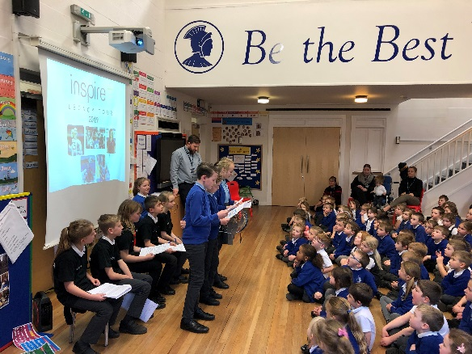
The Daily Mile | The Daily Mile is aimed at every school child with the target of them being able to complete one mile a day.  It has been proven to prepare children for their lessons, leaving them more focused and ready to learn. The Daily Mile is non-competitive, easy and fully inclusive, alongside aligning with the new Obesity Strategy announced by the government. | The Daily Mile was thrown into national popularity through the additional backing from ITV.  The schools Young Ambassadors were tasked with starting up the Daily Mile within their schools, which around a third of schools implemented during the academic year.  “We have done it since Term 5 – main reason because of the legacy challenge. Now the children don’t ask they go and do it. Also, they moan if they don’t do in the morning!”  PE Co-ordinator | 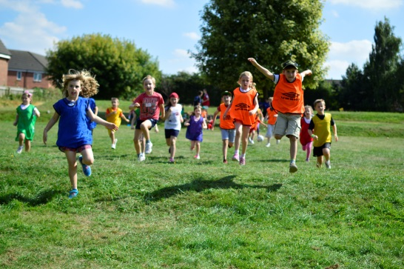
Playground Leaders | Following the successful introduction of in-school training, the charity continued to offer training to all member schools.  Schools receive 6x1 or 3x2 hour training sessions with their chosen group of pupils. Pupils get themselves a Playground Leader Training booklet to fill out during the course. This training can also incorporate working with the school’s teaching assistants, PE apprentices and midday, lunchtime supervisors.  At the end of the training the pupils get rewarded with a certificate and a Playground Leader Training cap. After they complete the course, they will be able to deliver new fun activities for other pupils during playtimes and lunchtimes. | During the 2018/19 academic year, there were 16 primary schools who did the Playground Leader Training and all pupils who did the training, passed!  The impact on the pupils who completed the training course - increased their understanding, knowledge, confidence and enjoyment by 175%.  The impact on the staff who attended the training - increased their knowledge and confidence by 75%. So, all staff who trained now feel more confident and have a better understanding on their delivery.  “Really enjoyed the sessions. Very clear and precise delivery. Well organised. Children are really enthusiastic to learn new games and to be playground leaders.”  Senior Midday Supervisor  “The programme involved structured activities for the playground leaders to deliver. The children all enjoyed the course and found it really fun.”  Teaching Assistant | 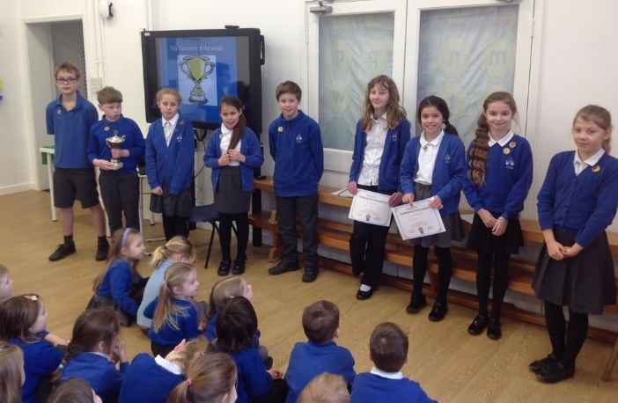  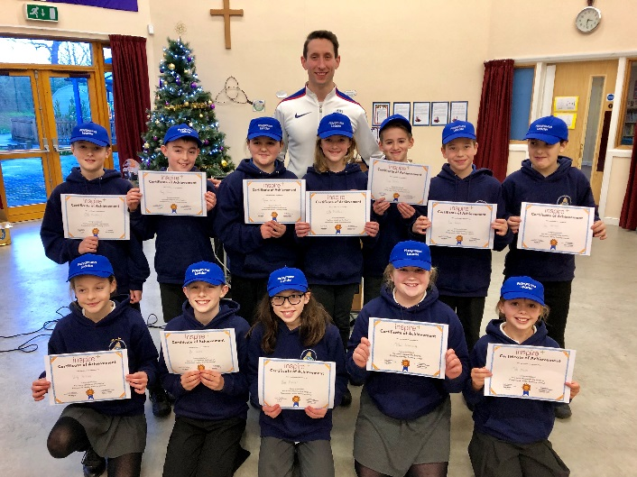
Specialist coaches | inspire+ help to provide quality coaching at schools through a comprehensive range of sports, to support increased OSHL and support the upskill of teachers delivering PE curriculum. | A total of 45 Primary Schools have accessed the specialist coaching service, with the majority receiving some sessions for free as part of their inspire+ membership. Schools consistently and regularly request additional coaching services.  Our specialist coaches provide teachers with the knowledge and guidance to improve and upskill their current PE experience.  This year, on average:  - Pupil enjoyment has increased by 223%  - Pupil confidence has increased by 114%  - Teacher knowledge has increased by 87%  - Teacher confidence has increased by 115% | 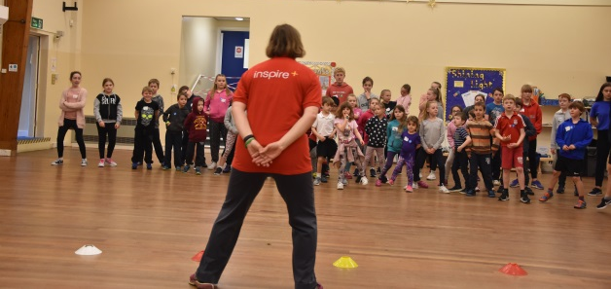  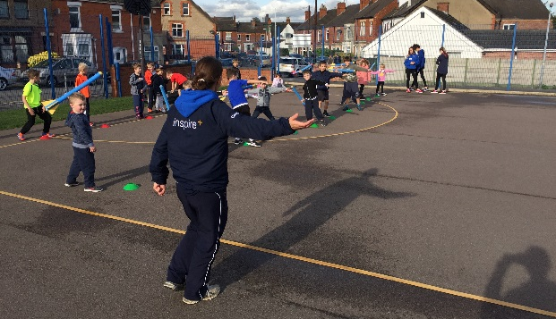
inspire+ mentor programme | Our mentors; Sophie, Sam and Chris provided support and guidance to young people with the aim to help remove barriers to learning in order to support effective participation, enhance individual learning and raise aspirations.  Schools identify young people who are not maximising their potential, either not applying themselves academically, have behavioural issues or have low self-esteem or confidence. The programme focuses itself around ‘The Big Top Model’ looking at four aspects of the children’s lives - school, home, diet, screen time.  Fitness Mentoring was also added to the programme for 2018-19. This focuses on balance, co-ordination, endurance and flexibility. Using these components of fitness to find new, fresh ways of getting physically active. | 20 schools received the Well-Being Mentoring programme, totalling 80 pupils participating in the programme.  21 schools received the Fitness Mentoring programme totalling 126 children participating in the programme.  Fitness Mentoring Feedback:  “Thank you so much Sophie! We really enjoy having you support our children; we feel that we see real improvements in the children’s attitudes and confidence. Thanks again” | 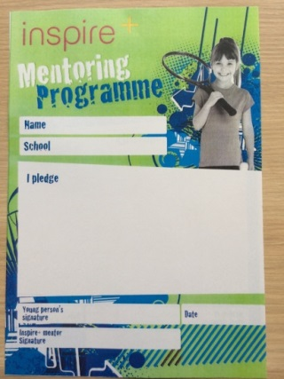
COMMUNITY
Olympic Sports Holiday Camps | Our holiday sports camps engage those participating in a variety of Olympic and Paralympic sport, giving children opportunities to be active in a structured and fun environment. Sessions delivered by our inspire+ core staff provide children with an insight into many different sports that they may otherwise not have the chance to take part in.  Over the 2018/19 academic year inspire+ held camp days at: Huntingtower Community Primary Academy, Belton Lane Primary School, Gonerby Hill Foot and Barkston Primary School.  Our camps follow Ofsted guidelines and we pride ourselves on the quality we provide for participants. The camps also give our Young Ambassador and Sports Leadership Academy volunteers the chance to gain valuable experience working with young people in a sports camp environment. This includes group management and assistant coaching. | This year the charity increased their sports camp provision by holding 50 sports camp days throughout the school holiday’s.  Each day runs from 8:30am to 5:30pm.  Over 400 children accessed throughout the year from the ages of 5 to 11.  Feedback from parents:  “The set up and staff have again been wonderful. Matthew has thoroughly enjoyed this last week and always wanted to come. It was also lovely to hear that those that met Matthew last year have seen a difference in his behaviour since we have now got a better control of his ADHD.”  “My daughter aged 5 really enjoys her time here during the holidays, always excited to go, staff are always a pleasure - nothing is too much trouble for them-a special shout out to Jack!” | 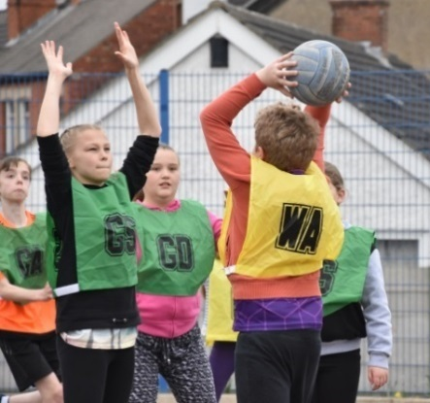  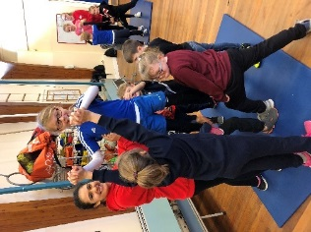
Website | In early 2019, we gave our website a new lick of paint and completely re-branded ourselves as a charity. The website now contains information about all inspire+ services and initiatives, as well as online booking forms for our holiday sports camps.  Schools can inform parents of their PE and Sport provision to pupils by linking the inspire+ website to the school’s website.  www.inspireplus.org.uk | Since partnering with local design company Nettl, our vision of turning inspire+ into a known brand has truly become a reality through the new website and branding material, which we hope you like.  Our website usage has grown and grown through the past few years, with now all of our sports camps bookings been made through the new website. | 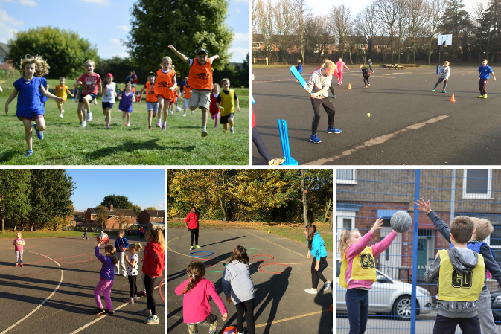
Secondary School Provision
Sports Leadership Academy | The Sports Leadership Academy has been running for 9 years and enables the leaders to make a real impact in their schools and local community. By working very closely with the local School Games Organisers we are able to provide these leaders great opportunities to impact sports within their schools and the local community.  We coordinate and run National Governing Body sports courses, which will help introduce them to those sports and enable them to coach, officiate and lead a group in that chosen sport.  Throughout the year we offer a wide range of volunteering opportunities for the leaders to assist and play a part in, these include local school festivals, inspire+ sports camps, local sports clubs’ programmes and other community events. | This year has been the busiest year to date for the SLA with the number of opportunities to volunteer reaching in excess of 100 events throughout the academic year.  This academic year has seen the continuation of 2 more initiatives that enhance the current Sports Leadership Academy. The Sports Leaders UK sports leadership courses provide the leaders with not only a higher level of training and confidence within the roles they already do, but to reward them with a nationally recognised qualification.  The second is our Business Skills Pathway which was in partnership with local businesses from Grantham. The Business Skills Pathway event provided the leaders with key business skills such as, Interviewing Skills, choosing the correct business and first impressions.  New for the Sports Leadership Academy this year was the introduction of Skills Camps to provide the new leaders with effective training around safeguarding and 3 sport specific  Here are some key facts from the academic year 2018/19:  - Total of 223 leaders involved, with 185 active leaders.  - 0ver 6,500 hours logged, which is an all-time record!  - Over 100 volunteering opportunities throughout the year, ranging from festivals to community events.  - 90 new leaders were trained.  - 15 different sports courses were run, of which 2 were new courses.  - Continuation of SLUK course, 39 Leaders successfully completed either their Level 1 or level 2 awards.  - 3rd year of the Business Skills Pathway.  With the new additions to the Sports Leadership Academy, the opportunities and depth of the programme that we provide is setting up the leaders for life. | 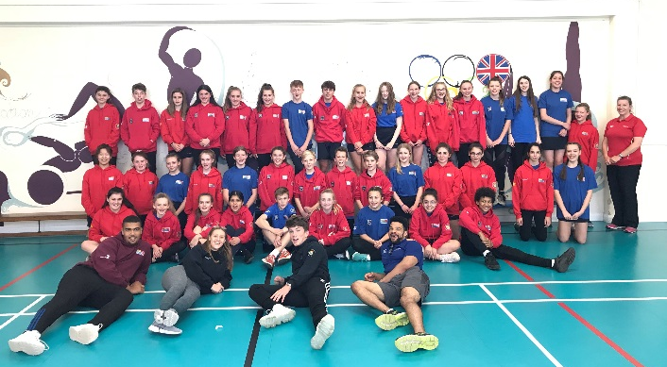  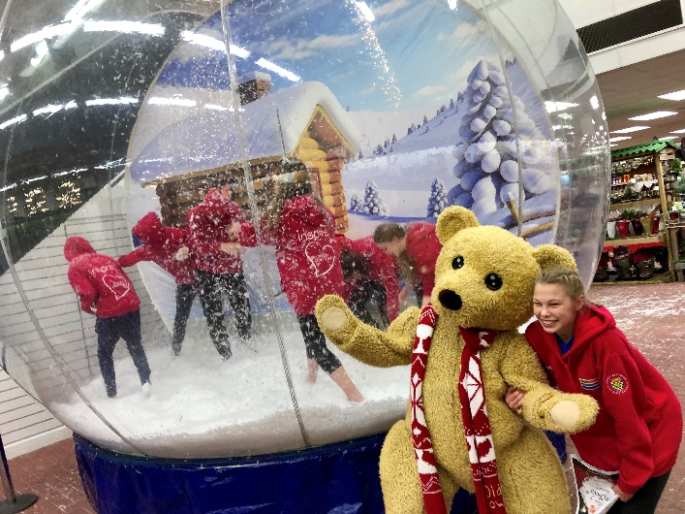  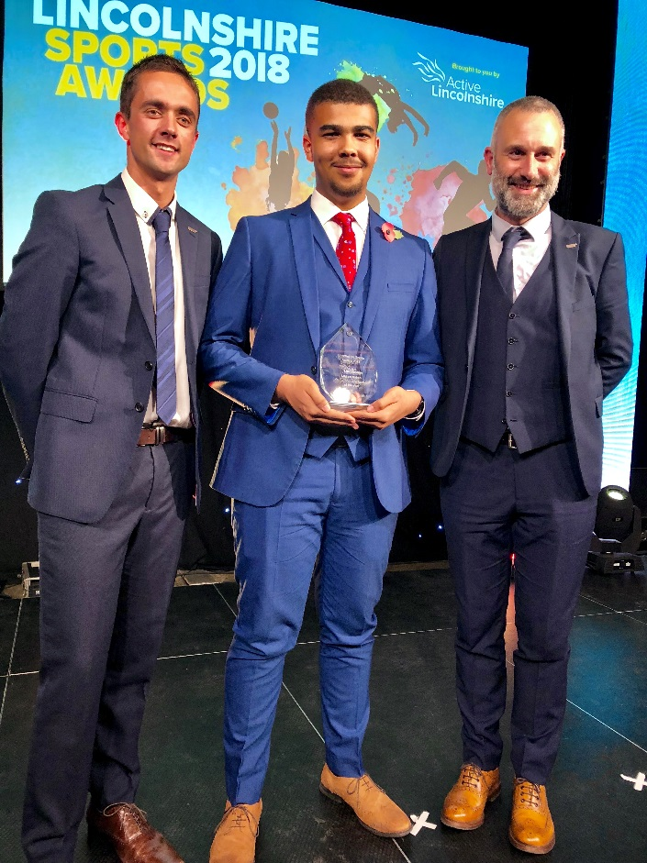
Business Skills Academy | The Business Skills Academy linked local businesses with our Sports Leadership Academy students.  Students attended a conference where 5 local businesses ran workshops in different areas key to applying for jobs; including CV writing, body language, being professional and researching companies.  Following this, these students could apply and go through an application process to take on work experience at one of the businesses from the conference. | 45 of the secondary school Young Ambassadors and Sports Leadership Academy students attended the conference.  From this a number of them applied for work experience across the businesses through sending in an application form and their CV. They then went under interview processes and were successful in securing work experience placements during the school holidays.  Pupils commented how beneficial they found the whole process as schools are not able to provide work experience anymore or spend much time teaching job and life skills. | 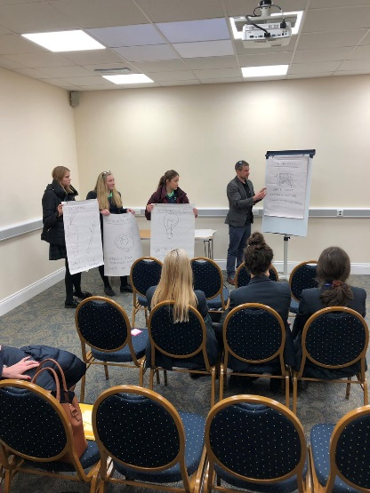
Young Ambassador  programme  (YAs) | The Young Ambassador programme originates from the success of London 2012 and wanting to continue the inspirational games ‘inspire a generation’ ethos.  The Young Ambassador Programme is a country wide initiative which ranges from Bronze YA’s in Key stage 2 through to Platinum YA’s in Key Stage 5.  We are proud to deliver all aspects of this programme which actively engages young people year 5 all the way through to year 13. | The Young Ambassador programme was available to all secondary schools in the Grantham and Stamford area. We have a total of 7 Silver, 19 Gold and 9 Platinum Young Ambassadors from all schools which have been active throughout the year.  The Gold and Platinum Young Ambassadors come together to create the South West Lincolnshire Young Ambassador Steering Group, who work with inspire+ and the Local School Games Organiser to support local community events, such as the Mini Olympics. | 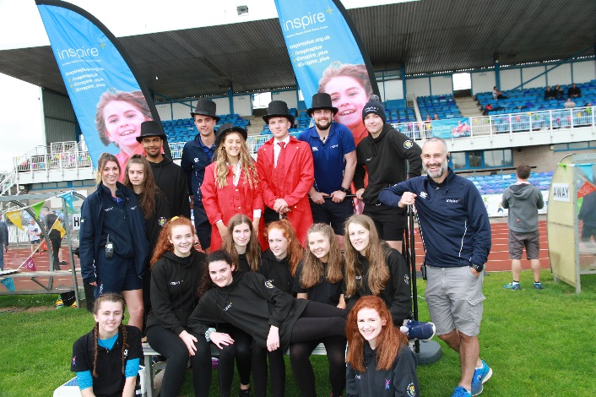
PGL Reward Trip | Linked to the Sports Leadership Academy, this year we were able to offer 8 leaders the opportunity to attend PGL as a reward for their hard work volunteering within the community. | 8 Sports Leaders were chosen from those that had applied to attend PGL Caythorpe as a reward for their hard work volunteering. Each leader had volunteered and logged at least 50 hours with the majority logging over 100 hours.  We saw the value in rewarding these leaders for their commitment to the SLA and working within the community. | 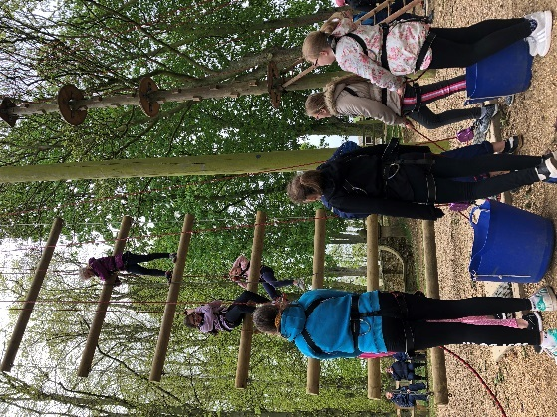
Education Team
Health Check and PE forum | PE co-ordinators and/or head teachers are invited to join us at termly PE forum meetings and have had the opportunity to request individual support for their school in the form of a PE health check. | After a busy year in 2017/18 less schools used the health check service, but it remains available to any school requiring it. We are happy to discuss your current provision and how you can enhance PE and school sport in your school. The PE forums take place once per term and focus on up to date PE and sport news and views. | 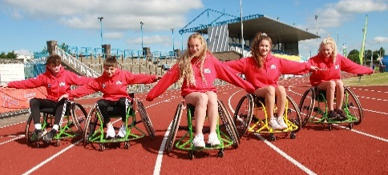
Apprentices | Our PE and School Sport apprenticeship is now in its third year of delivery. We provide the training for New College Stamford. Our apprentices give schools the opportunity to improve the quality of PE and school sport provision and participation. | Another hugely successful year saw over 80 apprentices and work-based learners qualify as PE and school sport apprentices gaining their NVQ Level 3 awards in supporting the delivery of PE and school sport and Employer’s Awareness. This year we look set to train up to 100 new apprentices and work-based learners in the east of England with cohorts in East Riding, NE Lincs, Norfolk, Lincoln, Grantham, Boston, Stamford & Northants. | 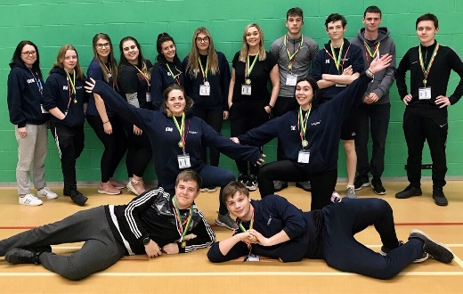
Level 3 NVQ | inspire+ are pleased to be able to offer their NVQ Level 3 programme for current school employees. Our work-based learning programme continues into the new academic year with a new cohort due to start before Christmas. | Our first cohort of work-based learners completed their training this summer after 18 months of work completed whilst working in their schools or coaching companies. This included 2 of our inspire+ staff who really enjoyed the course. If you have any support staff who might be interested in this course please let us know. | 