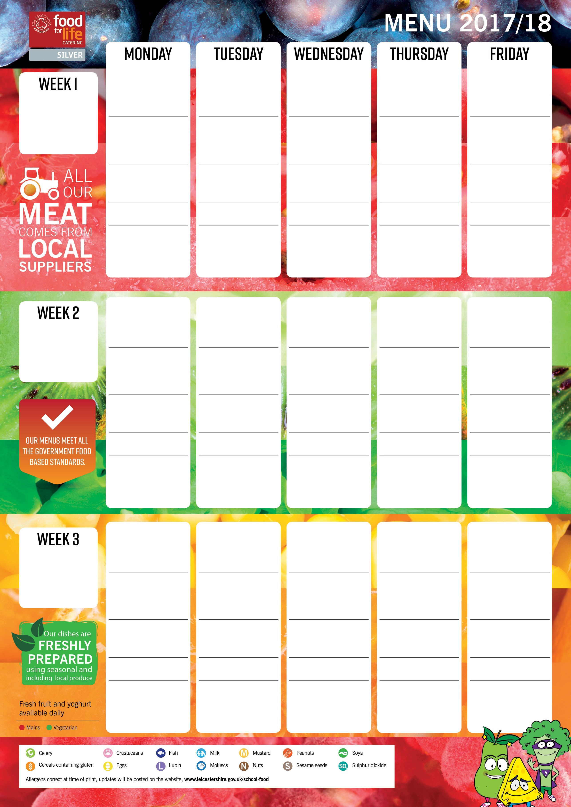

Cheese and onion topped bread

Wholemeal slice

Mexican sliced bread

Rustic farmhouse bread

**Roasted chicken with sage and onion stuffing**

Parsley potatoes

Medley of seasonal vegetables

Gravy

**Roast pork served with apple sauce**

Mashed potatoes

Seasonal vegetables of the day

Gravy

**Organic beef cottage pie**

New potatoes

Green beans Sweetcorn

**Vegetarian Shepherd’s pie**

Gravy

New potatoes

Seasonal vegetables of the day

**Macaroni cheese**

Herby wedges

Homemade creamy coleslaw

Salad bar selection

**Burger**

Chips

Baked beans

Peas

Homemade **cheese and tomato pizza**

Pasta spirals in a tomato sauce Homemade creamy coleslaw Broccoli florets

**Vegetable moussaka**

Chips

Peas

Salad bar selection

**Cheese pinwheel**

Pasta spirals in tomato sauce

Medley of seasonal vegetables

**Vegetarian filled tortilla baskets**

Cous cous

Peas

Sweetcorn

**Quorn dippers**

Chips

Baked beans

Peas

**Battered fish and lemon wedge**

Chips

Baked beans

Peas

**Chicken Strips**

Gravy

Creamy mashed potatoes

Medley of seasonal vegetables

**Organic Pork meatballs in a homemade tomato sauce**

Savoury rice

Sweetcorn nibbles

Broccoli Florets

**Salmon fishcake or fish fingers**

Herby wedges

Homemade creamy coleslaw

Baked beans

**Vegetarian sausage**

Chips

Baked beans

Peas

**Homemade margherita pizza** Pasta spirals in a homemade tomato sauce

Green beans

Sweetcorn

**Vegetarian meatballs in homemade tomato sauce** Pasta spirals

Peas

Sweetcorn

**Roast gammon served with pineapple**

Crispy roast potatoes

Seasonal vegetables of the day

Gravy

**Jacket potato with baked beans**

Salad bar selection

**Jacket potato with lentil curry**

Salad bar selection

**Vegetable Lasagne**

Jacket potato

Homemade creamy coleslaw

Broccoli florets

**Quorn tikka masala**

Savoury rice

Seasonal vegetables of the day

**Farm assured pork sausages**

Chips

Baked beans

Peas

Strawberry fool

**Quorn fajitas**

Savoury rice

Medley of seasonal vegetables

**Jacket potato with baked beans**

Salad bar selection

Homemade creamy coleslaw

**Jacket potato with tuna and cucumber mayonnaise**

Peas, Salad bar selection

**Cheese Flan**

Duchess potatoes

Sweetcorn nibbles

Salad bar selection

**Quorn sweet and sour**

Savoury rice   
Green beans   
Cauliflower florets

**Cheese and potato pie**

Jacket wedges   
Seasonal vegetables of the day

**Pizza topped with red pepper**

Pasta in homemade tasty tomato sauce

Peas,sweetcorn

**Brunch lunch**

Bacon, Scrambled egg   
Sliced potatoes

Grilled tomato

Baked beans

**Roast turkey served with sage and onion stuffing**

Gravy, Parsley potatoes Seasonal vegetables of the day

**2017**

5th June • 26th June

• 21st August • 11th September

• 2nd October • 30th October

• 20th November • 11th December

**2018**

15th January • 5th February

• 5th March • 9th April

• 30th April • 21st May

**Jacket potato with a tasty organic beef bolognaise**

Crudités with dip, Salad bar selection

**Jacket potato with cheddar cheese and fresh tomatoes** Green beans, Salad bar selection

**Jacket potato with mild vegetarian chilli**

Salad bar selection

Soft finger roll

Wholemeal bread

Onion flat bread

Farmhouse wedge

Chocolate and beetroot slice

Festival shortcake

Catherine wheel biscuits

Lemon drizzle cake

Cherry shortbread

Pineapple upside down pudding served with custard sauce

Oatie fruit cookie

Rice pudding with a fruit coulis

Apple crumble served with custard sauce

Assorted organic yoghurts

**2017**

12th June • 3rd July

• 28th August • 18th September

• 9th October • 6th November

• 27th November • 18th December

**2018**

22nd January • 19th February

• 12th March • 16th April

• 7th May

**Jacket potato with tuna and sweetcorn filling**

Salad bar selection

**Jacket potato with cheese and homemade creamy coleslaw** Salad bar selection

**Jacket potato with vegetarian chilli**

Salad bar selection

**Jacket potato with coronation chicken**

Salad bar selection

**Jacket potato with cheddar and red onion**

Salad bar selection

Sliced poppy bread

Herby bread

Soft rolls

Golden krispie cake

Carrot cake

Fresh fruit salad

Crunchy chocolate biscuit

Lemon iced bun

Steamed pear sponge served with vanilla sauce

Cheese and biscuits with grapes

Flapjack

Steamed syrup sponge served with custard sauce

Assorted organic yoghurts

**Organic beef bolognaise with spaghetti**

Garlic bread Peas sweetcorn

**2017**

19th June • 10th July

• 4th September • 25th September

• 23rd October • 13th November

• 4th December

**2018**

8th January • 29th January

• 26th February • 19th March

• 23rd April • 14th May

**Jacket potato with tuna mayonnaise**

Salad bar selection

**Jacket potato with cheese and homemade creamy coleslaw** Salad bar selection

**Jacket potato with chicken mayonnaise**

Salad bar selection

Garlic bread

Farmhouse wedge

Focaccia bread

Pumpkin seeded slice

Melting moments

Berry waffles

Blueberry muffin

Feather iced lemon sponge

Apple cake served with custard sauce

Banana flapjack

Chocolate brownie

Peach crumble served with custard sauce

Ice cream with a fruit coulis